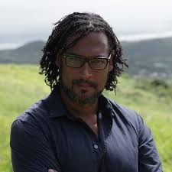**Black Britons in the Georgian period**

*Source: https://twitter.com/davidolusoga*

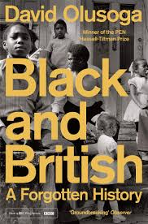

‘The picture is mixed and much of it is concealed. What we can say is that most black Georgians lived lives of **constrained** unfreedom as slaves or low-ranking servants. Some were brutally treated by men and women who regarded them as their property and as the law was unclear on the issue they were able to make their claim real through physical force and violence. Black Britons who rejected that **predicament** fell into another one, and struggled **destitute** on the streets, where many lived off charity or crime, their names turning up in the records of the courts. The lives of the most fortunate were characterized by some degree of social mobility, with opportunities for learning and engaging in a religious life. Those who had the time and the security to look beyond their own needs were politically active and culturally productive.’

*Source: www.amazon.co.uk/Black-British-Forgotten-David-Olusoga/dp/1447299760*

What can we learn from Olusoga about the status of people of African descent in Britain in the Georgian period?

1. What difficulties did they face?
2. What happened to most of those who weren’t slaves?
3. What did some manage to achieve?