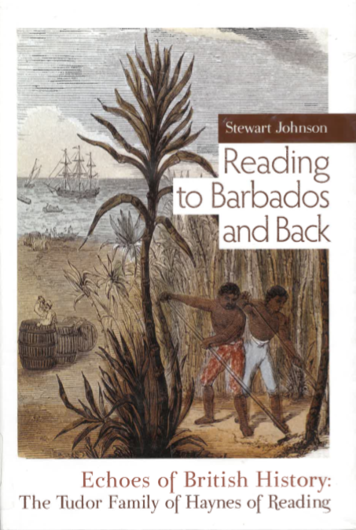
From Reading to Barbados and Back
Echoes of British History: The Tudor Family of Haynes of Reading
by Stewart Johnson
Source: www.amazon.co.uk/Reading-Barbados-Back-British-History/dp/1846246113
Why is it useful to consider the example of one family when studying history?

General Robert Haynes, born on a sugar plantation in Barbados, had a strong belief in the importance of his family and of his own destiny from an early age. He had grown up on stories of his ancestors and how they came to be in the West Indies and was clearly proud of the fact that he could trace his forebears to the early years of settlement of the island. He believed that he was descended from a Berkshire family living in the times of Henry VII and Henry VIII, whose coat of arms he would continue to use… Robert Haynes inherited Newcastle Plantation on his father’s death and was at once elected to the House of Assembly as a representative of St John’s Parish, which he served with distinction through a particularly turbulent period… He retired from government at a critical time for Barbados and remained to see the island through the emancipation process with which he was not entirely sympathetic. It was at this point that he and many of his family moved to England; he to the Reading of his forebears, and where on 18 April 1851, he died.

