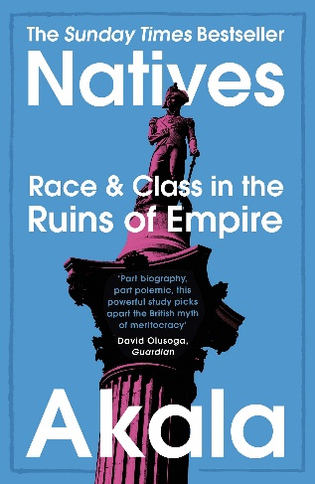
Scholarship reading
Akala’s Natives: Race and Class in the Ruins of Empire
Read this extract and answer all the questions. This is supposed to be hard. If you can’t answer all the questions, don’t worry!
https://www.amazon.co.uk/Natives-Class-Empire-Sunday-Bestseller/dp/1473661234
https://www.pieradio.co.uk/tag/akala
Highlight where Akala is pointing out Britain’s leading role in the transatlantic slave trade.
Bullet-point three of the points he makes on this:

‘Despite Britain spending almost two centuries as the dominant transatlantic slave trader, with all the torture, rape and mass murder that entailed, despite Britain refusing to back abolition when other European powers had paved the way, despite Britain spending the 1790s warring to keep slavery intact all over the Caribbean, despite Britain trying to crush the only successful slave revolution in human history and then helping their French enemies attempt to do the same, despite Britain refusing to even recognise the first Caribbean state to abolish slavery, despite all of this, some “historians”, teachers and assorted nationalists are asking us to believe the self-serving fairy tale that suddenly, in 1807 – just three years after Haitian independence – guided by William Wilberforce alone, Britain abolished slavery because it was “the right thing to do”. What a pile of twaddle.’
What does Akala call a ‘fairy tale’?

Why does he think it’s a ‘fairy tale’?
Why does Akala think that it’s unfair to focus on Wilberforce when talking about the abolition of the slave trade?

