CROSS CURRICULAR LINKS

This academic year we are joining with the Art and Music Departments in linking our study of World War One and we will be hoping to enter the Art, Music and Poetry competitions run by ‘Never Such Innocence.’
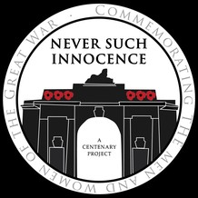

We are also going to organize for the academic year 2017-2018 a cross-curricular day for Year 9 based on World War One which will include History, Art, English, Home Economics, and Design and Technology departments.

