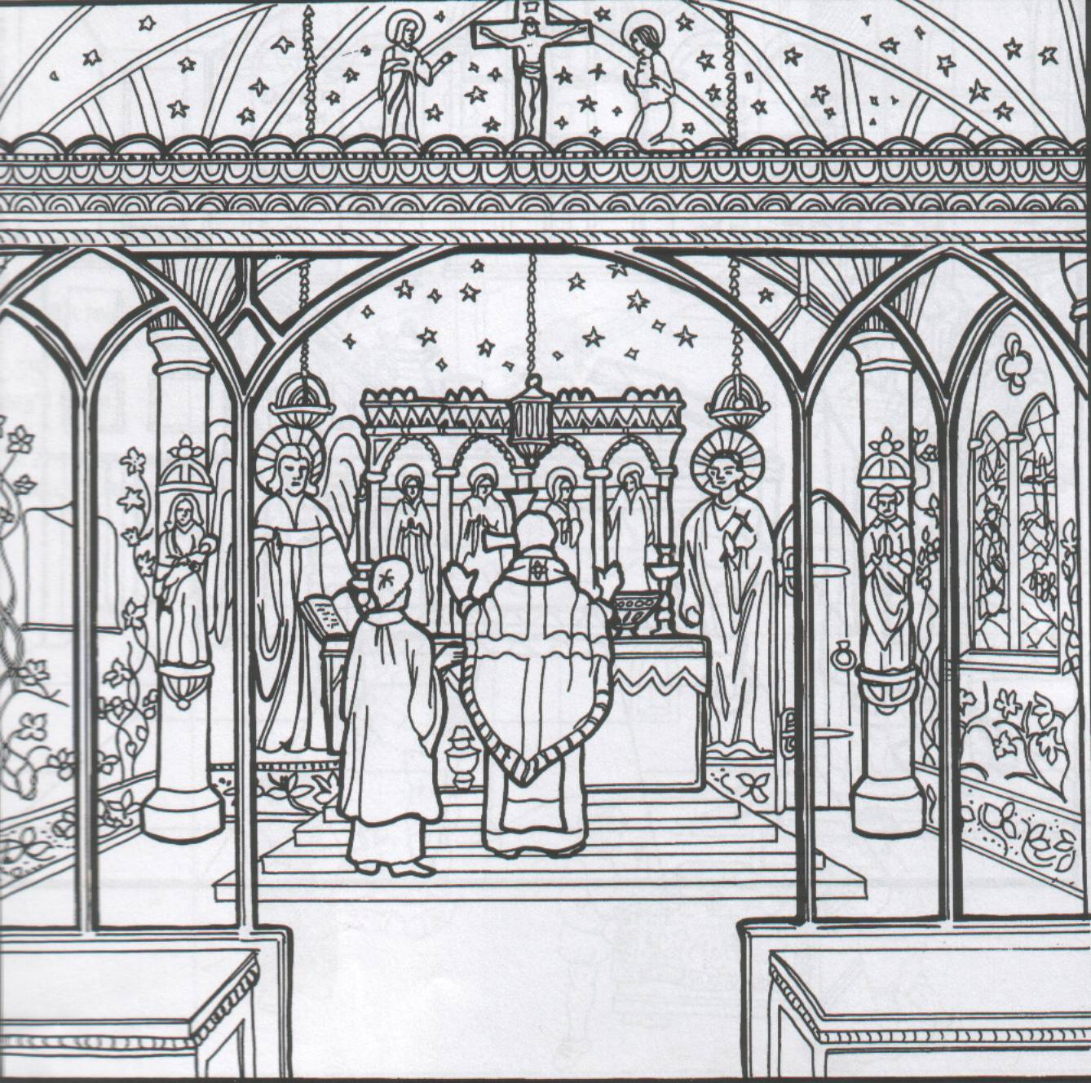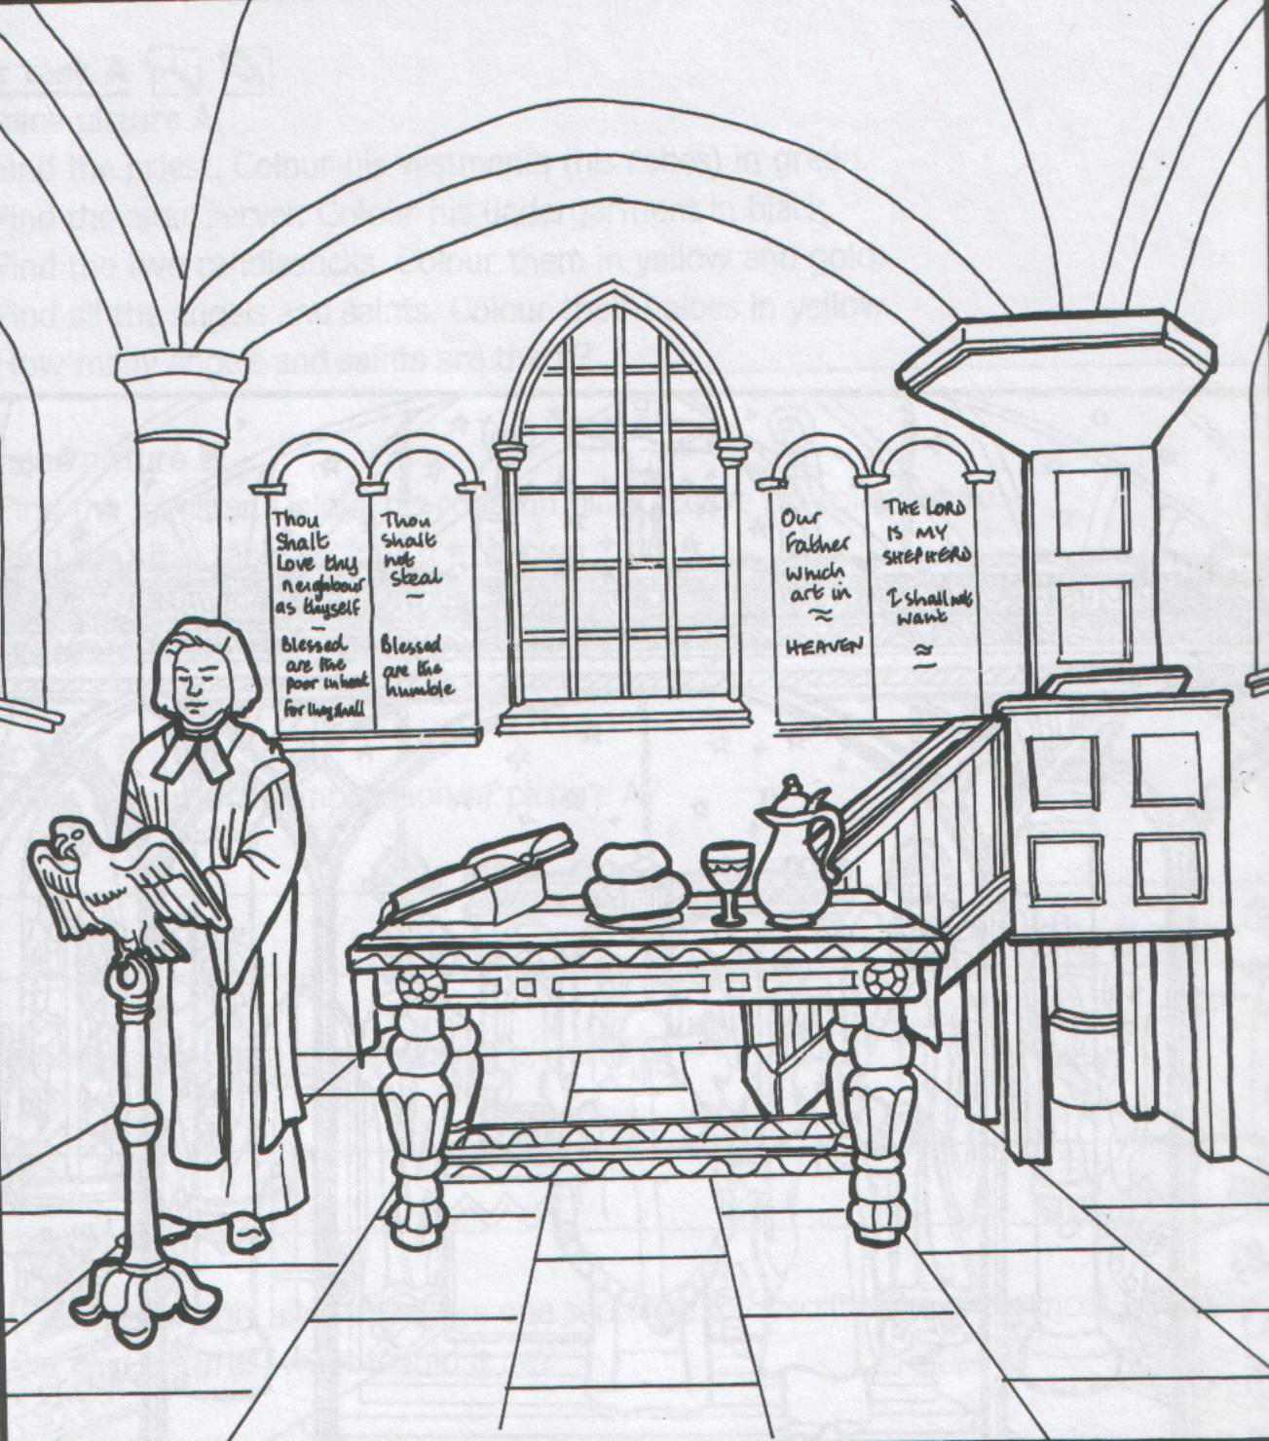

**Task 4: Label the diagrams showing which is the interior of a Catholic Church and which is the interior of a Protestant Church.**

**Circle 3 differences between the 2 pictures.**

**(total marks 5)**

**Task 3: Keywords**

**(total marks 5)**

*Below are some keywords. Match them to the correct definition. Write the correct letter.*

Dissolution = A: The main faith in Europe until 1517

Catholic = B: When Henry VIII replaced the Pope as Head of the Church in England

Act of Supremacy = C: The faith introduced by Martin Luther

Protestant = D: The closing down of the monasteries

Break with Rome = E: The law making Henry VIII Head of the Church in England

**Task 2: Chronology**

**(total marks 3)**

Put the following events in chronological order. Put the event that happened first as 1, the next as 2 and so on.

|  |  |
| --- | --- |
| The Elizabethan Church Settlement |  |
| The Dissolution of the Monasteries |  |
| The burning of heretics by Mary I |  |

**Task 1: Multiple Choice Quiz**

**(total marks 9)**

For each of the statements below, write whether they are true **or** false statements.

1. The mother of Edward VI was Ann Boleyn.
2. Catholic churches were plain and simple.
3. Elizabeth I was Supreme Head of the Church in England.
4. Martin Luther was a French monk.
5. The Lord Protectors of Edward VI were the Dukes of Somerset and Essex.
6. The daughter of Catherine of Aragon was Elizabeth.
7. The Elizabethan Church Settlement was a ‘via media.’
8. Philip II of Spain was married to Mary I.
9. Mary I burnt Catholics at the stake.

Year 8 History Knowledge Test 1 Name:

**Task 3: Keywords**

**(total marks 5)**

*Below are some keywords. Match them to the correct definition. Write the correct letter.*

Coffle = A: Freedom

Barracoons = B: A method of selling slaves.

Emancipation = C: A wooden neck brace.

Abolitionists = D: People who campaigned for the end of slavery.

Scramble = E: Prisons where slaves were kept on the African coast.

**Task 2: Chronology**

**(total marks 3)**

Put the following events in chronological order. Put the event that happened first as 1, the next as 2 and so on.

|  |  |
| --- | --- |
| The American Civil War |  |
| The Abolition of the slave trade in the British Empire |  |
| The discovery of the Americas by Christopher Columbus |  |

**Task 1: Multiple Choice Quiz**

**(total marks 7)**

For each of the statements below, write whether they are true **or** false statements.

1. The 2 sides in the American Civil War were the Cavaliers and the Roundheads.
2. The Middle Passage was the journey from Africa to the Americas.
3. The name of the farms where the slaves worked was plantations.
4. Slaves with a skill were cheaper when sold at auctions.
5. Slaves were given a European name.
6. The American Civil War started with the succession of the southern states.
7. The 3 continents in the triangular trade route were Europe, Asia and the Americas.

Year 9 History Knowledge Test 1 Name:

FALSE

**Task 4: What have you learned about the slave trade? (total marks 4)**

1. Can you give an example of how slaves might show resistance?

………………………………………………………………………………………………………………………………………………….

1. Can you name a campaigner for the abolition of slavery?

………………………………………………………………………………………………………………………………………………….

1. Can you name 1 of the products produced on plantations?

………………………………………………………………………………………………………………………………………………….

1. Can you name the American President who emancipated (freed) the slaves in the USA?

…………………………………………………………………………………………………………………………………………….

FALSE

peasant hut starter.tif

Year 7 History Knowledge Test 1 Name:

**Task 2: Chronology**

**(total marks 5)**

Put the following events in chronological order. Put the event that happened first as 1, the next as 2 and so on.

|  |  |
| --- | --- |
| The Spanish Armada 1588 |  |
| World War Two 1939-1945 |  |
| The Battle of Hastings 1066 |  |
| The Great Fire of London 1666 |  |
| The Black Death 1348 |  |

**Task 1: Anachronisms**

**(total marks 10)**

In the picture to your left, find 10 anachronisms. Circle them.

**Task 3: Keywords**

**(total marks 5)**

*Below are some keywords. Match them to the correct definition. Write the correct letter.*

Anachronism = A: Putting events in time order

Objective = B: Against time

Interpretation = C: produced in the time being studied

Source = D: writing from a balanced viewpoint

Chronology = E: produced after the time being studied