  - How well do the pupils understand the purpose of history?
The pupils voice is used at Heron Cross to develop an engaging and purposeful curriculum. Teachers delivering the curriculum will often feedback to the history lead regarding topics that they have covered with their class and whether they found that the children were engaged with the coverage. The history lead ensures that through learning walks and monitoring she is able to get a feel for the pupil voice and this allows topics to be developed to ensure that pupils understand fully what they need to do and why.
The children take part in cross-curricular theme days which helps to ensure that they are highly motivated about their topic and to ensure that they have a full understanding of the subject. The school also provide trips relating to the topics to help children to transfer their skills outside of the classroom,
After completing a book scrutiny and learning walk for humanities, the subject leader was able to provide feedback of the strengths within history and the development points. The subject lead found through discussion with the pupils that they enjoyed learning about history and developing their history skills. This was then fed back to the staff during a staff meeting. Please find below a screenshot of the feedback provided.
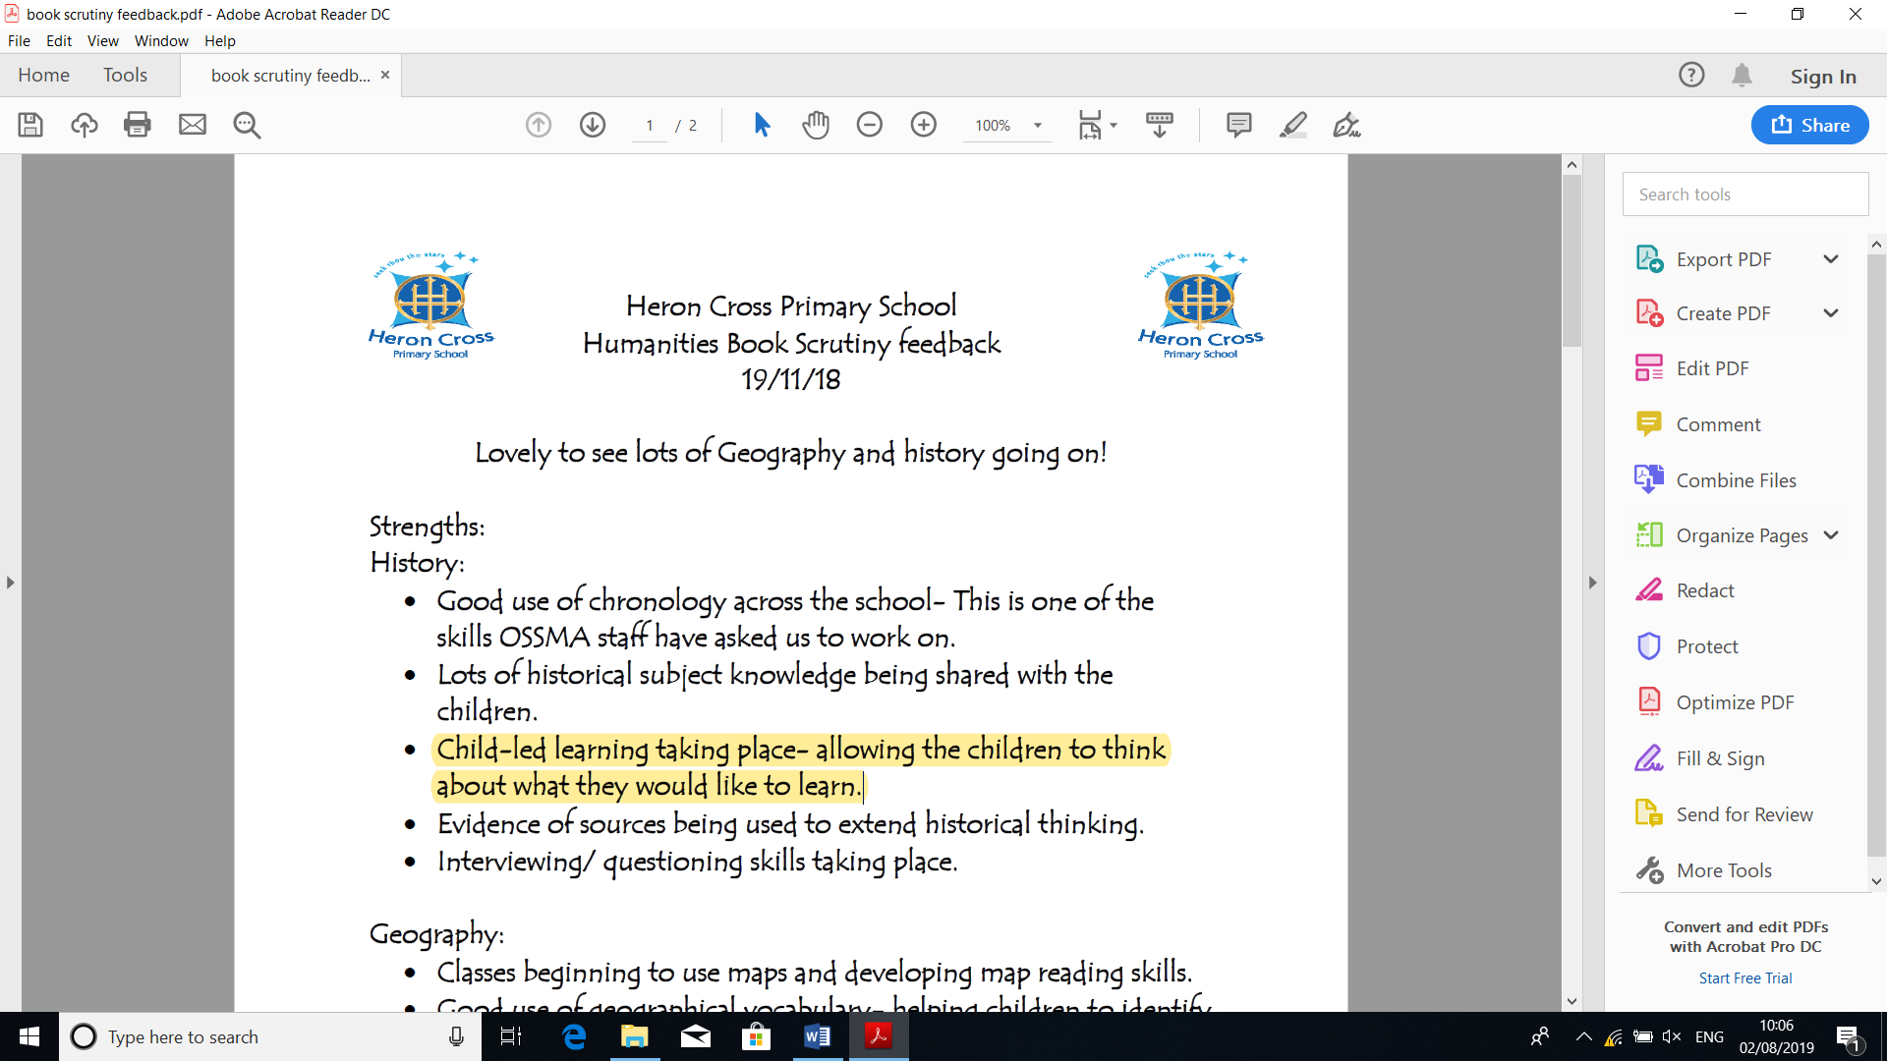

1.1
Extracts from pupil voice:
Enjoyment and understanding:
- Year 3: “I enjoy history because you get to do fun stuff and learn interesting things.
- “I like to learn new things.”

Purpose:
- Year 2: “I like to learn interesting facts. Finding out what they did then.”
- Year 3: “I like finding out about how things have changed.”
- Year 5 “I have enjoyed learning about different things and how people have used them.” (during an artefacts lesson).

1.2 How does history teaching impact upon learning and achievement?
Teachers plan cross-curricular lessons that help the children to become inspired by what they are learning and to begin to develop an inquiring mind and to allow them to use their historical skills independently. Each lesson the children are given a history WALT that allows them to identify the skills being taught. In a plenary for the session either part way through or at the end of the session each child receives a next step which allows them to identify any mistakes or misunderstandings or an additional question/ task which will further their knowledge or identify the skills they have developed.

During learning walks the subject lead will observe teaching and the environment to ensure that the quality of teaching remains high and that any feedback has been acted upon.

Teachers are asked to assess the children’s knowledge and skills a number of times throughout the year, this information is passed onto the history lead to ensure that progression is occurring. Teacher’s use the progression mapping document (please find in additional documents) supplied by the subject lead to ensure that all lessons are planned to promote achievement and progression of skills for all pupils

Please see Victorian Day Learning walk evidence.

1.2 continued…
WALTs are used for each lesson to ensure that clear historical skills are being taught. This allows teachers to track what has been taught and the skills that they are building upon.
Teachers can then identify any children who have not met the learning intention and ensure that they are given additional support when working on this skill again.
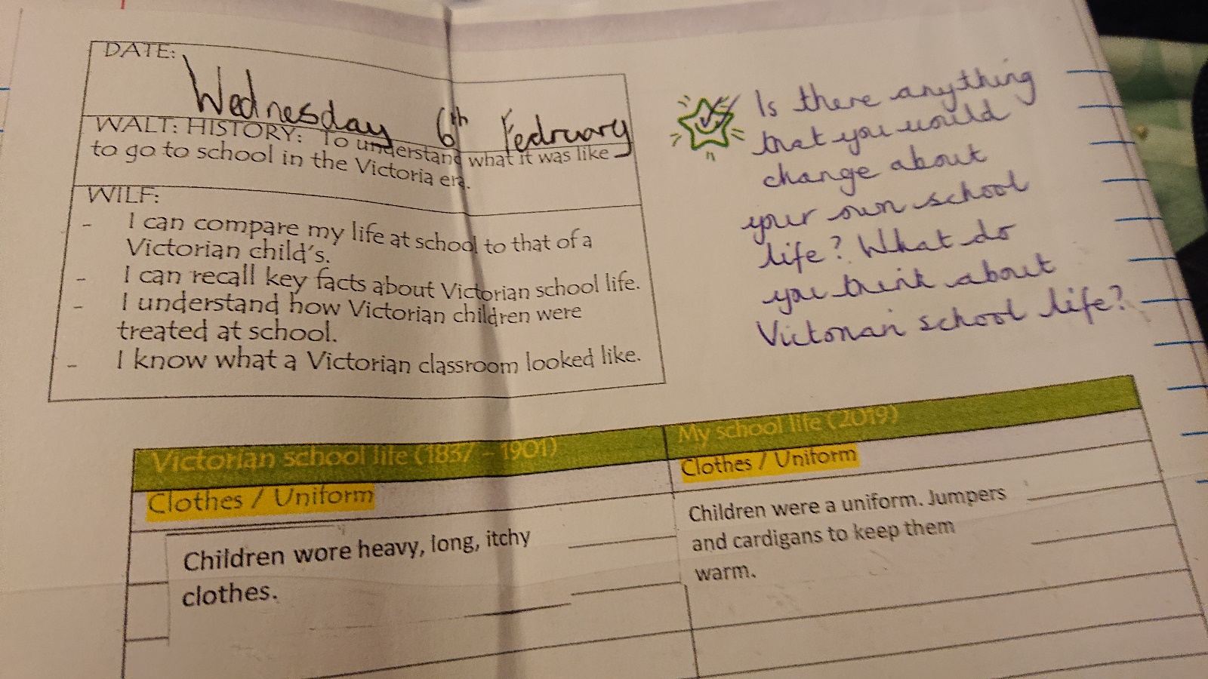

1.3 How effectively are resources deployed to aid learning and achievement?

Throughout the school teachers use cross-curricular teaching styles to increase progression and achievement of all ability of children. These occur during whole school theme days alongside timetabled sessions. The classroom and school environment is used to promote curiosity and interest in history. Displays are used to help to secure knowledge and links between different topics and these are made as interactive as possible to engage the children.

For each part of the curriculum a variety of resources are used to help the children to develop and build upon the skills that they may have previous acquired. Teachers will identify appropriate links within ICT, encourage the investigation of artefacts, role play and where possible will ensure a trip or workshop is implemented to help to develop practical skills and knowledge. Year 6 thoroughly enjoyed their trip in which they were able to learn about crime and punishment throughout different time periods. During our whole school World War 1 day all classes were able to take part in role play and a history organisation came to the school to provide the children with the opportunity to take part in workshops.

Please see Victorian Day learning obs for evidence of cross-curricular lessons and use of a variety of resource.

1.3
Victorian Whole School Topic Day:
The children in EYFS enjoyed learning about the Victorians and the games that Victorian children would play. They were excited to share the games that they play now and realised that some Victorian games are still played now.
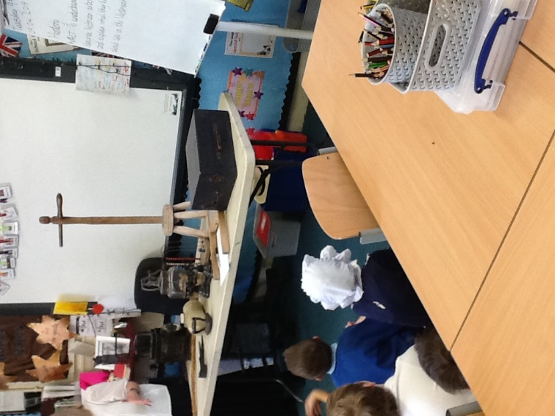
Artefacts were used to help to motivate, inspire and develop enquiry within lessons.
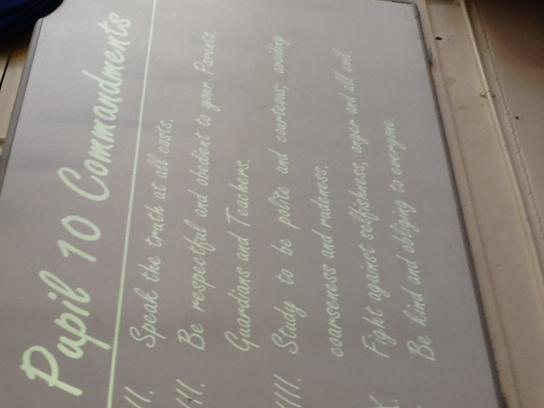

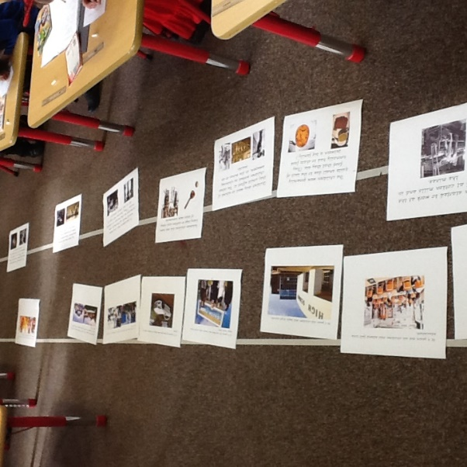
Through role play the children began to think about how Victorian Children might have felt and to begin to make comparisons with their lives.
In Year 2 the children created a timeline of a child in Victorian Britain and one and of their own life time and were able to make comparisons.
1.4 How does monitoring, marking and feedback help pupils make progress in history?
The subject lead has created the long term plan to ensure that coverage allows for progression not only of knowledge but also of historical skills. It has been planned to allow the children to begin to develop these abilities and to gain a feeling of independence. There are a number of different assessment strategies that have been put into place. We are currently using the rising stars assessment grid at different intervals to assess the children and the progression grid (please see additional document) created by the subject lead allows the teachers to ensure that all children are progressing, not only their knowledge but their skills as well. These documents allow the teachers to identify children who are secure at the national expectations and also those developing and exceeding. This allows teachers to plan lessons that ensure every pupil is being challenged and are able to succeed.

At Heron Cross the subject lead regularly monitors the teaching of history and the environment by completing learning walks, book scrutinys and pupil questionnaires. This allows her to monitor the standard of teaching, resources being used and whether children are progressing. Strengths and development points are then fed back to all teaching staff to ensure that high quality lessons are taking place.

When planning teachers ensure that they create a WALT for each lesson which allows them to provide each child with a differentiated target or goal. All teaching staff will ensure that the children can succeed in this challenge and active marking is used within the lesson. This allows the teaching staff to provide the children will an opportunity to extend the skills/ Knowledge they have been developing and to support any children that may be finding a specific task difficult.

1.4 continued…
WALTs allow the children to understand which skills they are learning and their objective for the lesson. During the lesson teaching staff are monitoring the completion of these and will either give the children more support or find a challenge to extend and build upon the skills that they are learning by using a “fix it star”.
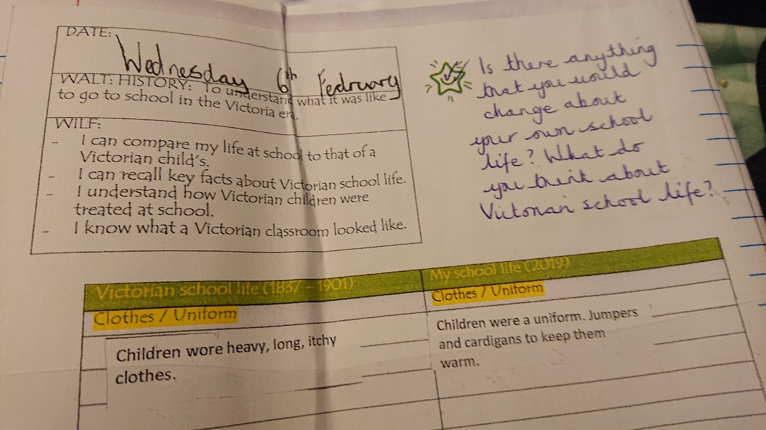
This also allows the subject lead to ensure that differentiation and progression are taking place throughout the school and that children who are struggling are supported as soon as it is identified.

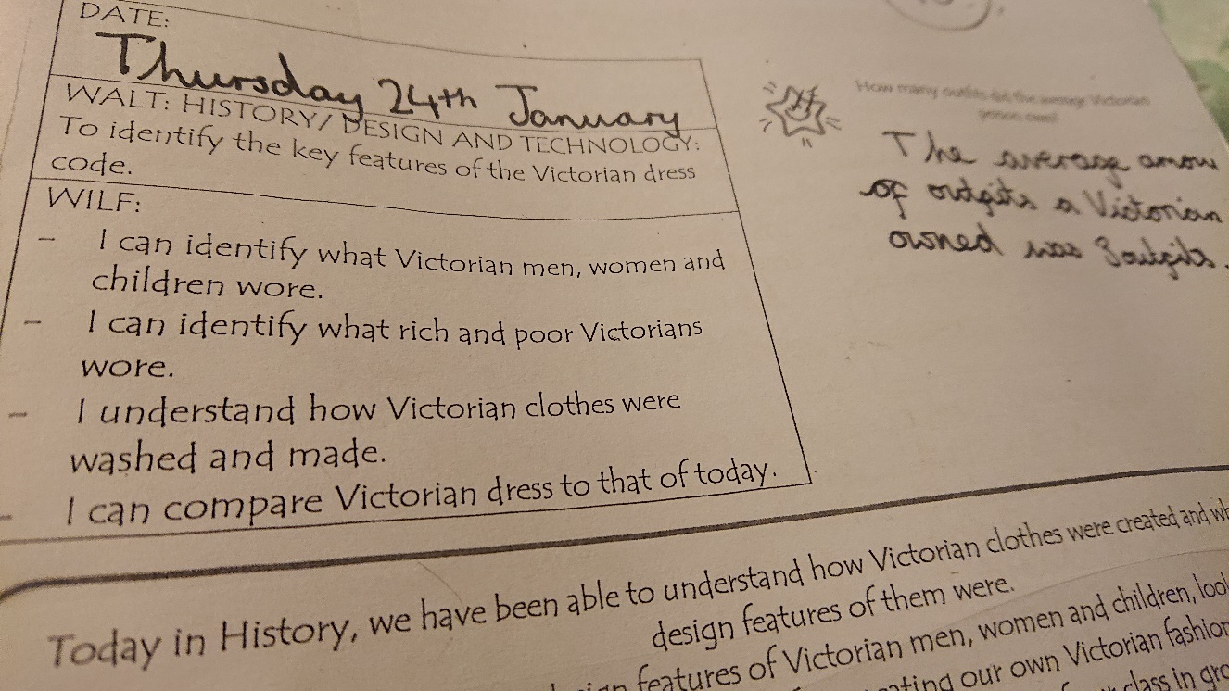

1.5 How well do pupils achieve in history relative to their starting points?

Through our new assessment documents teachers are able to ensure that they are planning lessons that help children to make good or outstanding progress in history from their relative starting points. Training provided by Aaron Wilkes has helped to ensure that all teaching staff understand how to to ensure that a wide variety or lessons are used to develop the children’s knowledge and skills. This has enabled them to provide the children with creative lessons that inspire the children and help them to understand what they must do to succeed. These assessment documents ensure that progressive challenge is present in the curriculum and this is made explicit on the progression grid.
To ensure that children are making the appropriate progress. The subject leader now tracks each group of children from their entry points to ensure that progression continues.
Progression of historical skills and understanding is evident from children’s books.

