3.1 How broad, balanced and engaging is the history curriculum?
Through monitoring systems, pupil and teacher discussions the subject lead has developed a curriculum that covers all areas required in the National Curriculum whilst using engaging and motivating topics which the children enjoy. The progression maps that the subject lead has introduced allows teachers to have a clear understanding of the progression that the children should be making and allows them to identify areas that the children may need additional challenges or support in.
The curriculum has been planned to allow the children to make links between what they are using and to use their previous knowledge as introduction to enquiry or as comparisons. Over the last year, the subject lead has begun to increase the status of local history and there are now topics within KS1 and KS2 relating to this. This has helped to inspire the children as they are able to relate more to this history as they have a real life comparison to focus on.
Cross-curricular lessons ensure that all pupils access the subject and find the activities to be engaging and motivating.

SEE LONG TERM OVERVIEW

3.1 continued…
To ensure that the curriculum is broad, balanced and engaging. Teachers try to give the children as many different types of opportunities to be immersed into historical learning.
Below are photos and screenshots of children being provided with cross-curricular activities to increase motivation, engagement and inspiration.
Year 2 enjoyed a visit from the Head teacher to discuss her experience of the moon landing. They used ICT to find out facts about the moon landing before using their historical skills.
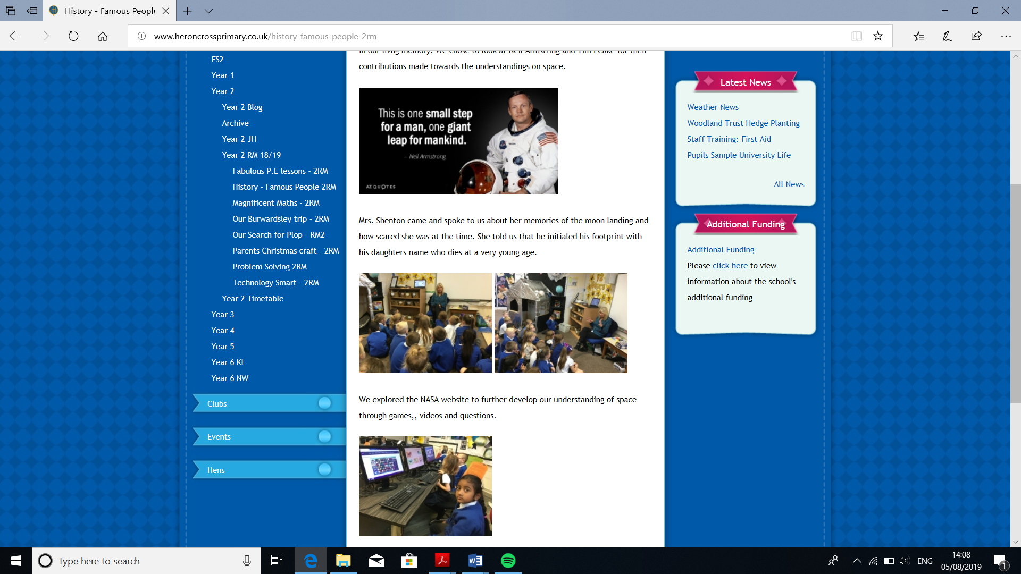

3.2 How aware are pupils of links and connections between the history covered?
At Heron Cross the children are taught about a wide range of periods, locations and themes. The children are able to make links between the periods and are able to contrast different time periods looking at similarities and differences. This occurs throughout the entire school with KS1 making links between the time and the present day and within KS2 whereby children make links between different times periods that they have studied.
Year 6 completed a crime and punishment topic which allowed them to link different time periods together and to identify similarities and differences in these times.
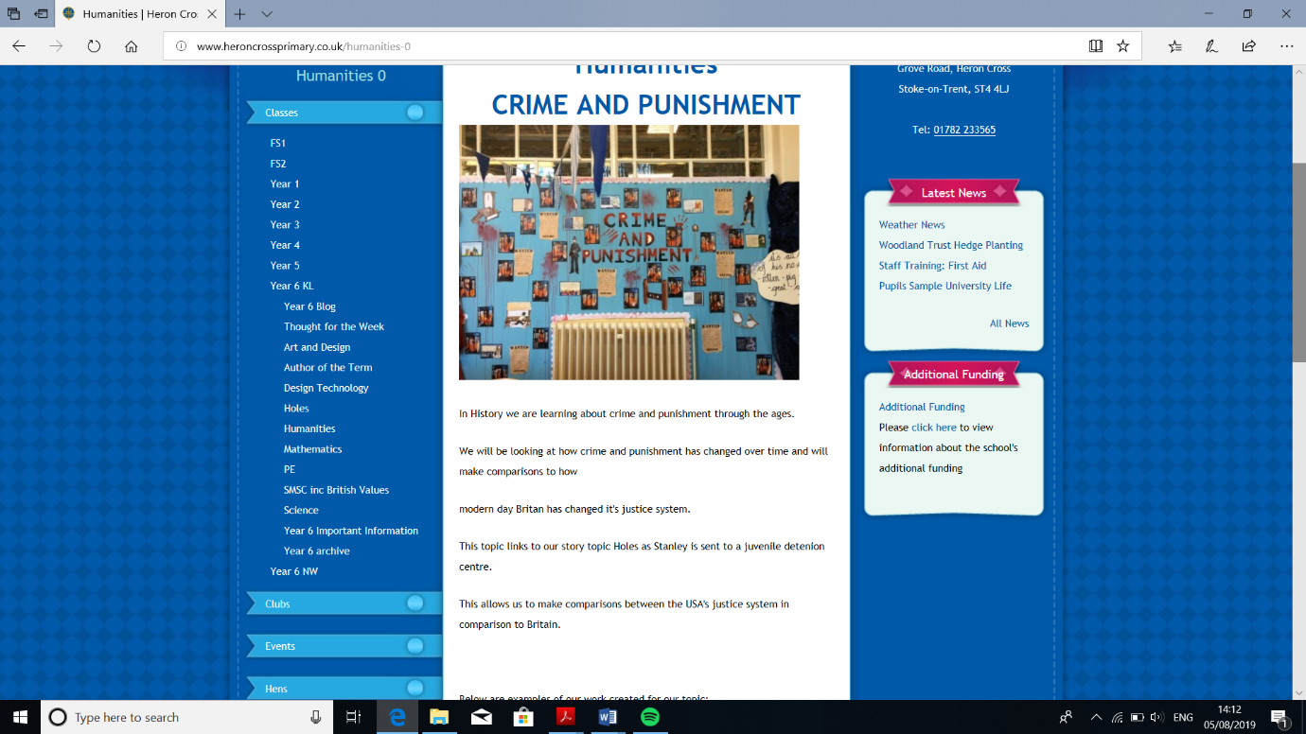

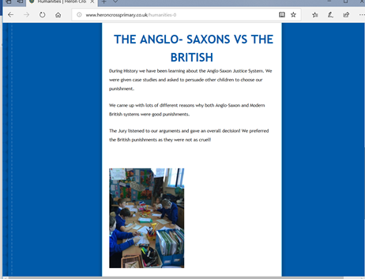
They were able to look at Crime and Punishment in Roman times, Victorians times, Anglo-Saxon punishments and compare these alongside crime and punishment in Britain and USA today.

This was then linked with their trip to the National Justice Museum. In which the children were able to see different punishment methods throughout different eras.
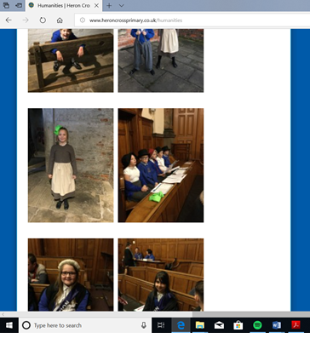

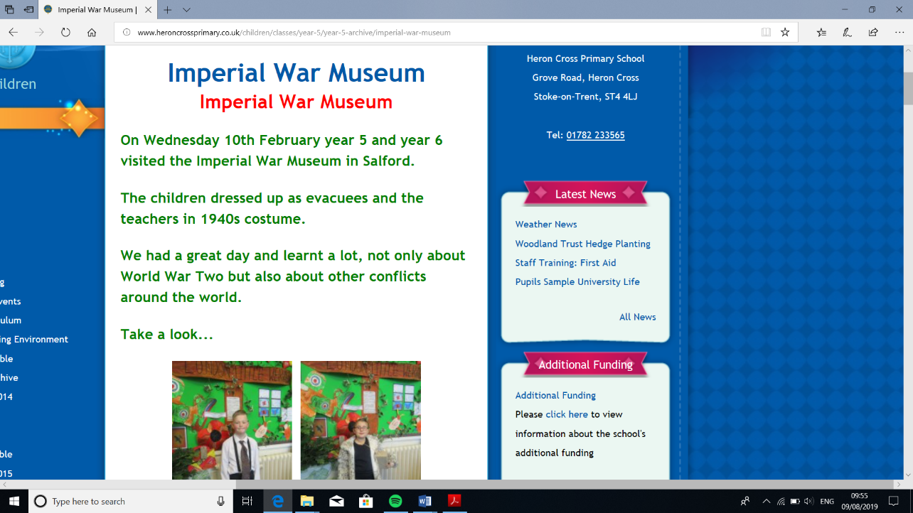
Year 5 and 6 also went on a trip to the Imperial War Museum this gave them the opportunity to learn about World War 2 and link it by comparisons with other conflicts around the world.

