Sandham paintings
Insert image from
Image: www.nationaltrustcollections.org.uk/object/790177
Image: Scrubbing the Floor © The Estate of Stanley Spencer. Photo © National Trust Images
Insert image from
https://www.nationaltrustcollections.org.uk/object/790176
Image: Convoy Arriving with the Wounded © The Estate of Stanley Spencer. Photo © National Trust Images

Image: www.nationaltrustcollections.org.uk/object/790177

Scrubbing the Floor – Beaufort Hospital
Convoy Arriving with Wounded – Beaufort Hospital
Image: https://www.nationaltrustcollections.org.uk/object/790176

Insert main image from
www.nationaltrustcollections.org.uk/object/790179
Image: Sorting and Moving Kitbags © The Estate of Stanley Spencer. Photo © National Trust Images / John Hammond
Insert image from
https://www.nationaltrustcollections.org.uk/object/790178
Image: Ablutions © The Estate of Stanley Spencer. Photo © National Trust Images
Ablutions – Beaufort Hospital
Image: www.nationaltrustcollections.org.uk/object/790179

Sorting and Moving Kitbags – Beaufort Hospital
Image: https://www.nationaltrustcollections.org.uk/object/790178

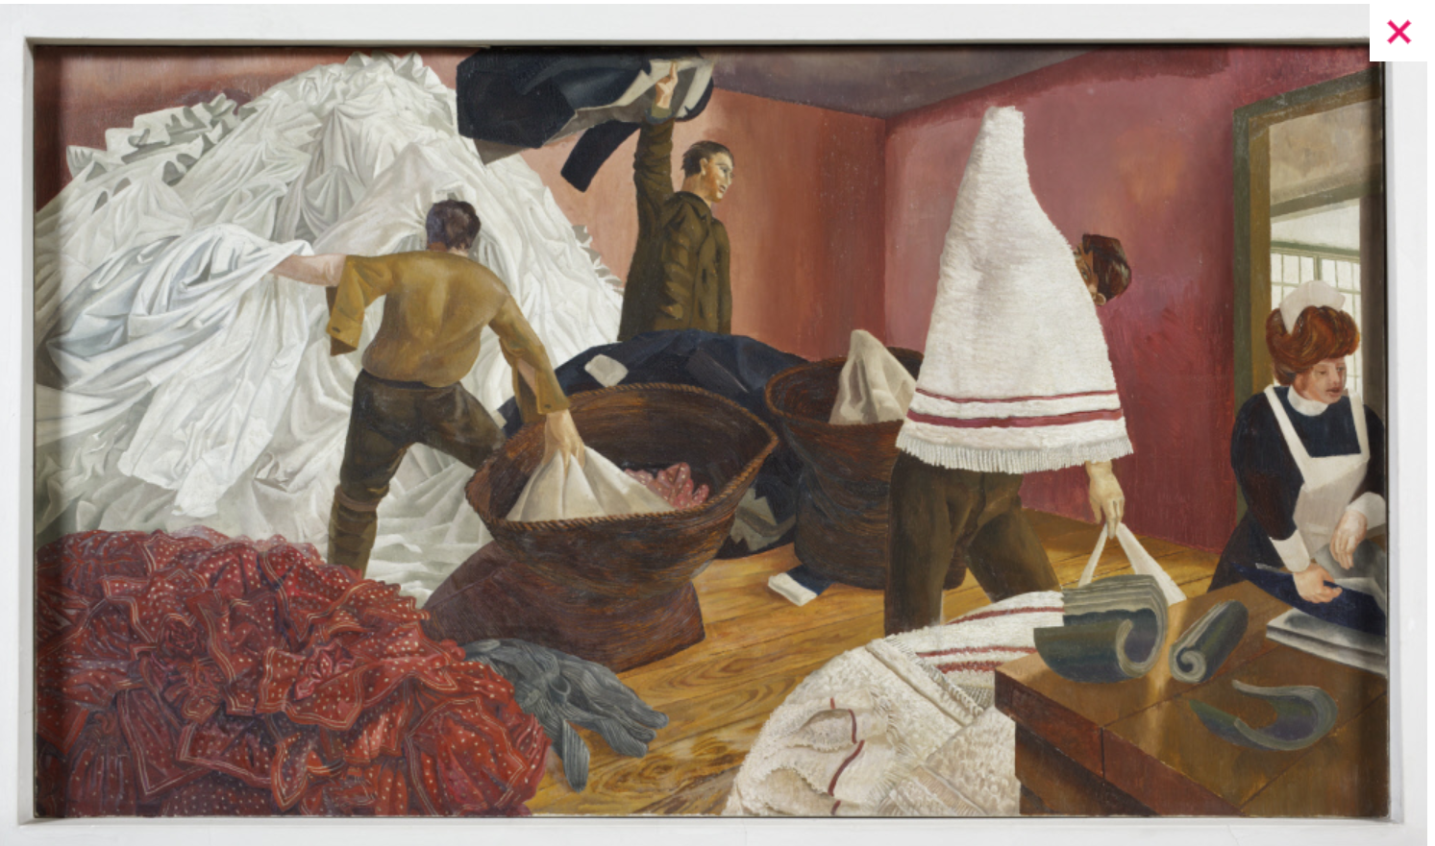
Insert image from
www.nationaltrustcollections.org.uk/object/790181
Image: Sorting the Laundry © The Estate of Stanley Spencer.
Photo © National Trust Images / John Hammond
Insert image from
https://www.nationaltrustcollections.org.uk/object/790180
Image: Kit Inspection © The Estate of Stanley Spencer.
Photo © National Trust Images / John Hammond
Image: https://www.nationaltrustcollections.org.uk/object/790180

Kit Inspection – Tweseldown Camp
Image: www.nationaltrustcollections.org.uk/object/790181

Sorting the Laundry – Beaufort Hospital

Insert image from
www.nationaltrustcollections.org.uk/object/790183
Image: Filling Tea Urns © The Estate of Stanley Spencer.
Photo © National Trust Images / John Hammond
Insert image from
https://www.nationaltrustcollections.org.uk/object/790182
Image: Dug-Out (or Stand-To)
© The Estate of Stanley Spencer.
Photo © National Trust Images / John Hammond
Filling Tea Urns – Beaufort Hospital

Image: www.nationaltrustcollections.org.uk/object/790183

Dug-Out (or Stand-To) – Macedonia
Image: https://www.nationaltrustcollections.org.uk/object/790182
Insert image from
https://www.nationaltrustcollections.org.uk/object/790186
Image: Reveille
© The Estate of Stanley Spencer.
Photo © National Trust Images / John Hammond
Image: https://www.nationaltrustcollections.org.uk/object/790186

Reveille – Macedonia
Insert image from
https://www.nationaltrustcollections.org.uk/object/790187
Image: Frostbite
© The Estate of Stanley Spencer.
Photo © National Trust Images / John Hammond
Image: https://www.nationaltrustcollections.org.uk/object/790187
Frostbite – Beaufort Hospital Hospital
Insert image from
www.nationaltrustcollections.org.uk/object/790189
Image: Tea in the Hospital Ward
© The Estate of Stanley Spencer.
Photo © National Trust Images / John Hammond
Insert image from
https://www.nationaltrustcollections.org.uk/object/790188
Image: Filling Water-Bottles
© The Estate of Stanley Spencer.
Photo © National Trust Images / John Hammond
Filling Water-Bottles – Macedonia

Image: https://www.nationaltrustcollections.org.uk/object/790188
Image: www.nationaltrustcollections.org.uk/object/790189

Tea in the Hospital Ward – Beaufort Hospital
Insert image from https://www.nationaltrustcollections.org.uk/object/790191
Image: Bedmaking
© The Estate of Stanley Spencer.
Photo © National Trust Images / John Hammond
Insert image from
https://www.nationaltrustcollections.org.uk/object/790190
Image: Map Reading
© The Estate of Stanley Spencer.
Photo © National Trust Images / John Hammond
Image: https://www.nationaltrustcollections.org.uk/object/790190
Map Reading – Macedonia

Image: https://www.nationaltrustcollections.org.uk/object/790191
Bedmaking – Beaufort Hospital
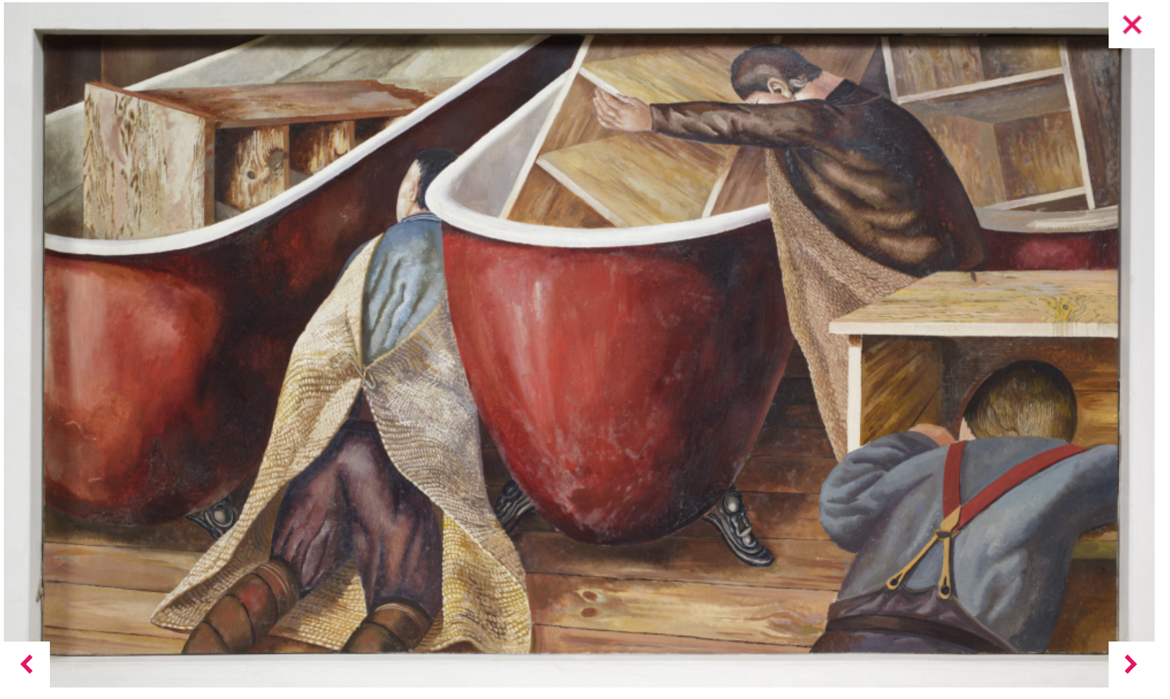
Insert main image from
www.nationaltrustcollections.org.uk/object/790193
Image: Washing Lockers
© The Estate of Stanley Spencer.
Photo © National Trust Images / John Hammond
Insert image from
www.wikiart.org/en/stanley-spencer/making-a-fire-belt
Image: Firebelt
© The Estate of Stanley Spencer.
Photo © National Trust Images / John Hammond
Image: https://www.nationaltrustcollections.org.uk/object/790192
Making a Fire Belt – Macedonia
Image: www.nationaltrustcollections.org.uk/object/790193

Washing Lockers – Beaufort Hospital
Insert main image from
www.nationaltrustcollections.org.uk/object/790184
Image: Camp at Karasuli
© The Estate of Stanley Spencer.
Photo © National Trust Images / John Hammond
Camp at Karasuli – Macedonia
Image: www.nationaltrustcollections.org.uk/object/790184

Insert main image from
www.nationaltrustcollections.org.uk/object/790194
Image: Riverbed at Todorovo
© The Estate of Stanley Spencer.
Photo © National Trust Images / John Hammond
Riverbed at Todorovo – Macedonia
Image: www.nationaltrustcollections.org.uk/object/790194

