When did the Normans complete their conquest?
TAKING CONTROL: Castles, cathedrals and Domesday

2. CATHEDRALS AND RELIGIOUS CHANGE
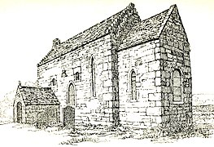
As the Conquest progressed, William I set about reorganising the Church in England. Religion was extremely important to people in England in the eleventh century, and these changes would have been noticeable to the ordinary population. The vast majority of people would attend church every Sunday, and the rhythm of their entire lives was shaped by Christian festivals – for example, Easter and Christmas. William brought men from France to be bishops and abbots; a key individual was Lanfranc, who became Archbishop of Canterbury (the most senior position in the English Church). Lanfranc helped William to reorganise the Church in England, and full obedience to King William and the Pope was expected. Impressive stone cathedrals and large monasteries were built – these were signs of Norman authority and were designed to show the English population the superiority of Norman culture. Most of the stone cathedrals built by the Normans survive today.
TASK: Answer the following questions in full sentences. Why do you think that William thought it was important to make these changes to religious worship in England? How did they help him to consolidate his power?

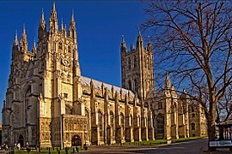
Images: Anglo-Saxon church, County Durham – https://commons.wikimedia.org/wiki/File:Escomb_Church,_County_Durham.jpg; Canterbury Cathedral – https://commons.wikimedia.org/wiki/File:Canterbury-cathedral-wyrdlight.jpg

