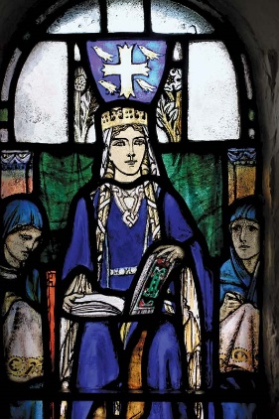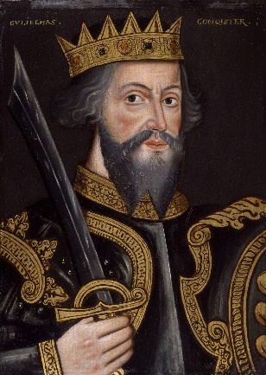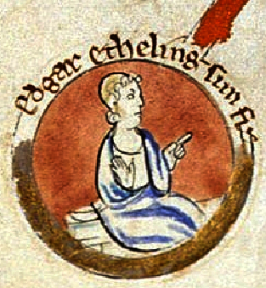

Images: https://commons.wikimedia.org/wiki/File:Malcolm3Canmore.jpg; https://commons.wikimedia.org/wiki/File:Queen_Margaret_(stained_glass).jpg; https://commons.wikimedia.org/wiki/File:Edgar_the_%C3%86theling.jpg; https://commons.wikimedia.org/wiki/File:William_the_Conqueror_by_an_unknown_artist_circa_1620.jpg

**William of Normandy, King of England 1066 - 1087**

**Malcolm III, King of Scotland 1058–1093**

**Margaret of Wessex, Queen of Scotland 1070–1093**

**Edgar the Aetheling**