A Hull hero
After being given his Victoria Cross medal by the King…
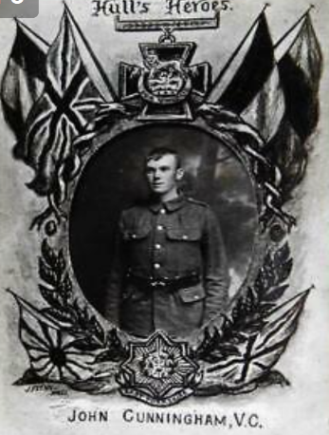
…Cunningham left London … to return home to Hull for leave and the City was to give him a huge welcome. Although his train arrived at Paragon Station at 1.28am, on a Sunday morning, the crowds and a band were waiting to greet their ‘local hero’. On emerging from the station … a great roar went up and he was immediately hoisted shoulder high and carried home. The initials VC were placed after Cunningham’s name on the Edgar Street shrine*. This included nine men from the street who had so far fallen during the war. The Roll of Honour was decorated with flowers and a crowd remained outside his parents’ house for the rest of the day.
During the same leave, he visited St James School. … The local cinema, the Hull Palace showed the film of the Hyde Park investiture, while Cunningham was on leave. John Cunningham, his parents and a younger brother were also invited to be guests at a crowded meeting of Hull City Council at the Guildhall on Wednesday 5th June 1917. [At the meeting] he was given an official welcome on behalf of the City and also presented with an Illuminating Address. The Lord Mayor, Alderman Francis Askew said this to Cunningham in his public address:
“…..It was open to him, as well as to any [men not born privileged], not only in the Army, but in civil life, by his zeal, industry, and determination, to achieve higher honours in the future. There was no doubt that his deed would be talked of for many years to come…”
Cunningham gave a short message of thanks and was applauded continuously. He was the first man connected with Hull to win the Victoria Cross in the 1914-1918 War.

*Streets in villages towns often had shrines (special places) to remember the men who were fighting and dying in the war.

(Extract with minor adaptations for readability from: https://www.proudgypsytraveller.co.uk/2016/10/07/1182/)

