After the war

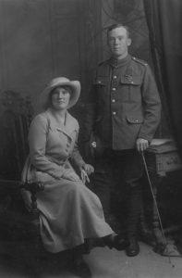
Towards the end of the war John Cunningham was quite badly wounded in the legs and lungs. He was discharged from the army in 1919 and returned to Hull. Many men suffered post traumatic distress because of their wartime experiences and struggled to settle back into civilian life.

Jack married Eva Harrison. He wore his medal at his wedding and there were celebrations of local people. The local Playhouse even showed a film of his wedding.

The couple’s little daughter, Annie, died as a baby. Their son John was born in 1920.

Jack Cunningham found it difficult to settle back into civilian life. He was regularly offered drinks as a local hero and this did not help. In July 1919 the local magistrate gave Eva Cunningham a separation order because Jack had been beating her. This happened again in late 1920. At this time Jack was also in a brawl and hit a man on the head with a bottle. In March 1922 Cunningham was sent to prison for a few months for failing to pay his wife separation maintenance.

In 1929 he was the victim of two fellow hawkers who stole goods from him. His life continued to be unhappy. He became more ill. He died at the age of 43 in Hull in 1941. He was buried in an unmarked grave in Hull Western Cemetery. Because he was a VC winner, his obituary was in The Times newspaper.

In 2018 a memorial stone was placed in Scunthorpe to remember Jack Cunningham. His medals are now in the York Army Museum.

