The Battle of the Ancre: 13-18 November 1916
This was a small battle that was the final part of the much larger battle of the Somme. The Battle of the Somme started on 1 July 1916. It was fought between the forces of the British and French Empires against the forces of the German Empire. Well over one million men were dead or wounded by the end of the Battle of the Somme.
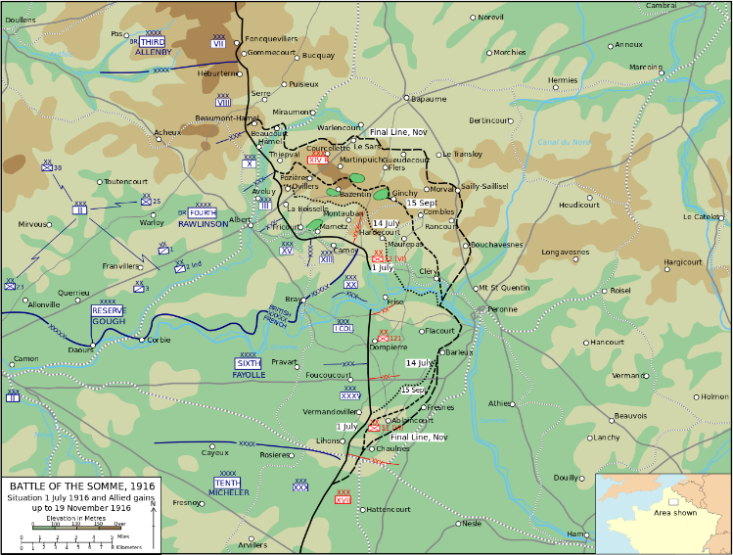
The Battle of the Ancre was fought by the river Ancre near the villages of Serre and Beaumont-Hamel.
Very wet weather delayed the start of the battle. The 31st Division aimed to gain land north of Serre.

The battle finally began after seven days when the German trenches were bombarded by heavy gun fire. British Empire troops advanced in fog on the early morning of 13 November. After five days the weather got worse again. No more attempts to advance were made until spring. British Empire troops had gained a few 100 metres of land. In five days, the German army had lost about 45,000 men and the British had lost about 22,000.
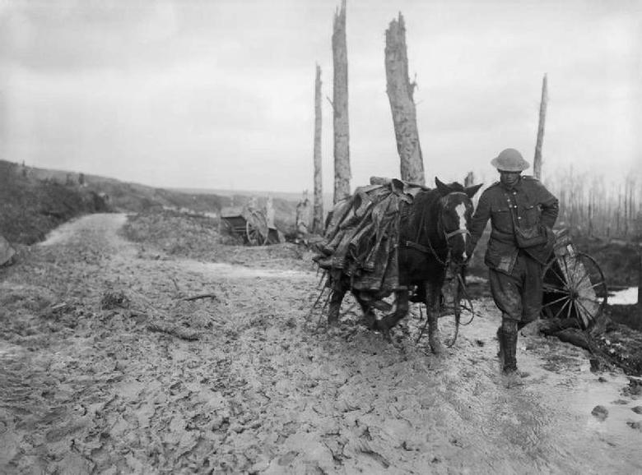
Picture taken of the battlefield area in November 1916. It shows the worsening conditions due to the very wet weather.

