The Hull Pals Battalions
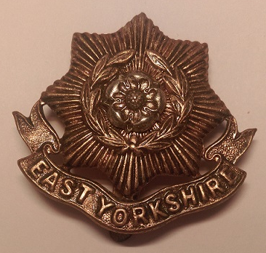
Britain declared war on Germany on the 4 August 1914. British Empire troops therefore joined what we now know as the First World War. Britain had a small army and so needed more soldiers. On 6 August there was a call for volunteers to train to fight. Men were encouraged to ‘join up’ with their friends – their pals.
Soldier’s cap badge
The city of Hull raised three Pals Battalions in the late summer of 1914. The third battalion was called ‘The Sportsmen’. A former England cricket captain helped with the recruitment. Actually, a lot of the men came from the Hull docks. Jack Cunningham joined the 3rd Hull Pals, he was 17 years’ old.
The Hull Pals became part of the East Yorkshire Regiment. The 3rd Pals trained in the East Riding of Yorkshire until the summer of 1915. At Christmas 1915 they were sent to Egypt to guard the important Suez Canal shipping route.
However, not long after arriving at Port Said in Egypt, they received orders to go to France. They landed at Marseilles in March and were sent north to the Western Front. They fought in the Battle of the Somme. The East Yorkshire Regiment stayed fighting on the Western Front until the end of the war.

