John ‘Jack’ Cunningham’s life before 1914
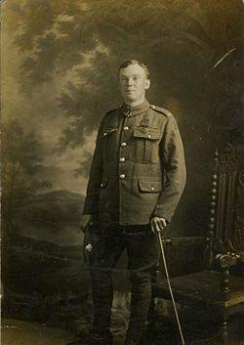
Jack was born on 28 June 1897. He was the eldest son of Charles and Mary Ann Cunningham. He had six brothers. The Cunningham’s were a Traveller family. Jack was born in a caravan parked off Manley Street in Scunthorpe. His father was a licensed pot hawker (seller) and the family lived in Hull during the winter and travelled the East Riding and North Lincolnshire during the months of better weather. Jack went to school when the family were in Hull. After he left school he became a pot hawker like his father. He was good at sports, liked racing his pet whippet “Meg” and was known to be a ‘good lad’.

