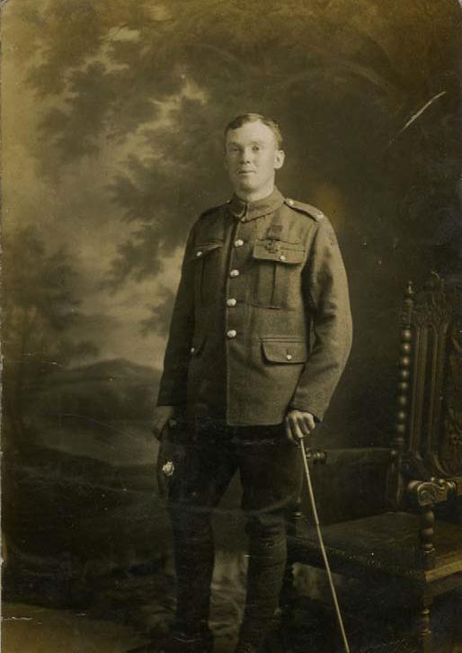
John Cunningham VC of the East Yorkshire Regiment pictured after the award ceremony in Hyde Park when he received the Victoria Cross from the King in July 1917.

