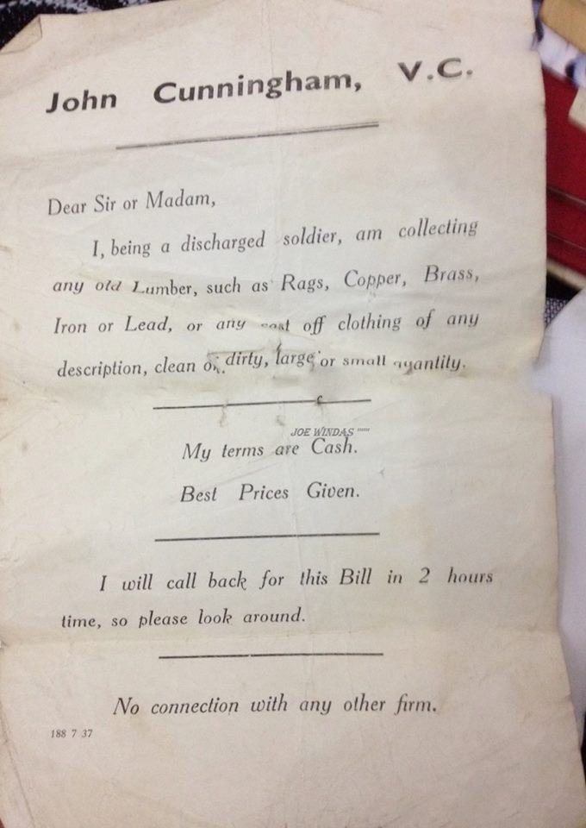
After the war, Jack Cunningham went into the ‘rag and bone’ trade. He was disabled by a serious injury received towards the end of the war. He delivered leaflets like this to local houses. This leaflet was kept by a family member.

