Announcement of Victoria Cross awards. The Victoria Cross is the highest award for bravery given to people in the British military forces. Announcements were made in the London Gazette. The citation (reason) for the award was given.
The citation for Private John Cunningham, East Yorkshire Regiment
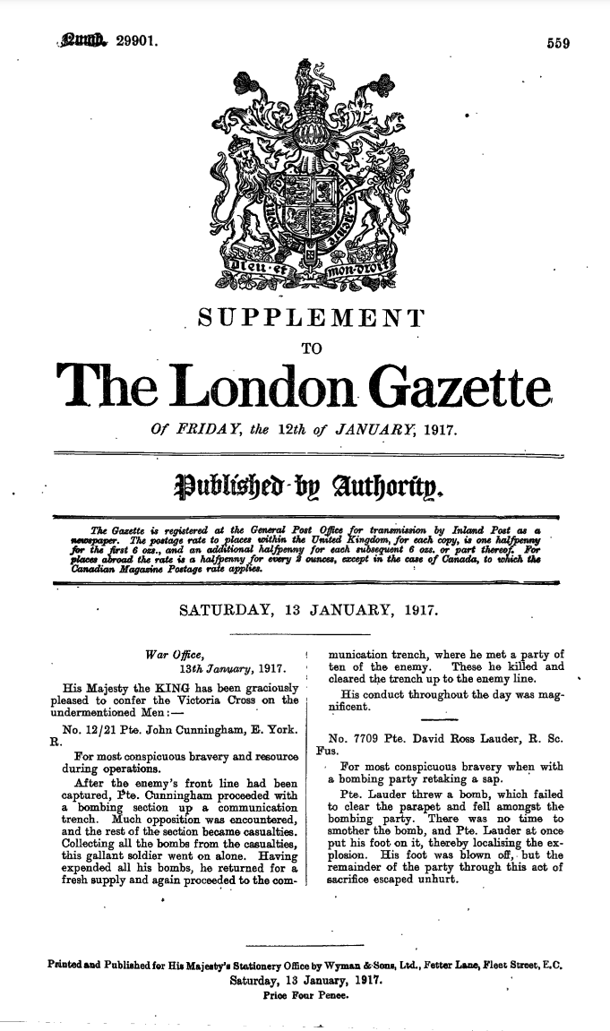
“After the enemy's front line had been captured, Private Cunningham [went] with a bombing section up a communication trench. Much opposition was [met], and the rest of the section [were either killed or wounded]. This gallant soldier [collected up all the hand grenades and] went on alone. Having [used up] all his [hand grenades], he returned for a fresh supply and again [went up the] communication trench, where he met a party of ten of the enemy. These he killed and cleared the trench up to the enemy line. His conduct throughout the day was magnificent.”
