What does the story of fairs reveal about life in Britain over time?

Introduction
Have you ever been to a fair? What do you think of when you picture a fair in your mind? Fairs have a long and interesting history. They can help us to understand more about living in Britain over time.
Task: as you read make a list of all the reasons why fairs have existed over time. Then review your list and put a * by the reasons that are still reasons why fairs exist today. What changes and continuities do you notice?

Fairs have existed a long time
The medieval Kings of England granted fairs Royal Charters. If a fair had a Royal Charter than it was approved by the King and organising it was lawful. The King got a sum of money from the fair, and a town (or a village, or an abbey) had the right to control and organise the fair. By 1300 most fairs that took place in England had a Royal Charter. Between 1199 and 1350 over fifteen hundred charters were issued granting the rights to hold markets or fairs. A few fairs did not have charters, but they had existed for many years and were allowed to continue.
There was a shortage of workers after famine and the Black Death plague cut the population of England by up to 50% in the first half of the 1300s. In 1351 Parliament passed the Statute of Labourers for King Edward III to try to control workers and their wages. New hiring fairs began, also called Mop Fairs. At these fairs landholders could hire labourers to help with agricultural work in the growing and harvesting seasons.
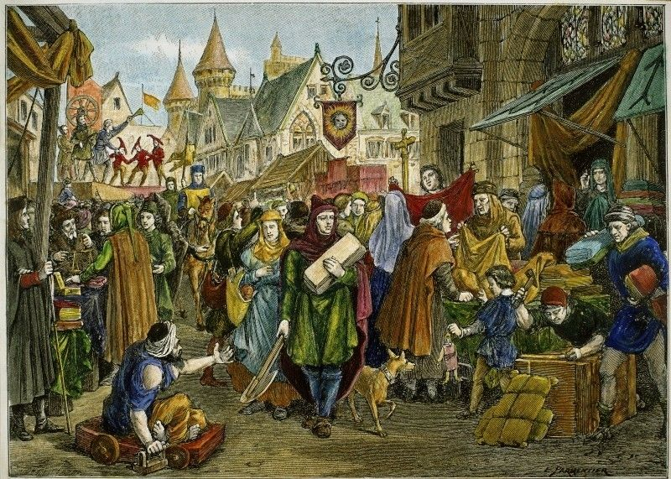
Fairs were places for buying, selling, trading and negotiating. Until the 20th century most people did not own, or buy, large amounts of possessions. It was cheaper to mend rather than to replace goods. Business was also done in person. There were no telephones and no internet. When people needed items they did not need to buy every day they went to fairs. At fairs they might buy cloth, or pots and pans, or working horses. They went to fairs to sell things they had made or grown themselves, such as barrels or apples. And while at the fair they might negotiate a loan, or to rent a piece of land.
An artists’ illustration of a medieval fair. What can you see happening at the fair?

All the ‘fun’ of the fair
People also enjoyed fairs. They were places to have fun, to meet friends, to meet new people, even to fall in love. Entertainments such as performances, games, attractions and gambling have long existed at fairs. And fairs have kept up with the times. For example, steam engines were used to power fairground rides from the 1860s. They have also been places to see and try new things. In the 1890s people were wowed by lots of use of electric lighting. In the early 1900s many people had their first ride in a motorcar at a fair.
There are also things that used to be part of at fairs that would not be permitted today. For example, animals were used as entertainment. People enjoyed watching animals, such as bears, perform and fight and today this is banned because of the cruelty and suffering it caused. People also enjoyed looking at marginalised people who were different and called ‘freaks’. This is something that horrifies us today. It reminds us that both values and what people think is right are things that change over time.
Changing times
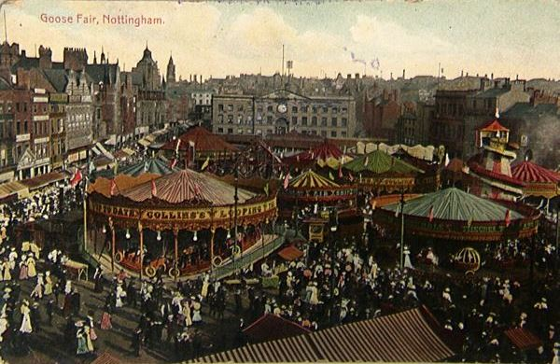
In the 1860s and 1870s laws were passed that allowed local authorities to put an end to fairs. However, many survived due to popular support. Even so, building in cities meant that traditional fairgrounds were lost. And people had other options, such as music halls and theatres, that offered places for entertainment. But fairs survived, for example as part of the newly fashionable and affordable seaside holidays at places like Blackpool. Fairground showmen innovated and kept exciting people with new modern and futuristic attractions, for example ghost shows, moving picture shows, and new and more daring rides.

A postcard of the Nottingham Goose Fair in 1909.
What can you see happening at the fair?

(Source: https://www.sheffield.ac.uk/nfca/researchandarticles/historyfairs)
There are still hundreds of regular fairs in the UK. Trading at fairs has become less important. Now we have more shops, we buy more new things, and we can buy online. Most people today think of going to a fair for entertainment and socialising. However, businesses still showcase what they offer at fairs for specific purposes. For example, there are agricultural shows and fairs, and there are wedding fairs.
Fair people
Gypsies and Travellers have been, and still are, an important part of fairs. Since the 17th century they have provided important items that people need to buy, from pegs to horses. Before the days of cheaper household goods, they also worked on mending things, from tables and chairs to pots and pans. This work was often done at fairs.
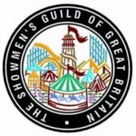
Gypsy and Traveller people were, and still are, popular entertainers at fairs. Having one’s fortune told by a Gypsy woman at the fair became very popular from the 1700s. In the later 1800s a popular attraction at Blackpool was the Gypsy camp on the South Shore. It had its own miniature railway and station. In 1899 the Van Dwellers Protection Association was set up in Salford. It represented a particular group of Gypsy and Traveller people called the Showmen. They have their own distinct traditions and customs. They speak a language called Paylaree. In 1917 the Association became known as Showmen's Guild of Great Britain. Today it is the recognised as the trade association for the travelling funfair business. It represents members who work with local authorities to organise fairs and circuses, for example the St Giles’ Fair in Oxford.
The badge of the Showmen’s Guild
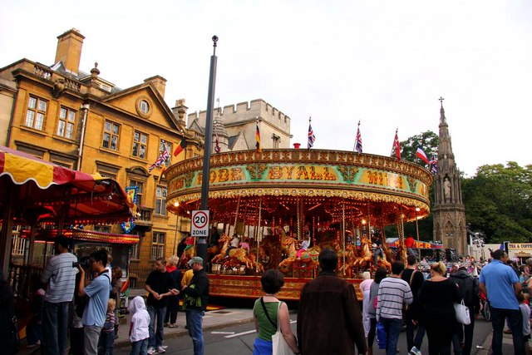
How is their work represented?

People enjoying St Giles’ Fair in Oxford

To finish
Let’s return to the many reasons why fairs have existed over time. Perhaps you have noticed that fairs are no longer at the centre of a town’s local economy. They are less important for buying and selling things than they were. However, they remain important as places that are part of local culture and where people go to have fun and to meet people. And finally, what does the story of fairs reveal about life in Britain over time?

