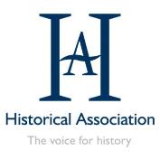

In partnership with
AHRC BBC History 100 Fellowship

Funded by

Teacher Fellowship programme
Broadcasting and Social Change in Sixties Britain

Understanding the local context of the civil rights movement in the United Kingdom through exploration of similarity and difference

Chloe Rodgerson

HA Teacher Fellowship: Broadcasting and Social Change in Sixties Britain

Understanding the local context of the civil rights movement in the United Kingdom through exploration of similarity and difference

Rationale:
When teaching the GCSE unit of Paper 3: The USA, Conflict at Home and Abroad 1954–1975, students were very interested in the questions of ‘What was happening in Britain at the time?’ and ‘What was the experience like for Black Britons?’. These questions are not covered in the GCSE specification but are something that would help students to better understand the world around them. By allowing students to explore the context of the civil rights movement though understanding efforts within Britain, they will have a great contextual understanding of the period, people and places they are studying for GCSE. Therefore, this project will focus upon similarity and difference as a conceptual focus. The Historical Association suggests that ‘engaging critically with similarity/difference strengthens pupils’ grasp of history as a discipline because it builds a disposition to question labels, categories and generalisations. It builds an expectation of complexity’.

A concern when teaching US race relations is that students are left with the assumption that these are issues that are exclusive to the United States. As was seen in 2020 with the widespread Black Lives Matter protests, it is clear that issues concerning equality and racism are not exclusive to America. When looking at our history classrooms, we need to consider how to address misconceptions about the past held by the students in our schools.

As there is limited time to cover all GCSE content, I have devised independent activities for students to undertake as homework. Making homework relevant and interesting engages students and improves their learning outcomes.

Resource outline:
This resource is a set of three learning tasks for students to undertake independently, along with a final overview task that could be completed either independently or in class. This project will therefore consist of an independent learning project to coincide with our study of the GCSE unit Paper 3: The USA, Conflict at Home and Abroad 1954–1975. It will look at similarities and differences between the British and in the civil rights movement. The first task compares bus boycotts in Bristol and the American Deep South. Students will have studied the Montgomery Bus Boycott and will be learning about the Freedom Rides of the early 1960s when they learn about the Bristol Bus Boycott. The second task compares the British and American Black Panther Parties. For the third task, students will compare the British and American reactions to Martin Luther King in the 1960s. These flag points will assist students in understanding similarities and differences in race relations across the 1960s and between two countries. This project could also be adapted for Key Stage 3 to give them the context of the UK civil rights movement.

Learning intentions:
The primary intention of this project is for students to be able to explain the similarities and differences between what was happening in the American civil rights movement and the British civil rights movement. In doing so, this will give them the local context to understand the nature of race relations in Britain during the 1960s and their impact on society today. By looking at two prominent protest movements – the bus boycotts and the Black Panther movement – students can draw direct comparisons. The focus in the third lesson on Martin Luther King allows students to compare the response within Britain to that in America and to further understand the development of US Black Power, along with the emergence of leaders such as Malcolm X, Stokely Carmichael and Angela Davis. Finally, students will showcase this learning though being able to explain the similarities and differences, giving specific examples to support their writing.

Scheme of work:
This project is aimed at giving students the contextual knowledge to understand the Civil right movement in the USA in greater detail. By comparing this with the UK Civil rights movement, students will be able to identify the elements of the movement that are unique to the USA and recognise elements of the movement that were emulated in Britain at the time. This will give students a sense of why we are studying the American Civil rights movement by seeing the impact that it had in Britain during this period.

Here I have laid out the wider SOW that the students will be studying, along with the independent learning project in which students will be taking part while studying this unit.
(1–13) The first lessons of the unit cover USA race relations of the 1950s
(14) Greensboro
(15) Freedom Rides: What were the similarities and differences between the Bristol Bus Boycott and the Freedom Rides?
(16) Birmingham, Alabama
(17) How significant was the March on Washington?
(18) Kennedy vs. Johnson: Who had a greater impact on the civil rights movement?
(19) How did Malcolm X change the nature of protest?
(20) Why did Black Power become popular in the 1960s? What were the similarities and differences between the American and British Black Panther Parties?
(21) How did the Black Panther Party protest for civil rights?
(22) What were the consequences of the Watts riots?
(23) Why did Martin Luther King campaign in the North?
(24) What was the impact of Martin Luther King’s assassination on the civil rights movement? How did the reaction to his death differ between America and Britain?
(25) What was the extent of progress by 1975?
Overview: In what ways were the UK civil rights movement similar and different to the American movement?

Summary of lessons/activities:
Focus | Objectives | Learning activities | Resources for the lesson
What were the similarities and differences between the Bristol Bus Boycott and the Freedom Rides? | - To explain the reasons behind the Bristol Bus Boycott  - To evaluate the similarities and differences between the Bristol Bus Boycott and the Freedom Rides in America | - In what ways were British rules on buses similar and different to those in America?  - What was the main focus of the Bristol Boycott? How is this different to American bus-based protest?  - What was the outcome? Was this the same as in America? National/local? | - Independent learning focus sheet, pp. 8–9  - Complementary lesson material/ teacher guide
What were the similarities and differences between the American and British Black Panther Parties? | - To understand the origins of the British Black Panther Movement.  - To compare the methods used of the British and American branches. | - Students to listen to oral histories on BBC to find out and explore the role of the British Black Panther Party.  - This lesson could be further developed by looking at the Freedom News Archive that students could explore to find out more about the Black Panther Movement in Britain. | Independent Learning focus sheet. P. 10-11  Complimentary lesson material/teacher guide.
How did the reaction to Martin Luther King differ between America and Britain? | Students will have been learning about the rise of Black Power in the USA, along with the emergence of leaders such as Malcolm X, Stokely Carmichael and Angela Davis.  The focus of this lesson will be on how reactions were different to Martin Luther King in England. | - Students to study the Face to Face interview and analyse what it shows about British reactions  - Students to evaluate the impact of Martin Luther King in England and compare this to what they know about the USA  - There is the potential in this lesson to extend it and look at the impact of the ‘Rivers of Blood’ speech if delivering to an A-level class | - Independent learning focus sheet, p. 12  - Complementary lesson material/ teacher guide  - Supportive conversation to be had with students about language used in the clip
Overview: In what ways was the UK civil rights movement similar and different to the American movement? | - To explain the differences between the movements, drawing on prior knowledge  - To explain the similarities, drawing on prior knowledge | Outcome task –  students to complete and explain question:  Explain how the UK civil rights movement was similar and different to the American movement | - Focus sheet, found on p. 13 of this document

Conclusions and reflections:
The resource was powerful due to the focus upon similarity and difference in specific cases of activism from both British and America. Students found that the local context allowed them to understand that activism was not something that just happened within America. This has long been a misconception I have noticed in my teaching career, as well as something that has been recognised in a wider context by others. To support the teaching of this project, I taught a lesson earlier in the unit about Asquith Xavier, upon which students were able to pull for the context of Windrush and activism in the 1950s. This set the scene for understanding the events being studied from the 1960s. The use of audio-visual resources was also significant and exploring these in lessons I think helped more students to be able to access the work when completing it at home. I was conscious of students’ ability to access the work on devices at home, and therefore carving out that time to introduce and discuss the sources was very helpful to students when working independently.

The underlying principles behind this resource are to get students thinking about similarity and difference between places. By looking at bus boycotts in Bristol and the American Deep South, British and American Black Panther Parties and finally British and American reactions to Martin Luther King, students gained an understanding of the ways in which different areas responded to racism in similar and different ways. There is potential for this to be used for a more modern-day comparison by looking at the ways in which activism today is similar and different to activism in the past. Although this lesson is primarily designed to support the delivery of Paper 3: The USA, Conflict at Home and Abroad 1954–1975, there is also potential for these lessons to be used in other areas of study. The resource could also be adapted for teaching in Key Stage 3 with a study of the 1960s or of civil liberties through time. Being able to give students the context of activism within the UK is vital for their understanding of the society around them and the context in which we are living today. My hope is that this project would support other teachers in giving students that context and supporting in the dismantlement of the idea that civil rights campaigns only happened within America.

In terms of the teaching of this resource, it was very important that students were able to watch and listen to the primary sources and discuss them in the classroom, giving space for them to ask questions. Furthermore, students having printed copies of the resource allowed them to complete the work on paper when working at home. If possible, being able to set the work online for students and parents can be really impactful, as it enables parents to be involved in these very important discussions. Having previously taught and planned lessons on race relations in Britain and America in the 1950s, this gave myself and the students the context by which to understand the 1960s. Due to time constraints, this may not be a possibility but it is very valuable if possible.

Alongside our teaching within history, I and members of my team have been part of our school’s EDI working party. In this, we have worked with colleagues to discuss our approach to equality, diversity and inclusion within our school community. This means that when conversations are happening in classrooms, teachers are able to have the context of what different departments and teachers are doing. I have been able to build a multifaceted approach that is built around equality, diversity and inclusion being interwoven through curriculum and school life. Therefore, it is important to recognise that this resource is just one part of a much wider set of steps that all schools need to be taking towards building inclusive learning environments.

Bibliography:
Books:
Chapman, A. (2021) Knowing History in Schools: powerful knowledge and the powers of knowledge, UCL Press.
Olusoga, D. (2018) Black and British: a forgotten history, Basingstoke: Pan Macmillan.

Articles:
Historical Association (2020) ‘What’s the wisdom on... similarity and difference?’ in Teaching History, 180, September 2020, www.history.org.uk/secondary/categories/653/resource/9917/whats-the-wisdom-on-similarity-and-difference
Knight, B. (2020) ‘“They were afraid of us”: the legacy of Britain’s Black Panthers’ in Al Jazeera English, 7 December 2020, www.aljazeera.com/features/2020/12/7/they-were-afraid-of-us-the-legacy-of-britains-black
Muir, H. (2014) ‘Martin Luther King in London, 1964: reflections on a landmark visit’ in The Guardian, 2 December 2014, https://www.theguardian.com/us-news/2014/dec/02/martin-luther-king-in-london-1964-reflections-on-a-landmark-visit
Pien, D. (2018) ‘British Black Panther Party (1968–1973)’ in BlackPast, 2 July 2018, www.blackpast.org/global-african-history/british-black-panther-party-1968-1973
Ricciardi, A. (2021) ‘Remembering Dr King: US Black activism in the UK and beyond’ in Americas and Oceania Collections blog, https://blogs.bl.uk/americas/2020/06/remembering-dr-king-us-black-activism-in-the-uk-and-beyond.html
Sakai, K. (2021) ‘United Kingdom’ in The Black Panther Party: History and Theory, https://wp.nyu.edu/gallatin-bpparchive2021/international-branches/united-kingdom
Ward, B. (1995) ‘A king in Newcastle: Martin Luther King, Jr. and British race relations, 1967–1968’ in The Georgia Historical Quarterly, 79, no. 3, pp. 599–632.

Websites/sources:
Freedom News, 13 April 1968: https://freedomnews.org.uk/wp-content/uploads/2018/03/Freedom-1968-04-13.pdf

What were the similarities and differences between the Bristol Bus Boycott and the Freedom Rides?
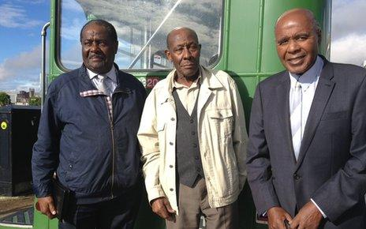
CONTEXT OF THE 1960S IN BRITAIN:
- Racial discrimination in Britain after the Second World War was widespread.
- Many of the immigrants were skilled workers but racism and discrimination meant that semi- or unskilled work was the only option.
- By the 1960s, the economy in Britain was declining and Black workers were the first to lose their jobs.
- Those that did manage to keep jobs usually did double the work for less pay.
- The racism and discrimination in Britain echoed that felt in America at the time.

TASK 1: How did the situation in Britain compare with the situation in America?

THE BRISTOL BUS BOYCOTT:
- The Bristol Bus Boycott of 1963 arose from the refusal of the Bristol Omnibus Company to employ Black or Asian bus crews in the city of Bristol, England, UK.
- Led by youth worker Paul Stephenson and the West Indian Development Council, the boycott of the company’s buses by Bristolians lasted for four months until the company backed down and overturned their discriminative colour bar policy.
- Paul Stephenson, in 1963, led a boycott against a racist public bus company. The Bristol bus company operated a colour bar that refused employment to Black or Asian people.
- Paul was a young social worker in Bristol when he embarked on the campaign that would change not only his life but the entire country.
- He was born to a British mother and West African father in Essex, 1937, and was determined to confront the racism that he encountered growing up in east London and since arriving in Bristol as a community development officer in 1962.
- So when a Bristol bus firm refused to employ Black or Asian people, Paul began a 60-day boycott of the company.

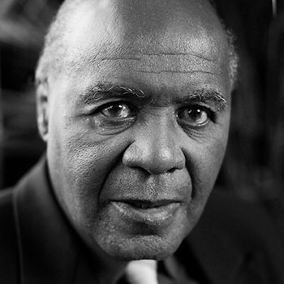

Paul says: ‘If you were a young Black person living in Britain, you couldn’t be a policeman, an ambulanceman or fireman. You couldn’t go into pubs, hotels, swimming pools, and now you couldn’t drive on the buses. I had been watching the amazing things that Martin Luther King had been achieving in America, and now I thought something had to be done here too.’
His campaign directly resulted in the company revoking their ‘colour bar’. Its defeat was confirmed on 28 August 1963, on the very day that Martin Luther King delivered his famous ‘I have a dream’ speech in Washington.

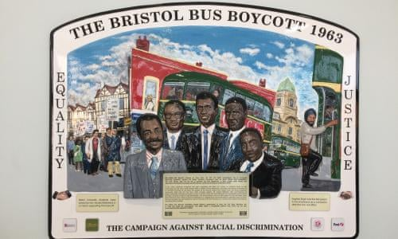
TASK 2: In class, we watched ‘What was behind the Bristol bus boycott?’. This can be rewatched here:
www.bbc.co.uk/news/av/uk-23863577
- Give three examples from the video that help to describe race relations in Bristol in the early 1960s.
- Why were Roy Hackett and his wife unhappy with the Bristol Omnibus company and the Transport and General Workers Union?
- According to Roy Hackett, what responsibilities does your generation have to take a stand for change in your communities?

TASK 3: What does Vernon Samuels’ story tell us about the roots of the Bristol Bus Boycott? You can watch or read his story here: www.bbc.co.uk/teach/class-clips-video/history-ks2-black-british-stories-the-bristol-bus-boycott-of-1963/z9k4g7h
 | What was the protest focused on changing? | What was involved in the protest? | What was the overall outcome of the protest?
America: Montgomery Bus Boycott and Freedom Rides
Britain: Bristol Bus Boycott

TASK 4: Complete the table as to the situation in America vs Britain.
What were the similarities and differences between the American and British Black Panther Parties?
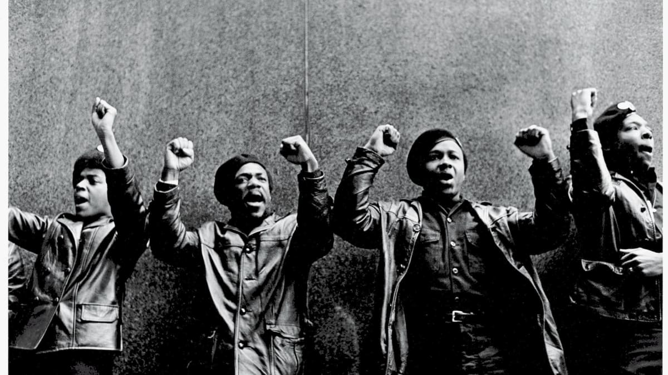
Obi Egbuna founded the British Black Panthers in 1968 in Notting Hill. Although it was not an official chapter of the Black Panthers, it was the first group outside of the United States.
Although directly inspired by the American movement, the British Panthers had their own set of objectives, which were laid out in their newsletters.
The British movement was focused on ending abuses by the police, carrying out outreach programmes and fighting racism at state and local level, which included housing and employment.

TASK 1:
Listen to the following: www.bbc.co.uk/sounds/play/m0007b0y
- What was happening in 1968 that set the scene for the British Black Panther Party?
- What did Mark Bonham Carter mean when he said that comparisons between the USA and Britain were dangerous? What do you think about this?
- What methods did the British Black Panthers use?

TASK 2: After listening to the BBC Sounds podcast, fill out the following table with the British methods.
American Black Panther Party methods | British Black Panther movement methods
- Self-defence
- Founding Black-owned bookstores
- Food co-operatives
- Farms
- Media
- Printing presses
- Schools
- Clinics and ambulance services

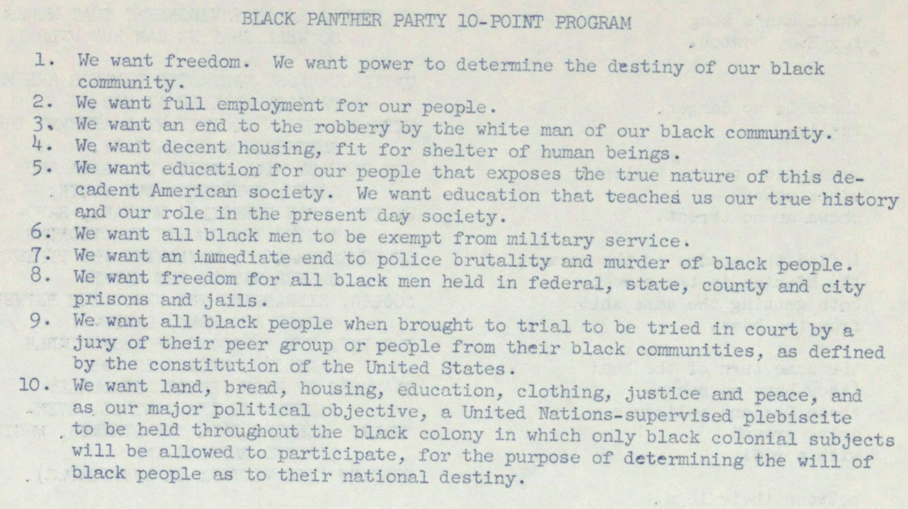
TASK 3:
Read the US Black Panther Party and the British Black Panther Party aims. Highlight the similarities and the differences between the two programmes.

Black Panther Party 10-point program
From Ann Arbor Sun, 5 December 1968, https://aadl.org/node/192744

Message to the Black People of Britain
July 1968, digitised by Shades of Noir, www.shadesofnoir.org.uk/artefacts/black-panther-newsletters/#message-to-the-black-people-of-britain/3
How did the reaction to Martin Luther King differ between America and Britain?
TASK 1: Face to Face with Martin Luther King Jr. You can watch the full clip here: www.bbc.co.uk/iplayer/episode/p00lgzyl/face-to-face-martin-luther-king
- This clip was first shown in 1961 on the BBC. What do you think people of the time would have thought about this programme?
- How does Martin Luther King describe the American civil rights movement?
- What do you notice about the types of questions being asked and the language being used?

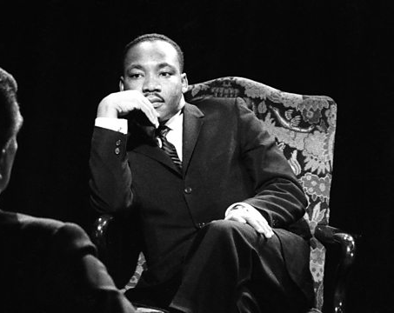

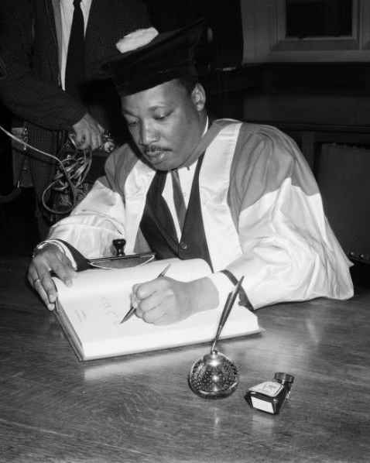
TASK 2: Read the following article: www.theguardian.com/us-news/2014/dec/02/martin-luther-king-in-london-1964-reflections-on-a-landmark-visit
- What was Martin Luther King’s opinion about the state of race relations in Britain?
- How did the British view Martin Luther King?

TASK 3:
In 1967, Martin Luther King was given an honorary doctorate in civil law from the University of Newcastle. At this time in America, divisions had started to emerge within the movement, with many people turning to leaders like Malcolm X due to their stance on the use of violence.
What does this honour show about the difference in reaction in Britain vs the USA?

King signs the degree roll at Newcastle University after receiving his honorary doctorate in civil law, November 1967.

Explain how the UK civil rights movement was similar and different to the American movement
TASK 1:
Explain one way in which the UK civil rights movement was similar to the American movement.

You could include:
- Reasons and results of the Bristol Bus Boycott
- Methods used by the Black Panther Party
- Reactions to Martin Luther King
TASK 2:
Explain one way in which the UK civil rights movement was different to the American movement.

You could include:
- Reasons and results of the Bristol Bus Boycott
- Methods used by the Black Panther Party
- Reactions to Martin Luther King
__________________________________________________________________________________________________________________________________________________________________________________________________________________________________________________________________________________________________________________________________________________________________________________________________________________________________________________________________________________________________________________________________________________________________________________________________________________________________________________________________________________________________________________________________________________________________________________________________________________________________________________________________________________________________________________________________________________________________________________________________________________________________________________________________________________________________________________________________________________________________________________________________________________

Sources and images used:

Image 1: Guy Bailey, Roy Hackett and Paul Stephenson with a 1960s-era Bristol bus, https://ichef.bbci.co.uk/news/976/mcs/media/images/69452000/jpg/_69452465_boycottmen3.jpg

Image 2: Paul Stephenson, https://tuc150.tuc.org.uk/stories/bristol-bus-boycott

Image 3: A plaque at Bristol Bus Station, Guardian website, https://i.guim.co.uk/img/media/d2d3a7e8f13c211d0967951b22c33e18b02df119/0_220_3264_1958/master/3264.jpg?width=620&quality=45&dpr=2&s=none

Video 1: www.bbc.co.uk/news/av/uk-23863577 0.00 ‘Montgomery Alabama 1955’ to 10.11 ‘… they will never change culture’

Video 2: www.bbc.co.uk/teach/class-clips-video/history-ks2-black-british-stories-the-bristol-bus-boycott-of-1963/z9k4g7h 0.00 ‘Hi, my name's Amelia and I’m 13 years old’ to 5.03 ‘... and now me, to do the same’

Image 4: Black Panther Party, https://rozsixties.unl.edu/items/show/786

Video 3: www.bbc.co.uk/sounds/play/m0007b0y 0.00 ‘We have complained about the police to the police’ to 56.57 ‘… that we are rich already’

Image 5: ‘Black Panther Party 10-point program’, Ann Arbor Sun, 5 December 1968, https://aadl.org/node/192744

Image 6: ‘Message to the Black people of Britain’, July 1968, digitised by Shades of Noir, www.shadesofnoir.org.uk/artefacts/black-panther-newsletters/#message-to-the-black-people-of-britain/3

Video 4: www.bbc.co.uk/iplayer/episode/p00lgzyl/face-to-face-martin-luther-king 0.00 ‘BBC 4 Collections’ to 31.41 ‘… on the basis of race or colour’

Image 7: Martin Luther King, Face to Face BBC image, https://ichef.bbci.co.uk/images/ic/640x360/p099w5ff.jpg

Image 8: King signs the degree roll at Newcastle University after receiving his honorary doctorate in civil law, November 1967, https://blogs.ncl.ac.uk/speccoll/files/2020/03/king-2.jpg

‘What’s the wisdom on... similarity and difference?’ in Teaching History, 180, pp.52-53

