1:1 How does teaching impact upon achievement? How good is history teaching?
How effectively does teaching enable all pupils to make progress?
Teaching is no longer graded, but positively reviewed.
The school uses a generic comment WWW/EBI system for lesson observations. An older style type lesson obs., which was graded outstanding, is also included.

Please see below for your feedback regarding the recent Middle Leader Lesson Visit which was completed by:
Date: 24/03/2023
Year Group: Year 12
Lesson/Subject: history
The Strengths identified were:
Good subject knowledge is evident in content choice
Work is coherently sequenced so that pupils accumulate sufficient knowledge, understanding and skills to secure future learning
Subject matter is presented clearly, promoting appropriate discussion and response
The Development Areas identified were:
SEND T&L expectations are evident and support student success
The following additional comments were also made:
A fabulous lesson, well structured building literacy and knowledge. With questioning when students are struggling, consider using pair-share more.
As a result of this feedback, we recommend the following CPD historical association A level reading
Please see below for your feedback regarding the recent Senior Leader Lesson Visit which was completed by:
Date: 07/12/2022
Year Group: Year 10
Lesson/Subject: History
The Strengths identified were:
Teacher provides high levels of practice for all students
Practice is monitored closely to ensure high success rate
Calm and purposeful independent study conditions are established
Students are supported to achieve strong levels of independence where required
The Development Areas identified were:
The following additional comments were also made:
Students were working well independently and circulates the room, monitoring engagement and supporting students where necessary. Students can explain beautifully. Relationships between teacher and students are strong supporting a lovely learning environment. I thoroughly enjoyed my visit :)
As a result of this feedback, we recommend the following CPD:N/A

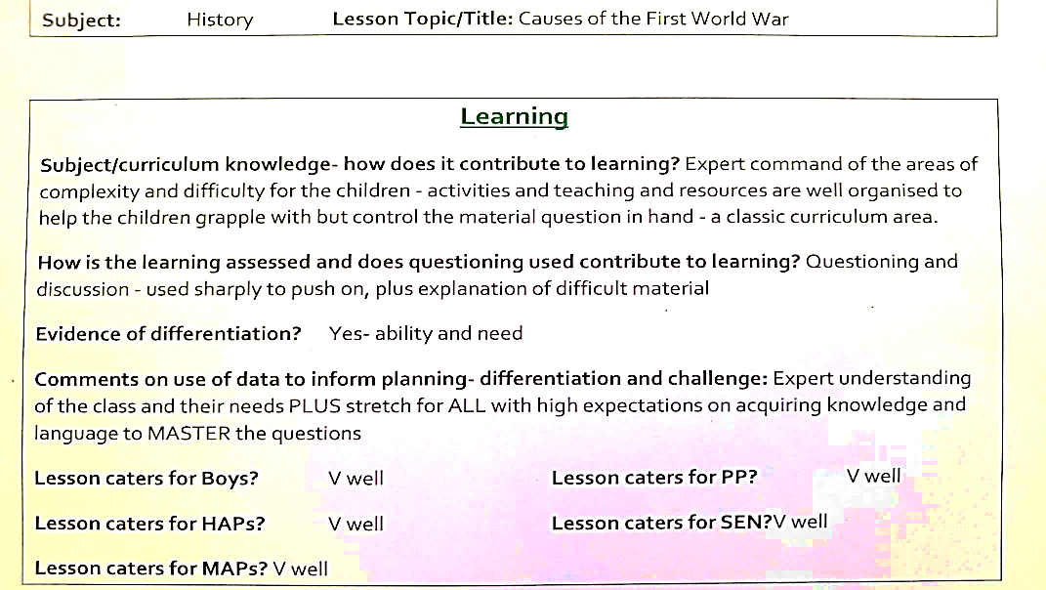

Student survey and feedback results showing a sample of student views on making progress in lessons and quality of teaching in their opinion.
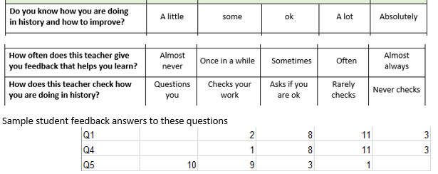
1
4
5

A summary of how students viewed progression

