1.2 Teaching and learning: How much progress do pupils make in lessons? How do you know?
Teachers try to use a wide range of strategies that are linked to clear objectives to improve progress. The whole school focus is to develop independent learning and so strategies are focused upon this. Modelling and tracking aim to ensure good progress. QA shows effective learning of knowledge, concepts and processes in lessons.

Progression is most clearly evidence by outstanding GCSE and A level results. GCSE results have improved significantly year on year since the introduction of a new principal and HoD at the school rising by 15%. Results now outperform other similar schools and compare well to other subjects in school.
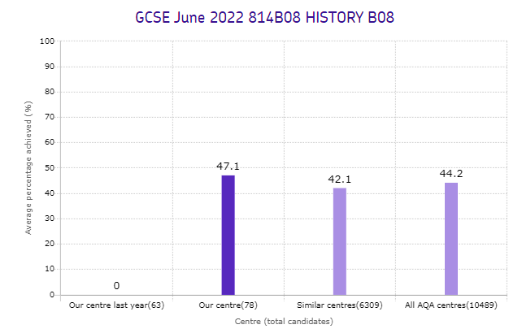
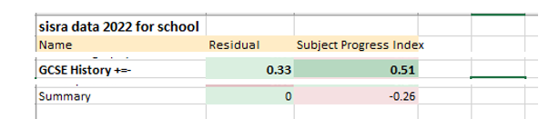
school

AQA data

A level results have been consistently excellent, even though our PP and EAL students were significantly impacted by Covid, which affected wellbeing and access to resources.
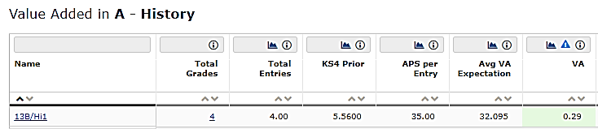
2022

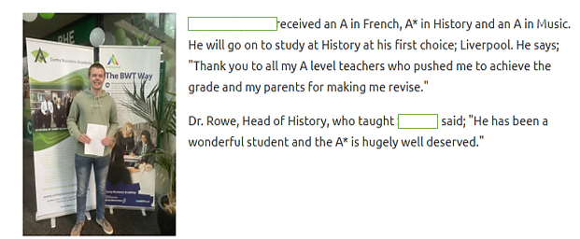

The school has also made significant progress over the past 5 years now achieving good.
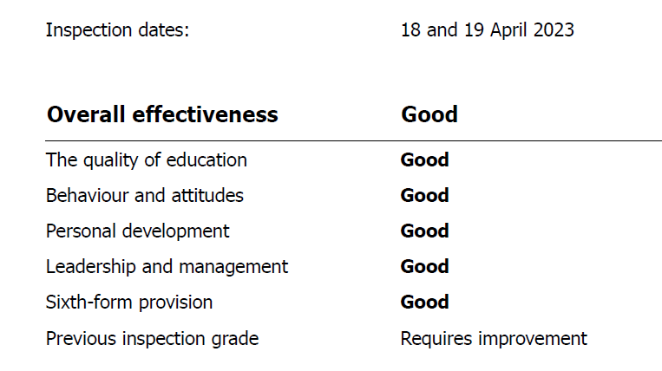
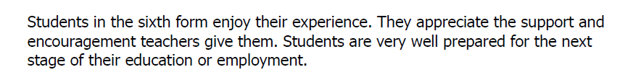
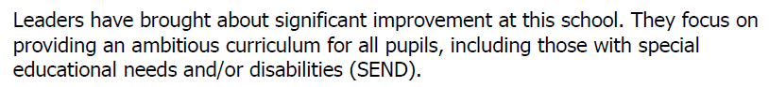

There is an emphasis on staff knowing how well students are doing through rigorous whole school and departmental tracking and moderation systems across all Key Stages
Through use of overview and depth analysis
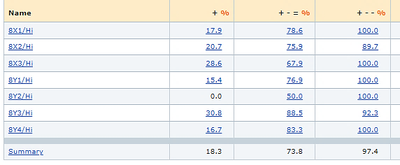
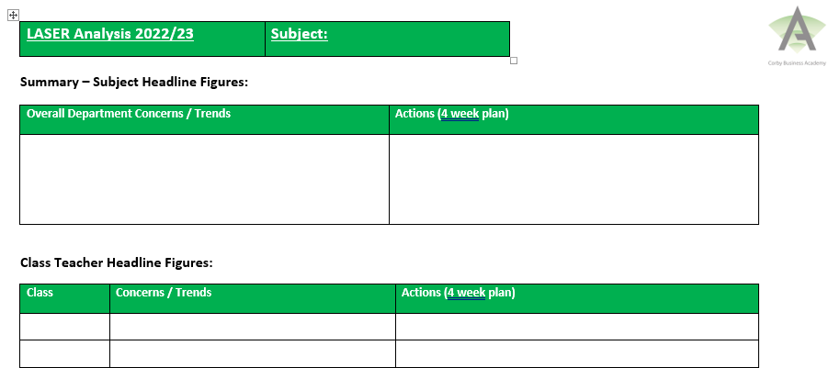

Department meetings minutes
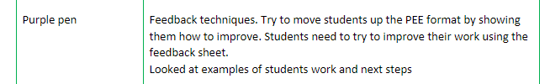

Students are also encouraged to self evaluate their performance and work on improving.
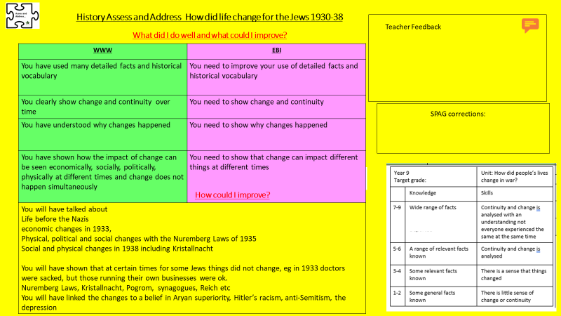

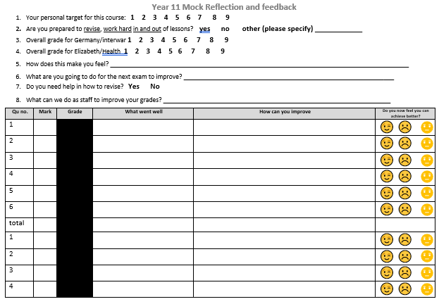

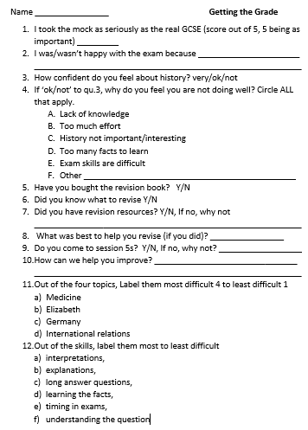

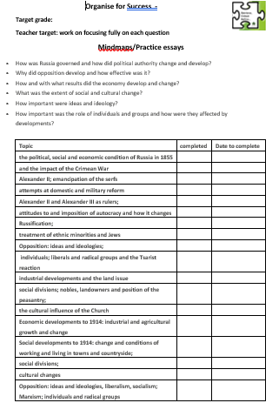

Rigorous use of pedagogical techniques such as interleaving, metacognition, road stories, dual coding and modelling at both departmental and school level ensure a range of strategies are used to increase progress.
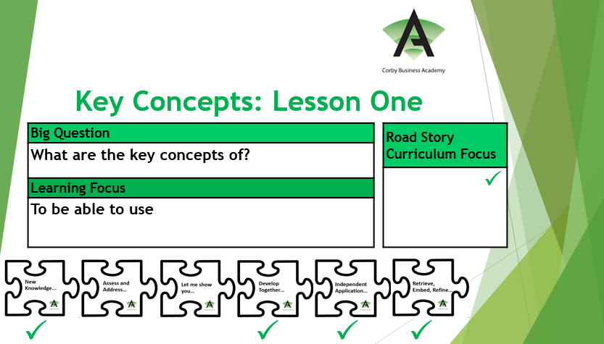
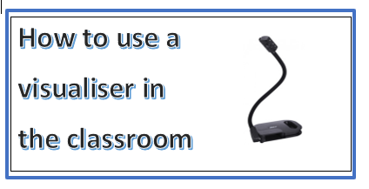

The curriculum is designed to generate progression both in disciplinary and substantive knowledge
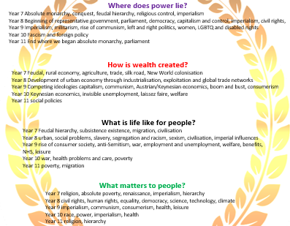
Well defined assessments with clearly defined objectives linked to the road stories provide rapid and specific understanding of student misconceptions
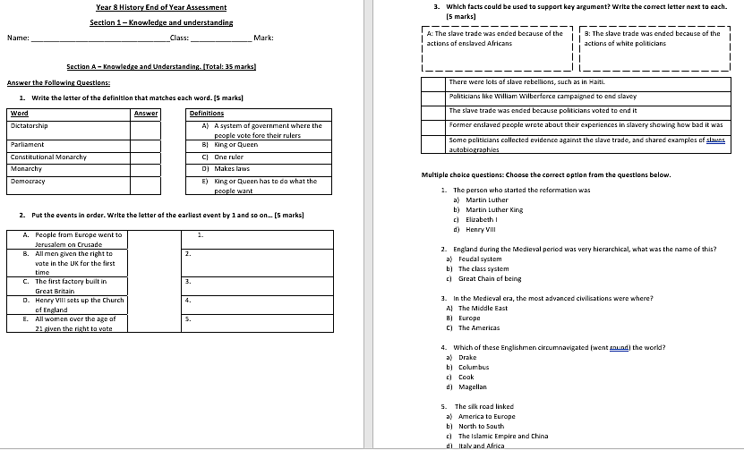
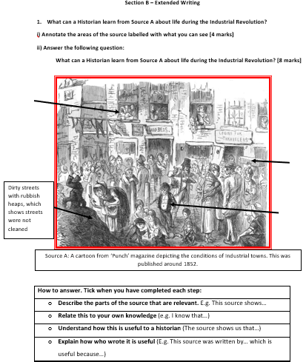
Sample of an assessment showing how progression is structured and scaffolded so that accurate assessment of student progress can be made

