2.1 CPD programme: How does the school ensure effective CPD in history? What impact does an effective CPD programme in history have on learning and teaching?
There is corporate membership with Historical Association and the department makes use of HA CPD and resources. The department seeks up-to-date knowledge. History CPD is matched to needs identified through self-evaluation. We believe CPD has made an impact on learning and teaching.

The school and department take CPD seriously. Whole school CPD is monthly using WalkThrus. In addition, history uses What the Wisdom On webinars, HA CPD, AQA training, National College as well conferences and Trust meetings.
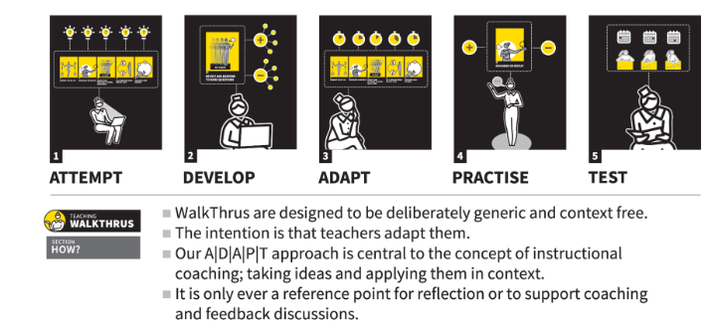
Whole school CPD

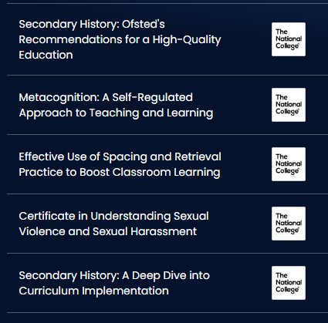
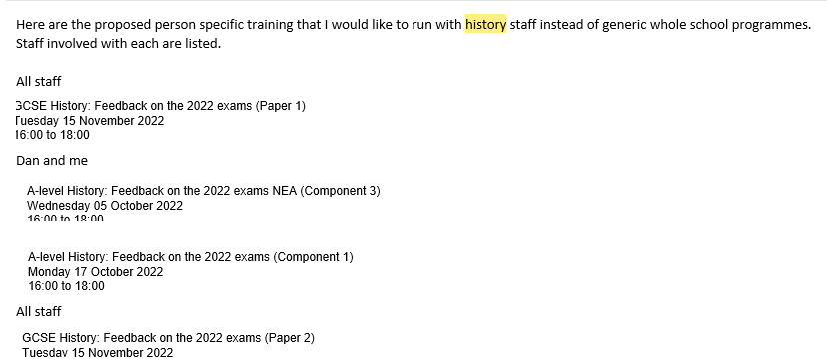
The school will adapt CPD to make it specific for staff.

Completed
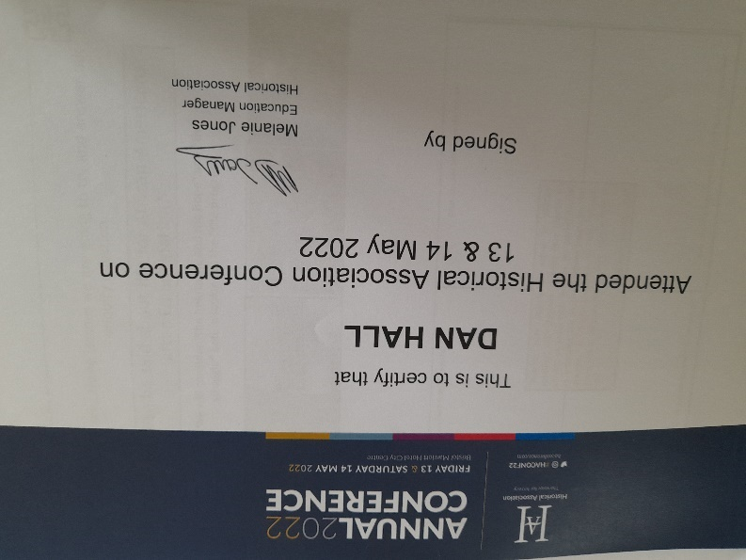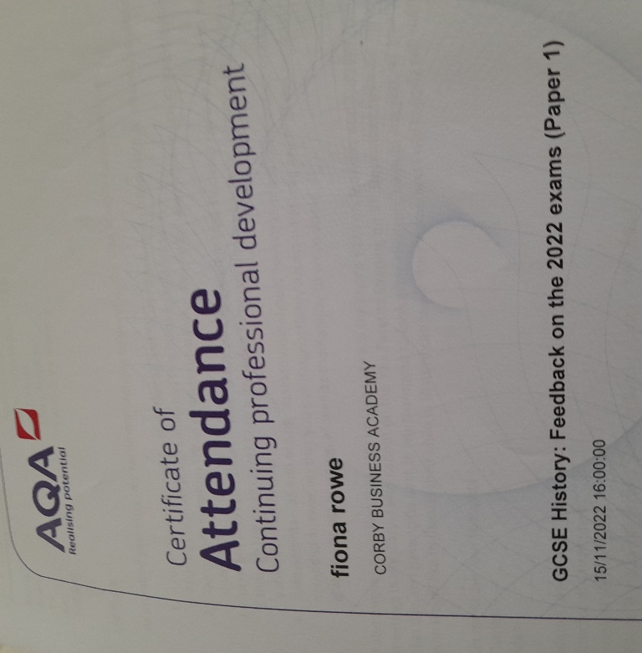

History CPD is collated and put on the department area of the VLE for all staff to find and utilise easily. It contains Historical Association, National college, Ofsted, Pearson, Ford, CBA and AQA training documents
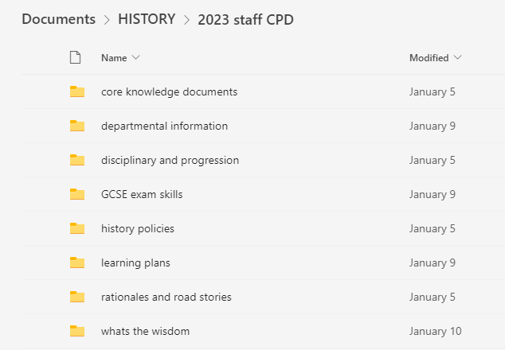

Historical Association CPD such as ‘what’s the wisdom’, Ofsted advice, moderation and lesson planning is discussed in department meetings
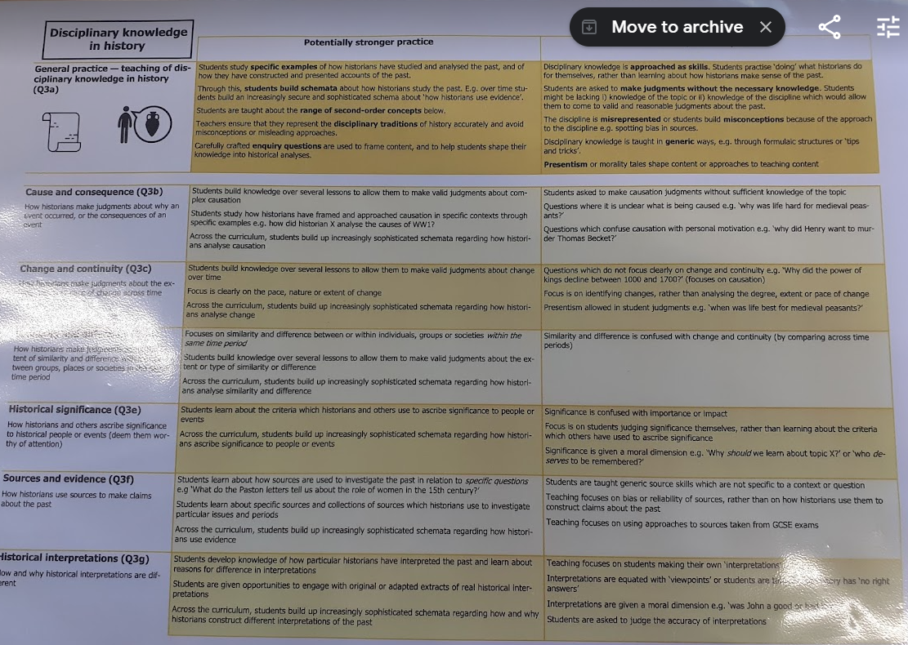

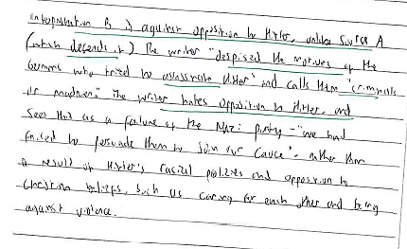

Discussing marking

Trust encourages subject specific CPD
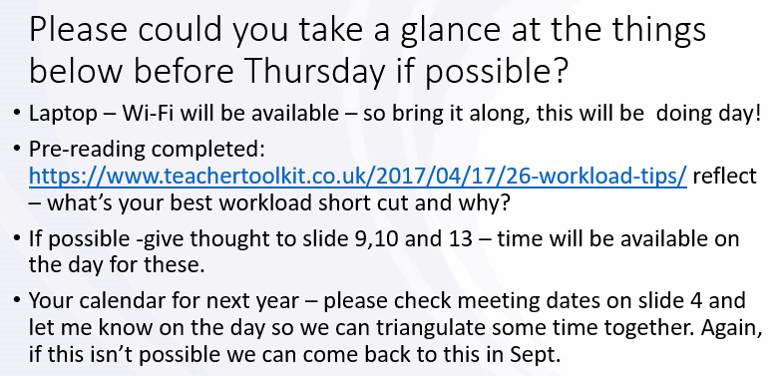
Trust matches CPD needs to individuals and will provide one to one support
Evidence of impact of CPD
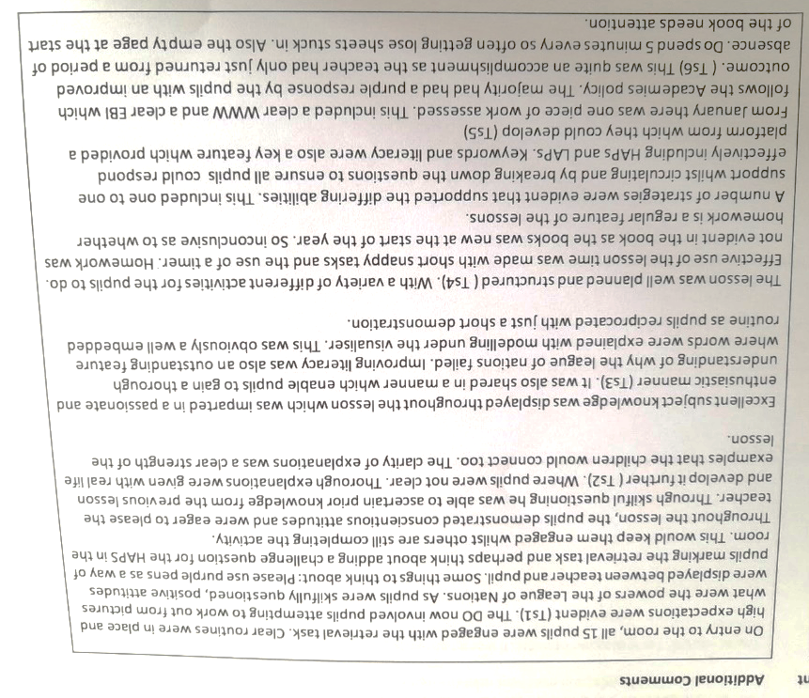

Teach First lesson observation feedback

Extract from Department minutes

