2.2 Organisation and management: What structures for organising and administering history are in place?
Leadership seeks to manage the subject well and those involved in teaching history want to have a strong commitment to the subject.
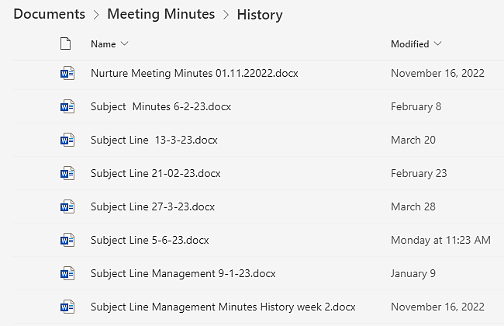
The department consists of 5 members of staff, four experienced staff (one until recently worked abroad, one Head of Year, one a Vice Principal and HoD) and an ECT. Within the department, collaborative leadership is encouraged. Our ECT has recently been promoted to head of KS3.

We meet most weeks to discuss curriculum, SEND, misconceptions, moderating, behaviour, training and feedback.

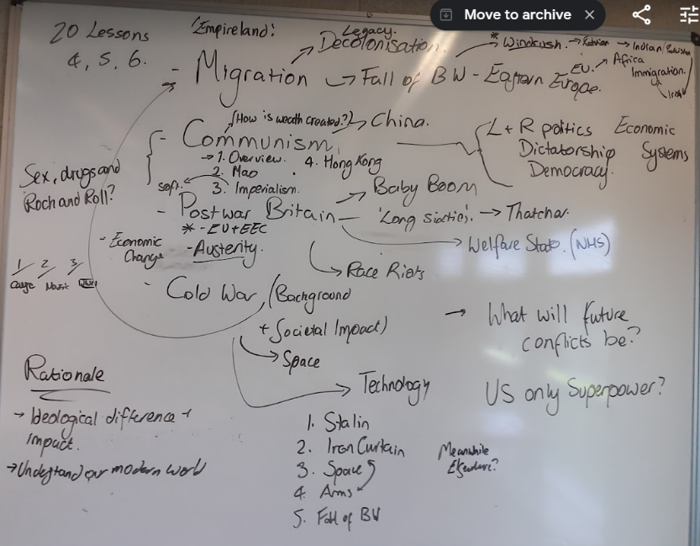

Curriculum is discussed and collaborated on. Staff share planning. All lessons are fully resourced on a hub for staff to use, but they are not constrained by these lessons and are free to develop lessons as long as they follow the curriculum core knowledge.
Collaborative planning uses staff interests and skills are used to deliver an innovative curriculum, such as using the specialisms we have about South Africa and post war Britain.
6 | Development of Empire in South Africa | Dutch colonisation and subsequent British takeover.
7 | Colonisation of South Africa | Boer War & discovery of gold in the Transvaal.  Nature of the war.
8 | Life in British South Africa | Union of SA and equality.  Treatment of indigenous South Africans
9 | Assessment Prep | Core  Bring together similarities and differences between South Africa and India
10-11 | Assessment and Purple Pen | Use lesson 10 for assessment and revision in prep for assessment.
11 | Legacy 1 | Teach only if needed, otherwise spend time on feedback & purple pen
12 | Legacy 2 | Look at contemporary debates on the British Empire.

The history department is well respected within school and responds to new changes and challenges. History is valued in the school and receives 2 hours per week at KS3 and 3 hours per week at KS4. The stability and improvements that have come under the current leadership team mean that the curriculum has been developed with a clear curriculum intent that shows road stories, rationale and pedagogy.
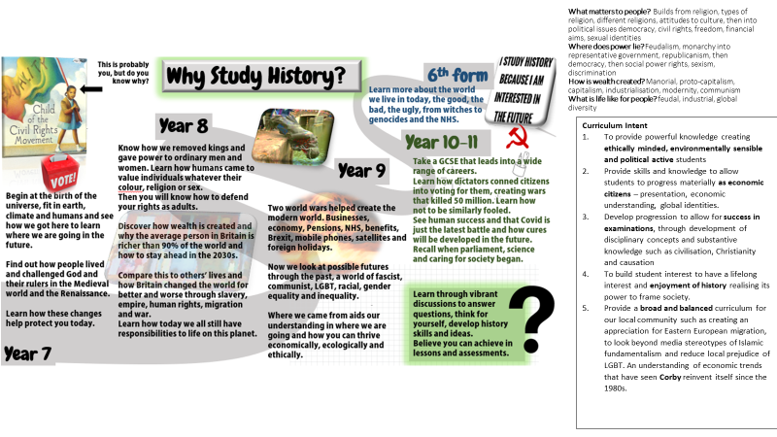
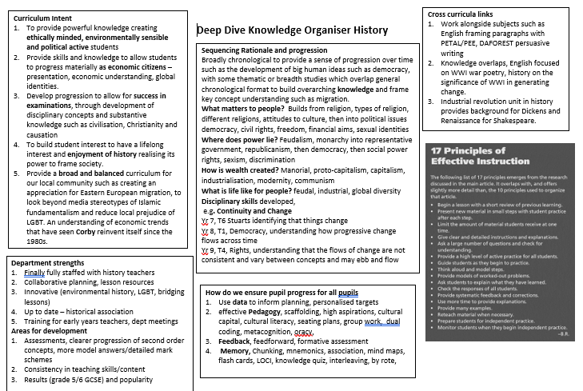
The department seeks to lead beyond its own classrooms. It is involved at the Trust level helping out other schools and working with other departments at CBA such as CEIAG and PD to provide resources.
