3.2 How broad and balanced is the history curriculum?
We seek to use a broad, balanced and cohesive range of chronological periods, geographical scales, areas and perspectives of history. We want concepts and processes well-embedded, reflecting the diversity of Britain. We have thought about how to increase challenge. We try to use a local dimension to enhance pupils understanding.
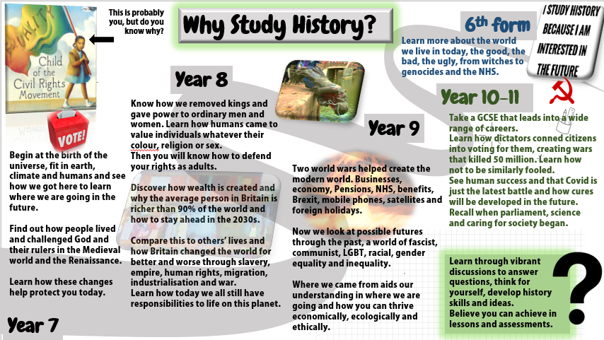
The student rationale shows the scope of the history curriculum, including environmental history, post war Britain, women’s rights and contributions, LGBTQ and disabled history and the history of youth. We journey along the silk road and across to the Native Nations of the Americas, down to South Africa and Medieval Zimbabwe and north to Russia.
The curriculum is adapted to the local context, including units on Zimbabwe and Eastern Europe as well as post war migration to Corby. The curriculum is continuously updated and improved building on rectifying student misconceptions and utilising Historical Association guidance and best practice. This year we have added decolonisation into our schemes of work and added lessons on India. (sample of lesson below)
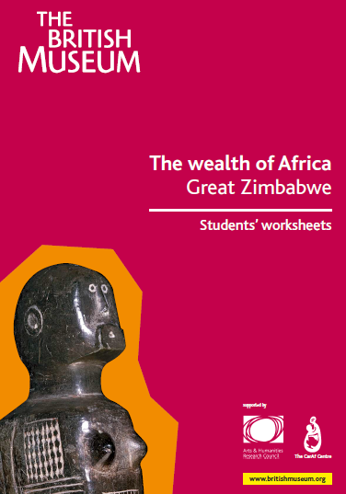

We draw on a range of resources to construct our lessons.
Thanks to our sister school Thomas Clarkson for the worksheet below.
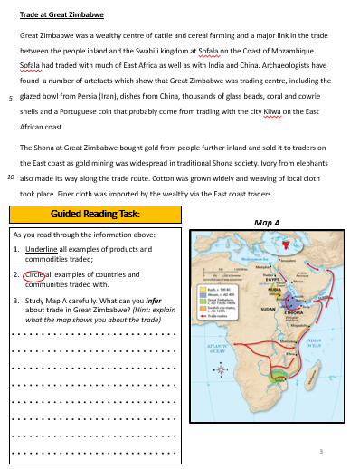
There is a clear rationale for building generative substantive knowledge.
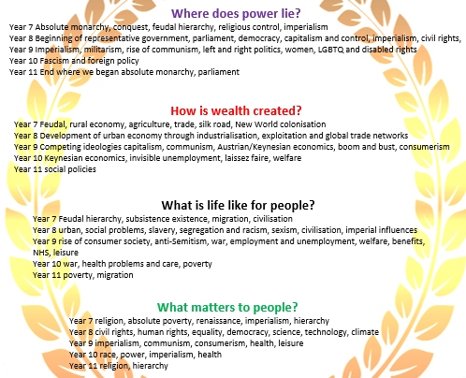

Disciplinary knowledge has been clearly mapped and best practice adapted from Ford and Pearson to address misconceptions and build progression by increasing difficulty over time
1) Causation |  | 4) Historical Interpretations
SIGNPOST 1  Causal Webs | Change happens because of MULTIPLE CAUSES and leads to many different results or consequences. These create a WEB of related causes and consequences. | SIGNPOST 1  Identifying Interpretations | Historical interpretations are everywhere. Every piece of historical writing is an interpretation of some sort. The past is not fixed but CONSTRUCTED through interpretations.
SIGNPOST 2  Influence of Factors | Different causes have different LEVELS OF INFLUENCE. Some causes are more important than other causes. | SIGNPOST 2  Drawing Inferences from Interpretations | It is possible to draw INFERENCES from interpretations of the past, just like with historical sources. INFERENCES will reveal the MESSAGE of a particular interpretation.
SIGNPOST 3  Personal and Contextual Factors | Historical changes happen because of two main factors: The actions of HISTORICAL ACTORS and the CONDITIONS (social, economic etc.) which have influenced those actors. | SIGNPOST 3  Evaluating Interpretations | The APPROACH of an author must always be considered. This means considering their VIEWPOINT, PURPOSE, AUDIENCE and EVIDENCE chosen to build their interpretation and how this might impact on the final interpretation.
SIGNPOST 4  Unintended Consequences | HISTORICAL ACTORS cannot always predict the effects of their own actions leading to UNINTENDED CONSEQUENCES. These unintended consequences can also lead to changes | SIGNPOST 4  Interpretations in Context | Historical interpretations must be understood on their own terms. This means thinking about the CONTEXT in which they were created, what conditions and views existed at the time, and how this might impact the final interpretation.
2) Change & Continuity |  | 5) Significance
SIGNPOST 1  Identifying Change | Past societies are not fixed, there are changes which have occurred spanning centuries. Changes in the past can be identified by looking at DEVELOPMENTS between two periods. | SIGNPOST 1  Resulting in Change | Events, people and developments are seen as significant because the RESULTED IN CHANGE. They had consequences for people at and/or over time.
SIGNPOST 2  Interweaving Continuity and Change | Change and continuity are INTERWOVEN and both can be present together in history. CHRONOLOGIES can be used to show change and continuity working together over time. | SIGNPOST 2  Revelation | Significance is ascribed if they REVEAL something about history or contemporary life.
SIGNPOST 3  Flows of Continuity and Change | Change is a process which varies over time. Change can be described as a FLOW in terms of its PACE and EXTENT and can be said to TRENDS and have specific TURNING POINTS. | SIGNPOST 3  Identifying Significance Criteria | Significance is seen as something constructed therefore CRITERIA are needed to judge the significance of events, people or developments within a particular historical narrative.

Each year is organised to build on prior knowledge and develop core knowledge, an example of this is seen in an overview of the Year 7 scheme of work. We are constantly reviewing and adapting schemes to improve enquiry questions and misconceptions as children’s knowledge changes, particularly post-covid.
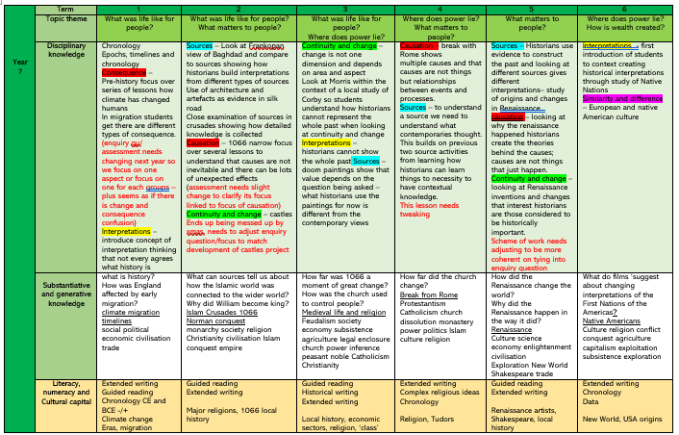
Each scheme of work is carefully planned to identify the core and hinterland knowledge we want students to learn
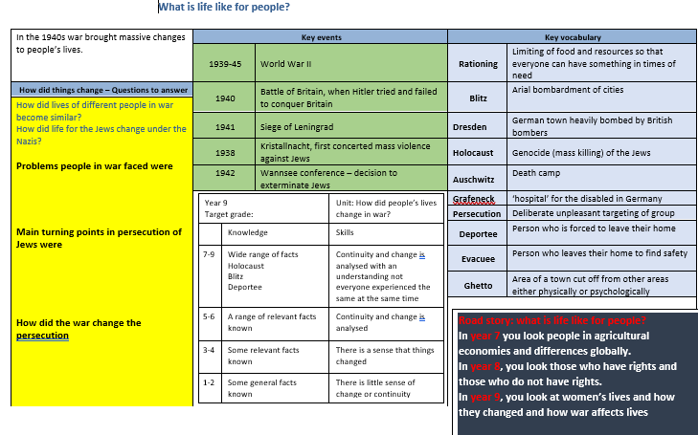
Staff have crib sheets to ensure that they remember to focus on core knowledge and know how to adapt the curriculum if their class’s learning is changed through bank holidays or other issues.
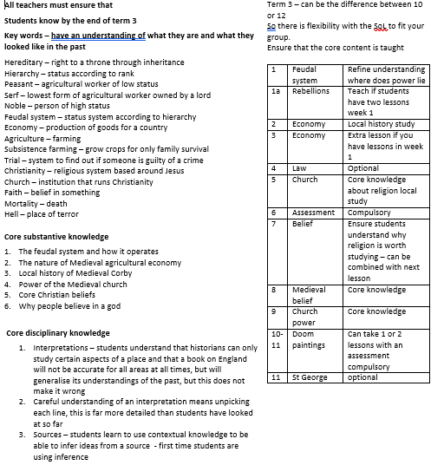
The local content brings to life abstract concepts
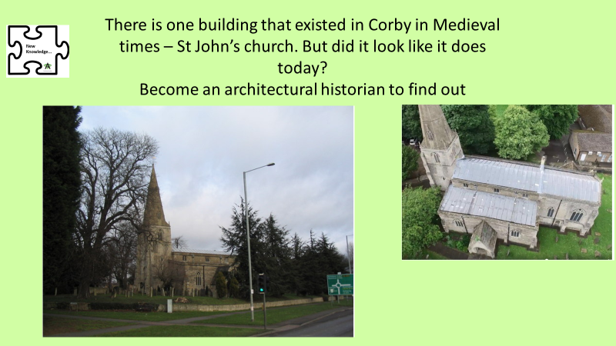
Case study of second order concept progression at KS3– causation.
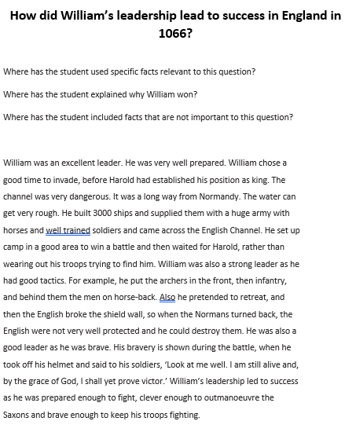
This concept is started early as it is less complicated than some concepts.

Term 2 year 7 – mini enquiry on leadership in Battle of Hastings, not the old-style full analysis of causes, but looking at the role of leadership.
Scaffolded with focus on how to analyse causation. Very basic introduction to the concept focusing on a single cause.

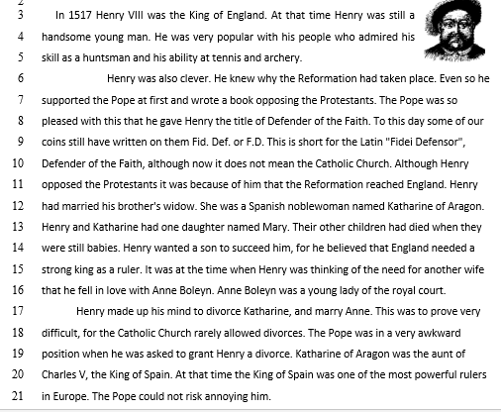
Term 4 year 7 Lesson inspired by internet resources Causation is developed as a relational multi-causal concept. The reading is more about context than fully focused on the cause alone, but with detailed questions to scaffold. The activities are designed to develop independent discussion to develop understanding with students then developing independence and high order skills by working on the connections between causes.
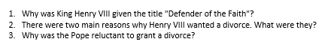

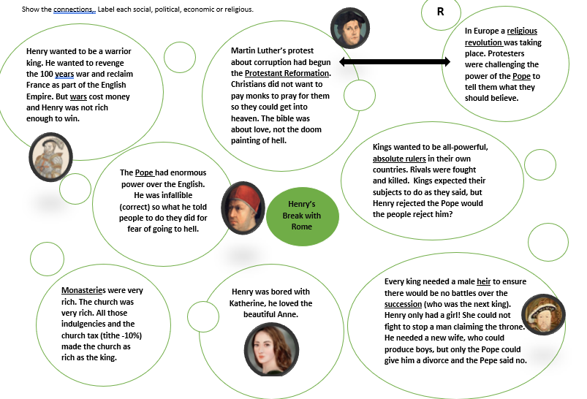

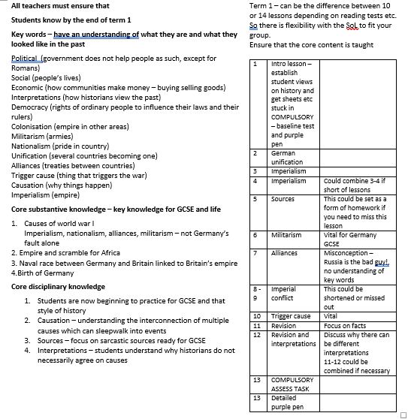
By year 9, analysis is of long/short term multi-causal reasons, as relationships and unintended consequences with copious contextual knowledge.

A term’s Enquiry question ‘Did Europe sleepwalk into World War I?’.

