3.3 Enquiry: How is enquiry used to effectively develop pupils’ historical thinking and understanding?
The department seeks to use a broad range of approaches to develop pupils’ historical skills in order to build pupils’ depth of knowledge, understanding and skills. (see evidence 1.2, 1.3, 3.1, 3.2)
Each unit of study is framed around an enquiry question over several lessons, each lesson has its own enquiry question and the enquiries build into the 4 road story enquiry questions.
Example of how the scheme of work builds and interleaves across a year group.
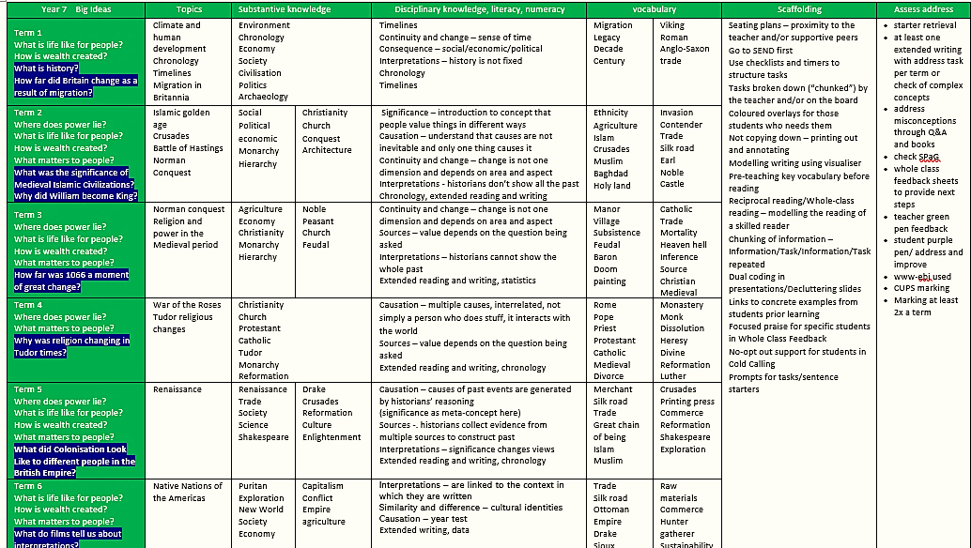
By year 8, concepts like economy and environment are becoming embedded, so that complex ideas about significance such as how historians ascribe significance can be grasped by a range of students. Using cultural capital of climate change we show how society’s ideas about industry have changed.
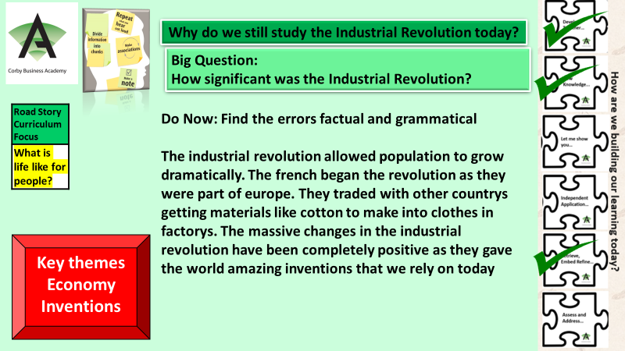
Case study of an enquiry question culminating in an assess task and progression check
