5.3 Website and communications: How does history contribute to the school’s online communications?
History has a dedicated section on the school VLE, there is also a collaborative Trust section for history, and each history class communicates with staff through their own pages to support learning. In addition, the website and social media platforms promotes the department.
There is extensive use of the VLE to support student learning. This was developed as online lessons during covid and has continued to support student learning across all Key Stages.
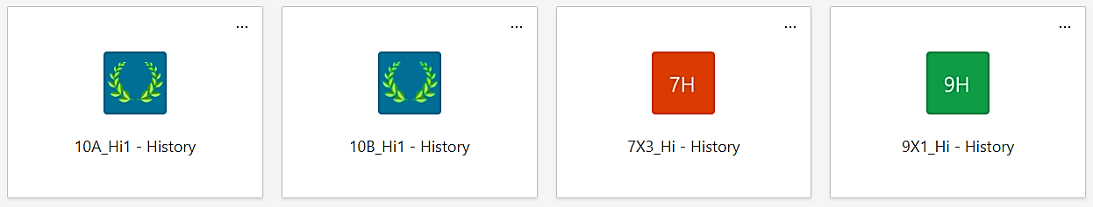
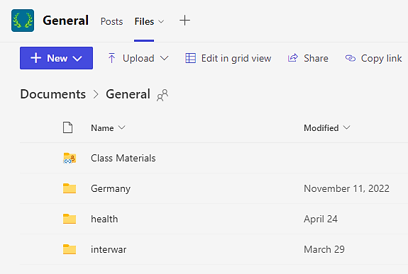
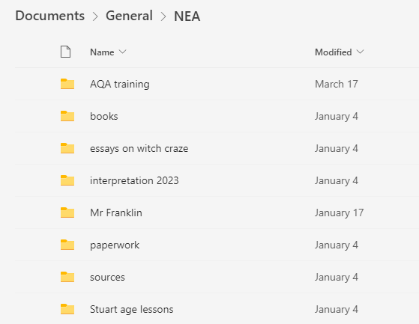
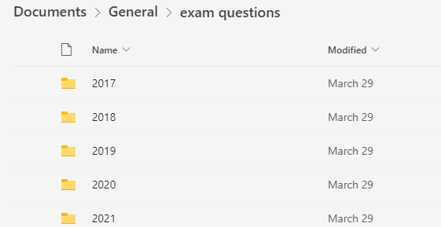
It is particularly useful for ensuring students working from home or abroad can keep up to date 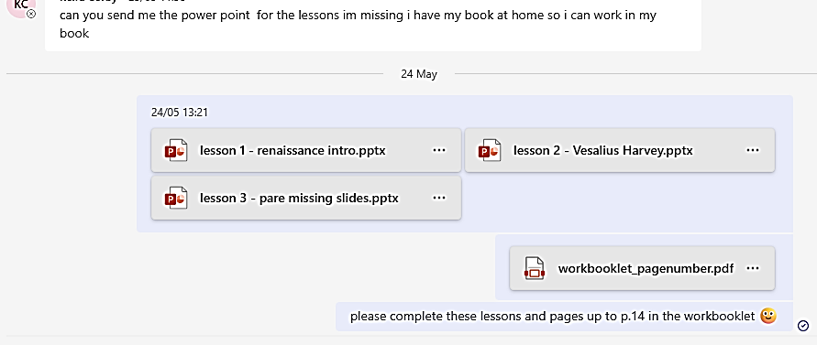
The VLE also provides a useful communication channel for ensuring best practice amongst staff by sharing resources within and across the Trust
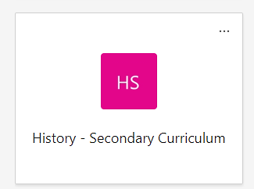
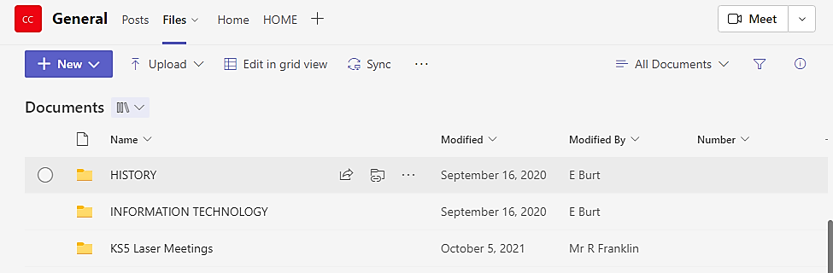

The school website and social media platforms celebrate student success and promotes the subject. (also see 4.4)
