
Mass Observation sources and potential enquiry questions
Professor Julie Gottlieb
Material sourced from the Mass Observation Archive, University of Sussex Special Collections
(Margot Jones 1071, “The Crisis”, M-OA: Directive Replies 1938, Box 11 of 13, Munich Crisis, Sept.-Oct.—Women)
“Wednesday, Sept. 14. No news yet—everything just the same or perhaps a shade worse. Had lunch with my father and said the same old things once again: nobody wants a war, but Hitler seemed mad, and it all depended on him. There was really nothing new to say or think. I made a speech to this effect: It seems there’s nothing worse than war. But if we don’t resist, if we and the world give in to Fascism, if Oswald Mosley becomes our king under Hitler, wouldn’t that have been worth fighting to prevent? But surely nothing can be worse than war? Deadlock.”
(Blackwell, I 3568, “Comments on the Crisis”, September 28, 1938, M-OA: Directive Replies 1938, Box 11 of 13, Munich Crisis, Sept.-Oct.—Women)

“I am one of these people who always follow the international news. I have been very worried over it and have been expecting war for a long time… Last week I felt ill with worry and not much better when Chamberlain came to his agreement with Hitler, for I felt if Hitler was allowed to get strong enough to dominate Europe we should have a war sooner or later and I would rather have it now, before he is too strong. Once war seemed a certainty, I lost my worry and began to feel quite an exhilaration in all the bustle and hurry, the anti-aircraft guns, searchlights, trenches, gas masks, queues…The atmosphere was exciting and chilling, so when the news came through about the Four Power Conference which seemed to out off the war I felt almost flat… Some think we are willing to fight for democracy against dictatorship and others for fear of German domination of Europe. Few seem to consider Czechoslovakia the real cause.”
(M.E. Grant 2251, Sept. 1938, Ramsgate, M-OA: Directive Replies 1938, Box 11 of 13, Munich Crisis, Sept.-Oct.—Women)
“Friday: Early morning. Peace declared, what a relief for everyone, and what a triumph for Mr Chamberlain and Herr Hitler. I most sincerely hope that England and Germany will remain great friends, my husband always says, you can trust a German anywhere, but only trust a Frenchman as far as you can see him. One school teacher told me that the children were very disappointed that there was no war, they were quite enjoying the excitement and were anxious to try out their gas masks… Friday night: The arrival of Mr Chamberlain was broadcast on the radio and there were great cheers at his home coming, everyone I know seemed to be listening for the news whenever it could be obtained on the radio. Church services had been going on continually during the week, with prayers for peace, it seems that their prayers have been answered. Saturday: people all seem back to their normal again, but everyone is still talking of the news of the last few days, while many seem quite satisfied with the change of events, several men only, not women, seem to think that we had not heard the last of it. One man fears what move Russia may take later on. Some say the trouble in Palestine and the Far East will be very serious during the next few months.”
(Mrs Phyllis Perlow (housewife), “Crisis” 1081, M-OA: Directive Replies 1938, Box 11 of 13, Munich Crisis, Sept.-Oct.—Women)
“N.B. Own policy as always—Pacifist, non-Party but definitely anti-fascist. I think with tonight’s majority…Own feeling: that no Peace Conference dealing with minorities can possibly consider it has given moral justice if the Jewish Question is not thrashed out. A lamentable omission….[attended a meeting on 1 October 1938] General impressions: ‘Peace’ is what we wanted—we have got it…for how long? (No one thought it was lasting; no one suggested beyond 3 or 4 years. All agreed it would be very much worse. Hitler has gained what he wanted, anyway. It was a supreme loss of prestige and honour for England. Chamberlain is pro-Fascist and we are not wanting a fascist country (only the excitable little Fascist bantam enthused about Fascism)… Relief at peace—but what now? Can anything be done before Germany takes possession of Czechoslovakia. It will be the final blow to democracy if she is allowed to do so; the issue has been ‘Communism or Fascism.’ Chamberlain has pawned democracy rather than risk Communism—The result seems to be Czech-mate—and Germany wins.”
(Margot Edgelow 1033, Mass-Observation Report, Sept. 28, 1938, M-OA: Directive Replies 1938, Box 11 of 13, Munich Crisis, Sept.-Oct.—Women) DS 801
“Some General Impressions: No hatred of Germany, feeling is only Hitler and the Nazis who wish war. Tremendous willingness to help on part of everyone. No grumbling. Great admiration for Chamberlain—is a nation’s hero. Have noticed spontaneous clapping in cinemas whenever he is shown in news reel. Have not found great sympathy for Czechs, or attitude of ‘back them up at all costs’. My personal opinion is that the Treaty of Versailles was very unjust, a wrong that needs righting…”
(W. Thompson 2053, Oct. 3, 1938, M-OA: Directive Replies 1938, Box 11 of 13, Munich Crisis, Sept.-Oct.—Women)
“Monday, 3rd October, 1938:… My father and my husband seem to think Chamberlain has done the best thing, and has gained a moral triumph, though not a diplomatic one. They say it is a big boost for the dictators. My father seems to think Russia could have been handled better, and that, though her main interests appear to be in the East, she is a force to be reckoned with in the future in Europe. Personally, I’m sorry Hitler has appeared so well out of all this. I admit he’s done some good for his country, but in my opinion he’s a madman, and not in the least to be trusted. I’m convinced that friendship with Germany is all to the good, and believe that peaceful negotiations having once turned aside war, the same method will probably prove successful a second time. I feel sorry for the Czechs. They’ve been fed to the wolves. I think England and France should grant them a gift of about £30,000,000. There is sure to be great unemployment and distress this winter. I feel somehow we have made Europe safe for ourselves, but made the British Empire hard to keep for the next generation. Still, it remains to be seen. If only the Church could start something, -- or even waken up. Surely the international trouble provides the Church with a stupendous moral. True religion,-- the only one that counts—is contained in Christ’s words ‘Love one another.’ Nothing else matters… But the nightmare is over now, and we can buy our Christmas cards, and presents, and perhaps plan our next summer’s holiday. Life is worth living again. I hope this is a lasting peace.”
(Day Survey 635 - Male Baptist Minister, Birmingham, 28 September 1938)
Woman (41), Housewife: ‘They will surely never begin a war. What can I do? How long shall I have my husband + my boy. I am thankful my other two children died - I sometimes wish we had let our remaining laddie die as well instead of working to keep him alive when almost gone.’
Man (31), Baptist Minister: ‘The news is better - twenty four hours breathing space’
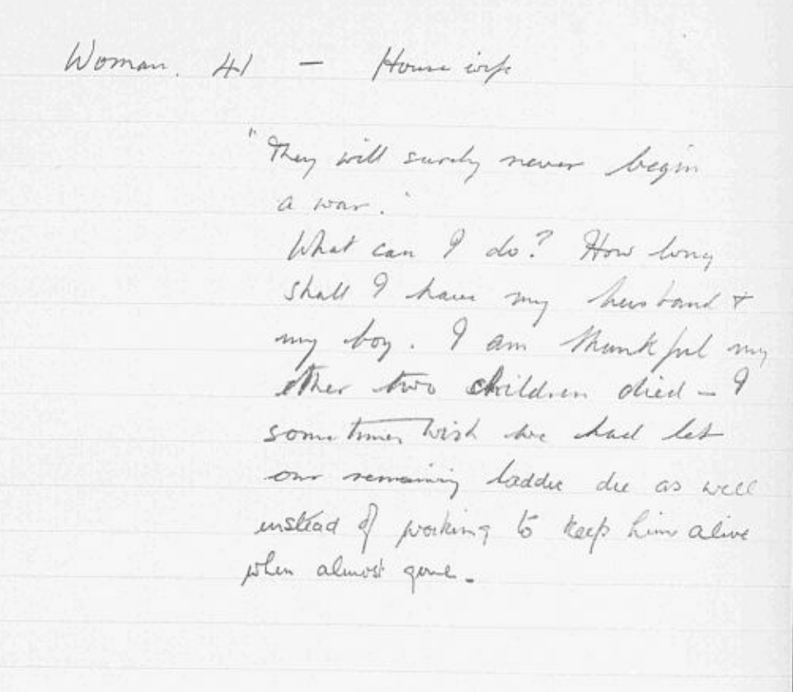
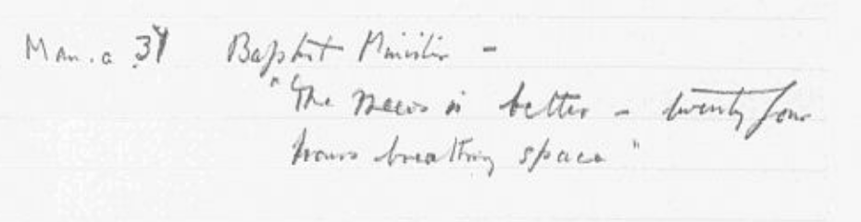

(Day Survey 804 - Single female office worker, Westcliff, 30 September 1938)
30 September. ‘Everybody feels as though a weight has been lifted…Satisfaction expressed that in event of more war fears, we are well equipped now. A middle aged typist - about 45 is going to get drunk for the first time in her life to celebrate the news.’
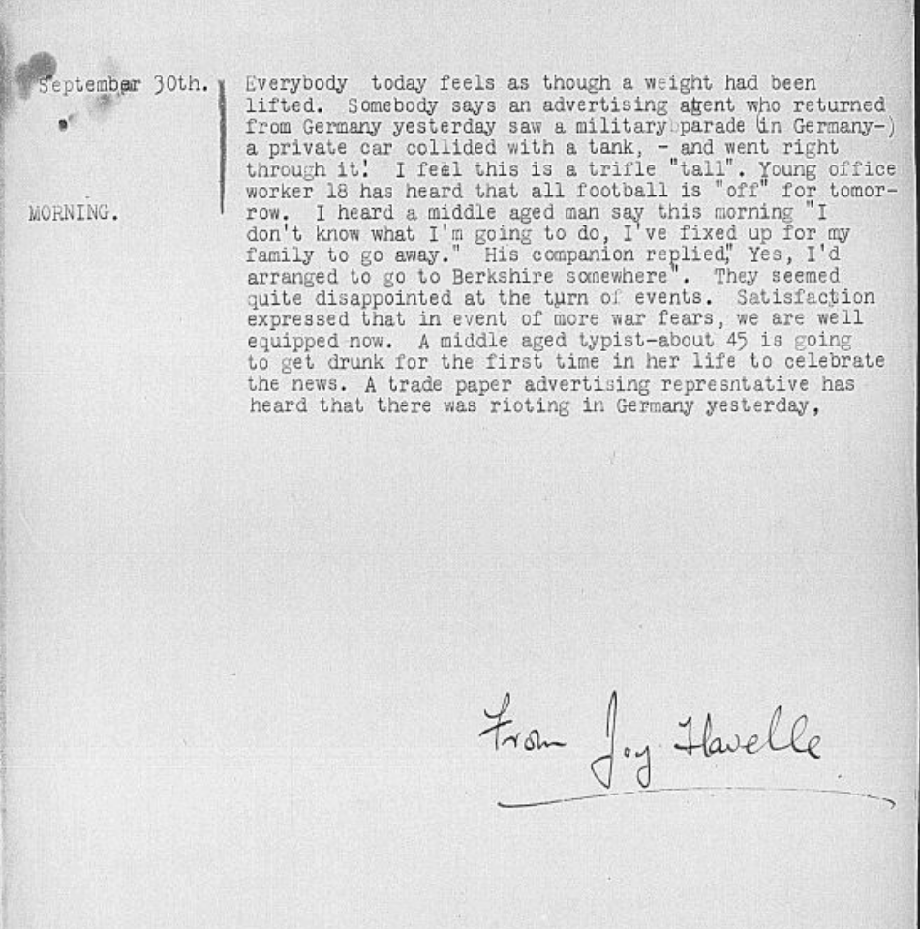
(Day Survey 793 - Female clerk, Northampton, 24 August 1938)
Wolverhampton. ‘I have not discussed [the crisis] with people - so I do not know whether they would agree with me or not. The fear of war is too horrible that I try to keep it out of my mind. In conversations I have had independently with Americans visiting this country, they have all said that over there, newspapers & travel agencies are saying - visit Europe this year or you will never see it the same again.
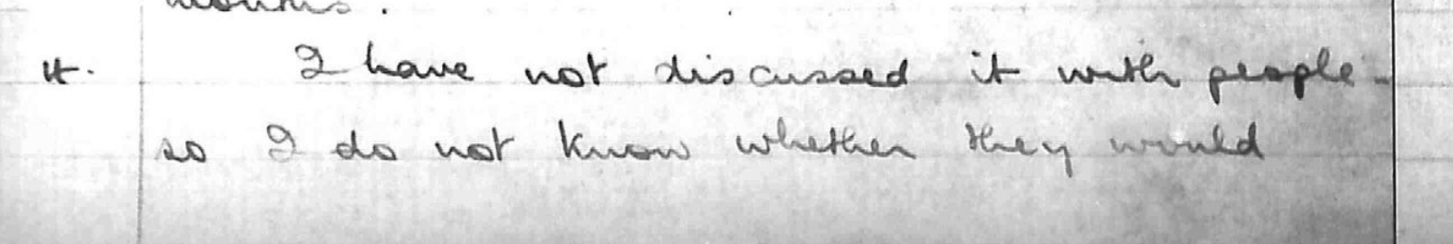
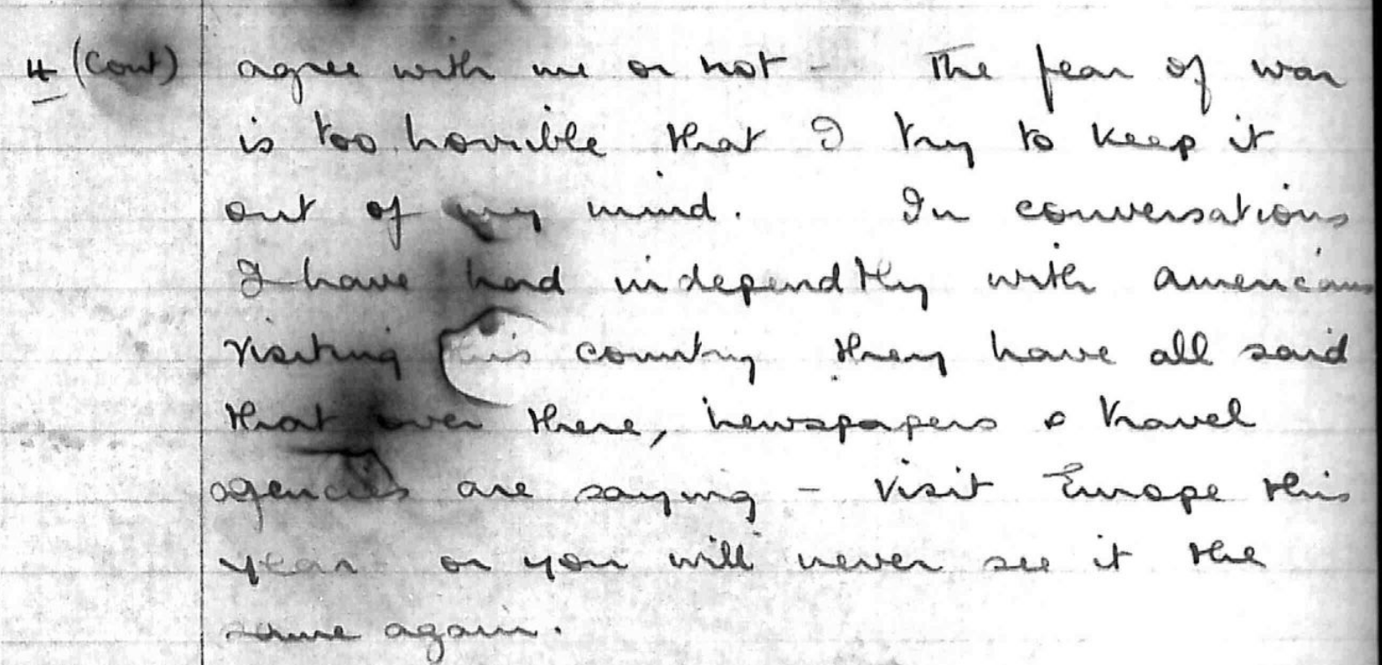
(Day Survey 718 - Single Male, Essex, 29 September 1938)
‘Personally I think it is rather unfair to expect anyone to give a definite answer to the first question [of whether there would be war]. One requires a good political knowledge even to make conjectures on the subject and the situation changes so suddenly that one’s opinion change rapidly. To demonstrate this uncertainty I may say that on Sunday I thought that we should have peace; on Wednesday morning I thought that war was almost inevitable; and on Wednesday evening it seemed that we should have peace after all. Next week, perhaps, war may again appear to be certain.’

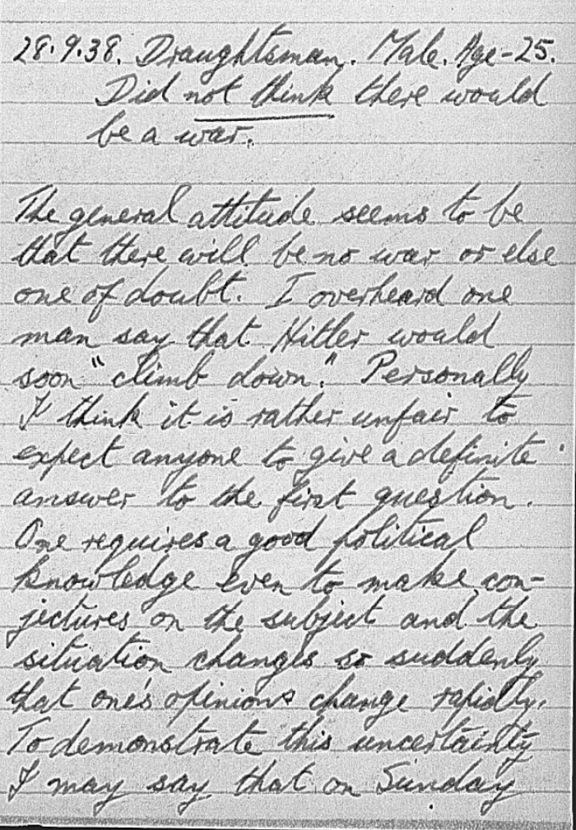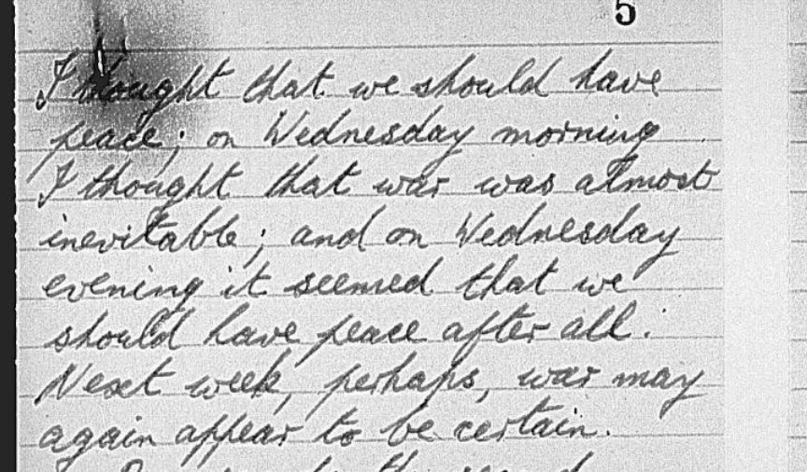

(Day Survey 650 - Male, 25, Local Government Officer, 28 September 1938)
‘On my way to work this morning I made a particular point of noting the attitude of the people to the crisis. It was evident from facial expressions that most of them were greatly perturbed. It was difficult to find a smiling face. This was most noticeable at the station where there were some 100-150 people waiting for the train up to London. The majority of the waiting passengers were busily studying newspapers but here and there small groups were talking in subdued tones and were evidently discussing the situation. At the office most people were discussing the crisis and many of us found it extremely difficult to get down to work. There was a terrible feeling of uneasiness and the majority of the people appeared to be anxious to discuss events and hear one anothers opinion. This feeling of unrest remained throughout the day…Another clerk (Male aged 28 yrs) said “Frankly, I’m scared. I hardly know what to think. War cannot come, we can’t stand it. I think we shall find a way out.”’
‘In the evening after my arrival home, I walked along to the post office, and on my way I met an old friend of mine (an auctioneer and estate agent - male - aged 26 yrs). His first words were “well boy, what do you think of it.” My reply was “Things certainly look black but I feel that war will be averted.” He replied - “So do I. If it should come I’m not going to rush off and join up. Let them come and fetch me. I’ve spent months studying and now I have finished I don’t see the fun in wasting my efforts.” We discussed the situation for some time and eventually my friend said “Well I’m off to the club for a drink, I’m not worrying so let the crisis go to hell.”
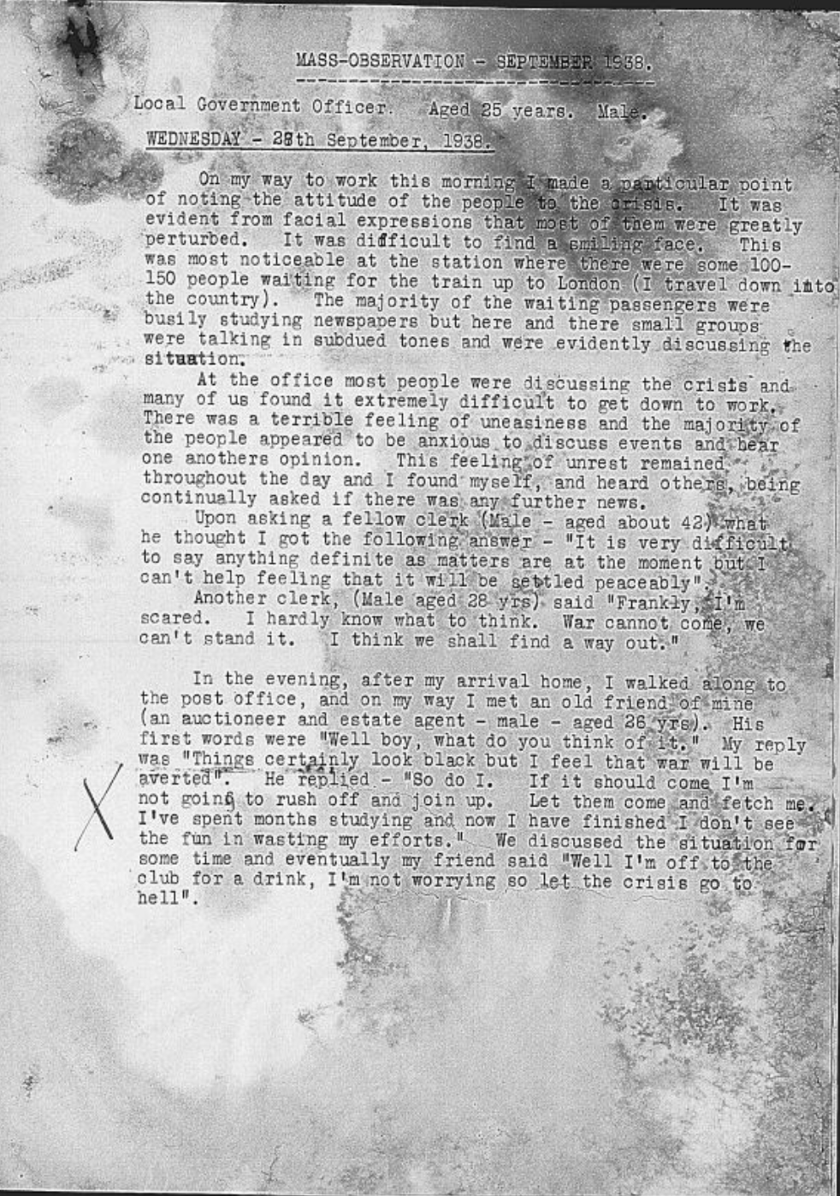

29 September 1938 (the next day): ‘The atmosphere at the office today was a great deal easier. Many people had rid themselves of that anxious look and many joked about the various schemes which had, and were being brought into force, and one would imagine that as far as we were concerned, the crisis was over. In spite of this brighter feeling, however, there was still a constant demand for fresh news and one could imagine that although things seemed a little cheerful one was not ti display any fear or alarm, although this fear was in most people’s minds. This “lighter’ feeling did not appear to be general and after my arrival home I went round to a local school to be fitted for a gas mask. On my way I met two of my mother’s friends who were busily discussing the situation. One, a lady of about 56 years, said “Well — what does your mother thing of things.” I replied “Naturally she is worried and I am doing my best to cheer her up.” The answer was “So am I. I don’t know what to think. I was determined to do several odd jobs this evening but i can’t settle down. In fact I can’t stop indoors. This afternoon I went for a walk round the fields with my dogs and I stood and looked around me, everything was so peaceful and quiet and beautiful and I thought there cannot be war, it’s madness - but I’m afraid.” This woman was in a terrible state of “nerves.” Her face was very white and she was so agitated that she couldn’t stand still. As a matter of fact had I not known her better I should have thought she was intoxicated. Her fears, like that of many mothers, was for her son.”
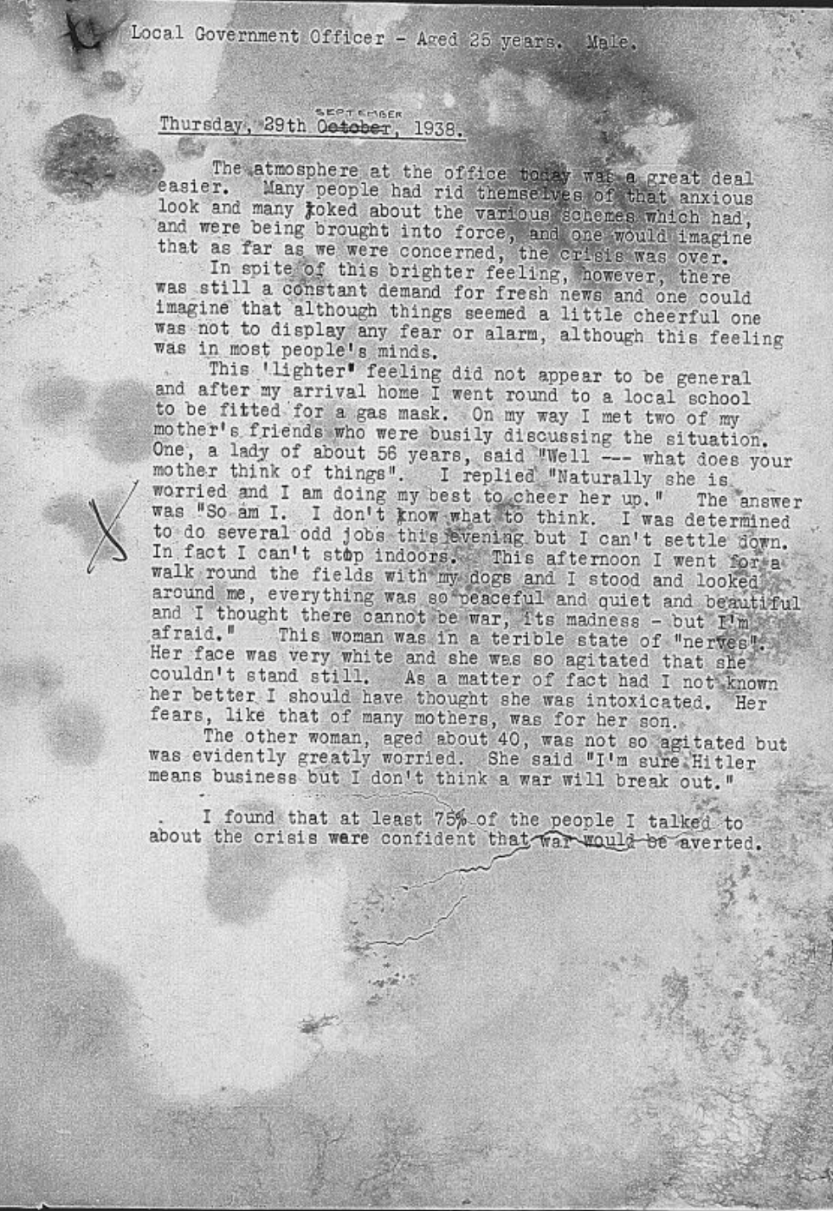

(Day Survey 639 - September 1938)
‘I was sitting in an A.B.C having my lunch during the time when the war strain was at its highest. Suddenly there was a crash as a waitress dropped a pile of plates. Normally this would have gone unnoticed but on this occasion the effect was electrical. Strangely enough it was the men who were most effected, not so much surprise as actual anticipation of something dreadful was registered on their faces.
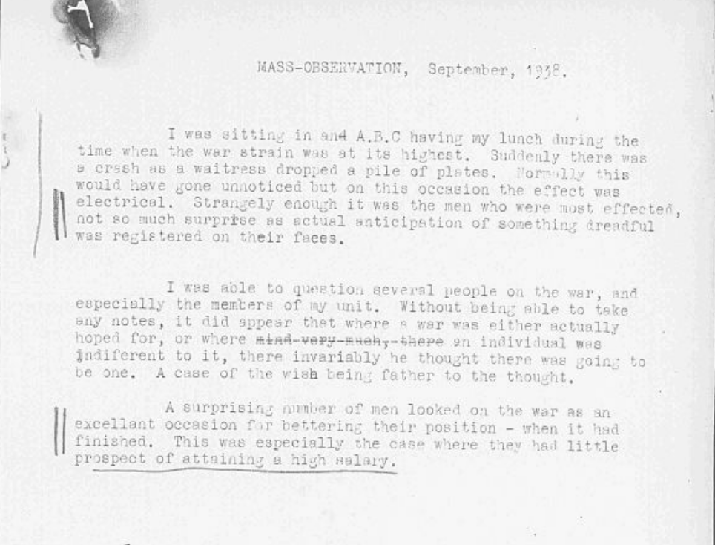

(Day Survey 684 [interesting theme of rumours here and relationship to fear - have only included one of 13])
‘For my own interest as much as for M.O. purposes I am collecting “war rumours” as I think such information can be of very great importance in the understanding of how false news gets spread about. Here are some rumours collected between the 27th and 28th September…’
- A typist working in a London Office rang up the office to say that her mother had refused to allow her to go that day as there was to be an air raid at 2.30pm. This rumour had obviously arisen out of the announcement of the German mobilisation timed for to-day and announced last night on the wireless, note the distortion caused by fear.
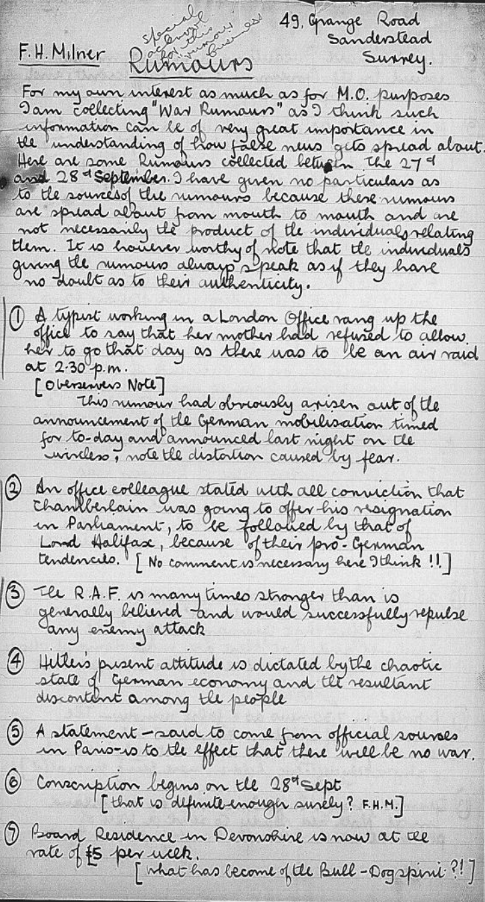

Analysing these sources: Questions to consider
Content: What is the excerpt about? Is it relevant to refer to the author(s) and consider their intentions and motivations? What argument is being put forward by the authors? What side of the appeasement debate is being represented here? What are the main points they are making about public opinion? How does the excerpt work as an M-O mission statement?
Historical Context: When was it written/published and what is significant about the timing? What other political and social trends does it reflect? What do you know about its reception that may be relevant?
Methodological Context: What kind of document is it? What is the genre? What is it setting out to show and to prove? What kind of concerns influence the method developed? What other kinds of social scientific research projects were running at the same time, and how does M-O different from newspaper reporting, BIPO polls, private sources etc.? Is there anything particularly problematic about the method?
Historiographical Context: How has this source been used in historical accounts of appeasement—place it in historiographical context. Have historians of appeasement perpetuated the elitism and side-lining of public opinion that motivated an organisation like M-O in the first place? If so, have historians justified their dismissal of M-O sources or merely ignored the archive?

