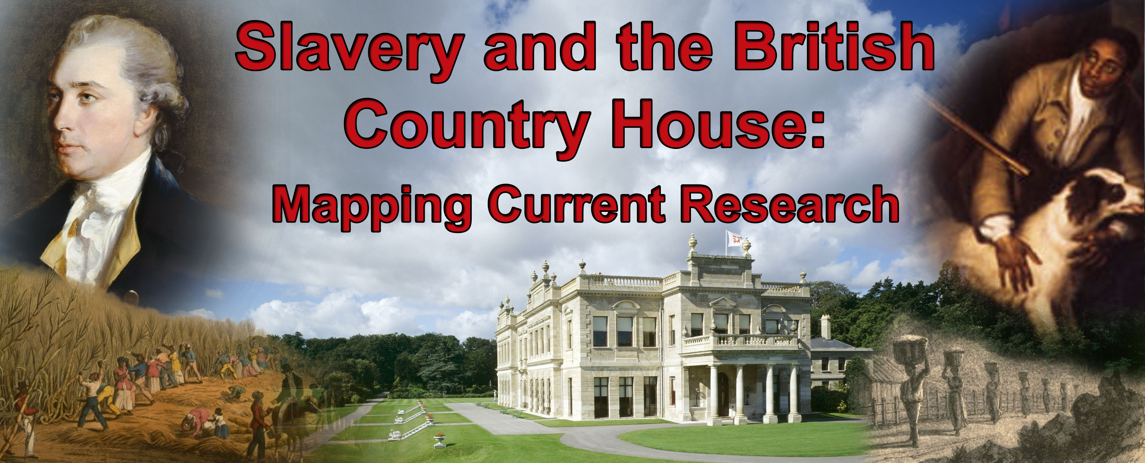
The Spencer Collection
Slavery and the British Country House:
Mapping Current Research

Saturday 21 November 2009

New Academic Building, London School of Economics
54 Lincoln's Inn Fields, London, WC2A 3LJ

As part of the legacy of the 2007 Bicentenary of the Abolition of the Slave Trade, English Heritage, the National Trust and the University of the West of England (UWE) are jointly sponsoring this one-day conference exploring the links between the country house in Britain and the Atlantic slave trade.

Building on important new research in this area, this conference will promote wider public understanding of the many ways in which the fortunes of the landed elite and their country houses were intertwined with slavery and the slave trade.

Papers will include:
‘The view from Yorkshire, Harewood House and After' - James Walvin (University of York)
'St. Vincent's topography and links with British country house owners' - Simon D. Smith (University of Hull)
'Liverpool merchants and their ‘Rural Retreats’’ - Jane Longmore (Southampton Solent University)
'Normanton Hall and Gilbert Heathcote, merchant and slaver of empire' - Nuala Zahedieh (University of Edinburgh)
'Bristol and Nevis: changing places' - Roger Leech (University of Southampton)
'Using Slave Compensation Records to measure rentier slave-ownership in Britain' - Nick Draper (UCL)
'Contesting the political legacy of slavery in Britain's country houses' - Caroline Bressey (UCL)
'Slavery at the Codrington Sites in England and the West Indies,' - Natalie Zacek (Manchester University)
'The Stately Homes of Bexley and their hidden links to the East and West Indies' - Cliff Pereira (Royal Geographical Society)
'The Atlantic trade and the 18th century fashion for landscape tourism' - Victoria Perry (UCL)
‘Property - attitudes to slaves, land and trade’ Susanne Seymour & Sheryllynne Haggerty (University of Nottingham)
‘Atlantic slavery and classical culture at Marble Hill and Northington Grange’ - Laurence Brown (Manchester University)
‘Slavery and Country Houses in the West of England’ Madge Dresser (UWE)

Early booking is recommended to avoid disappointment

For further details contact Ros Tatham: Telephone: 020 7973 3351; Email: slavery@english-heritage.org.uk
English Heritage; 1 Waterhouse Square; 138-142 Holborn; London EC1N 2ST
Slavery and the British Country House
Conference Booking Form

Name: Organisation:
Address:

Tel: Email:

I would like to register for the conference:

□ Standard conference (Full fee) - £30 □ Cheque for £________ (payable to
‘English Heritage’) enclosed

□ Concessionary rate (Concession) - £10 □ Credit/Debit card details enclosed (below)
(Students, members of community groups, independent researchers,
low and non-wage earners)

Do you have any special access or dietary requirements?: _____________________________

Are you happy for your name, organisation and email address to be circulated on
a list in the delegate packs? YES / NO

Are you happy for English Heritage, the National Trust and/or UWE to use
your contact details for post-conference follow-up and other relevant events? YES / NO

Signature:

Slavery and the British Country House Conference London, November 21, 2009

Credit/Debit Payment Card (circle one): Visa / Mastercard / American Express / Maestro / Solo

Credit / Debit Card No:

I authorise payment for the following amount: £ Issue No:
(Solo and Maestro only)

Valid From: ___ / ___ Expiry Date: ___ / ___ Security Code:

Address for Receipt:

Please return this form with Credit/Debit card payment details or a Sterling cheque to Ros Tatham via post:
English Heritage; 1 Waterhouse Square;138-142 Holborn, London, EC1N 2ST
OR via email: slavery@english-heritage.org.uk

