HISTORICAL ASSOCIATION

[DURHAM BRANCH]

LIFE PRESIDENT  Professor G. R. Batho  Miners’ Hall, Red Hill  Durham, DH1 4BD  0191 370 9941 |  | www.hepdurham.ning.com  gordon.batho@btopenworld.com

Welcome to the Treasures of South Yorkshire and Derbyshire (24 – 29 July 2010)
(Provisional Itinerary)

Saturday 24th July

13.00 Coach leaves Sheffield Station
14.00 – 15.00 Registration & light refreshments

16.00 Conisbrough Castle: (Guided Tour)
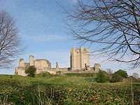

A 12c castle, considered one of South Yorkshires primary tourist attractions whose
ruins are dominated by a 97 foot circular keep, supported by six buttresses. probably
built by Hamelin Plantagenet. Audio and visual displays now help to reconstruct a
view of life in a medieval castle.

18.30 Dinner at the Edge

20.00 Lecture / Musical Evening

Sunday 25th July
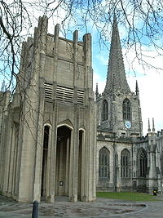

07.30 – 08.45 Breakfast

10.00 Sheffield Cathedral (Service at 10.30 (optional) plus Guided Tour)

Sheffield’s oldest building, the ancient heart of a great city and flourishing diocese where God
has been worshipped for over a thousand years. There has been a church on this site since
Saxon times. The parish church of St Peter and St Paul, was elevated to Cathedral status in
1914 and is one of five Grade 1 listed buildings in the city.

12.30 Millennium Gallery: (including lunch)
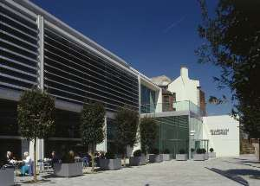

The Millennium Gallery is a modern, light and spacious building made mainly of glass,
white concrete and marble floors and opened in 2001. With four galleries under
one roof , there are all sorts of wonderful things to see and enjoy. Admire treasures
from the past, masterpieces from Britain’s national collections and discover new creat-
ions. There are also many examples of Sheffield artefacts, cutlery and Sheffield
Plate etc.

18.30 Dinner at the Edge

20.00 Lecture / Musical Evening

Monday 26th July

07.30 – 08.45 Breakfast

  - Hathersage Church: (Guided Tour)
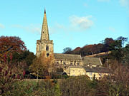

Thought to date back to 1381, but was restored between 1849 and 1852, St.
Michael and All Angels is one of the best examples of church architecture in the
country. The church houses 15 brasses to the Eyre family, which inspired Bronte’s
choice of her heroine’ name, Jane Eyre . The churches most famous feature is the
exceptionally long grave in the church yard which is said by tradition to hold the body
of Robin Hood’s friend Little John

  - Coach leaves for Mellor Round House

12.00 Mellor Round House:
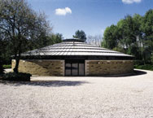

The David Mellor site was formerly the Hathersage village gasworks, this unique
purpose built factory designed by Sir Michael Hopkins, was built on the foundations
of the old gas cylinder hence the circular form is described by many as a minor
masterpiece of modern architecture, receiving many important architectural and
environmental awards.
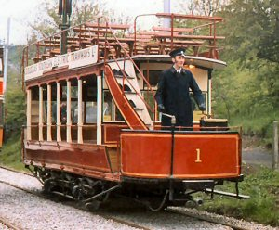
  - Crich Tramway Museum: (including lunch)

This fascinating Museum began during the decline of the tram in the 1950s. Founder
members became ‘people with a mission’ to rescue, store and restore as many types
of tram as possible. The museum has developed into a major tourist attraction on
the world stage, and is an important research centre for historians, scholars and
students alike.

  - Dinner at the Edge

20.00 Lecture / Musical Evening

Tuesday 27th July

07.30 – 08.45 Breakfast
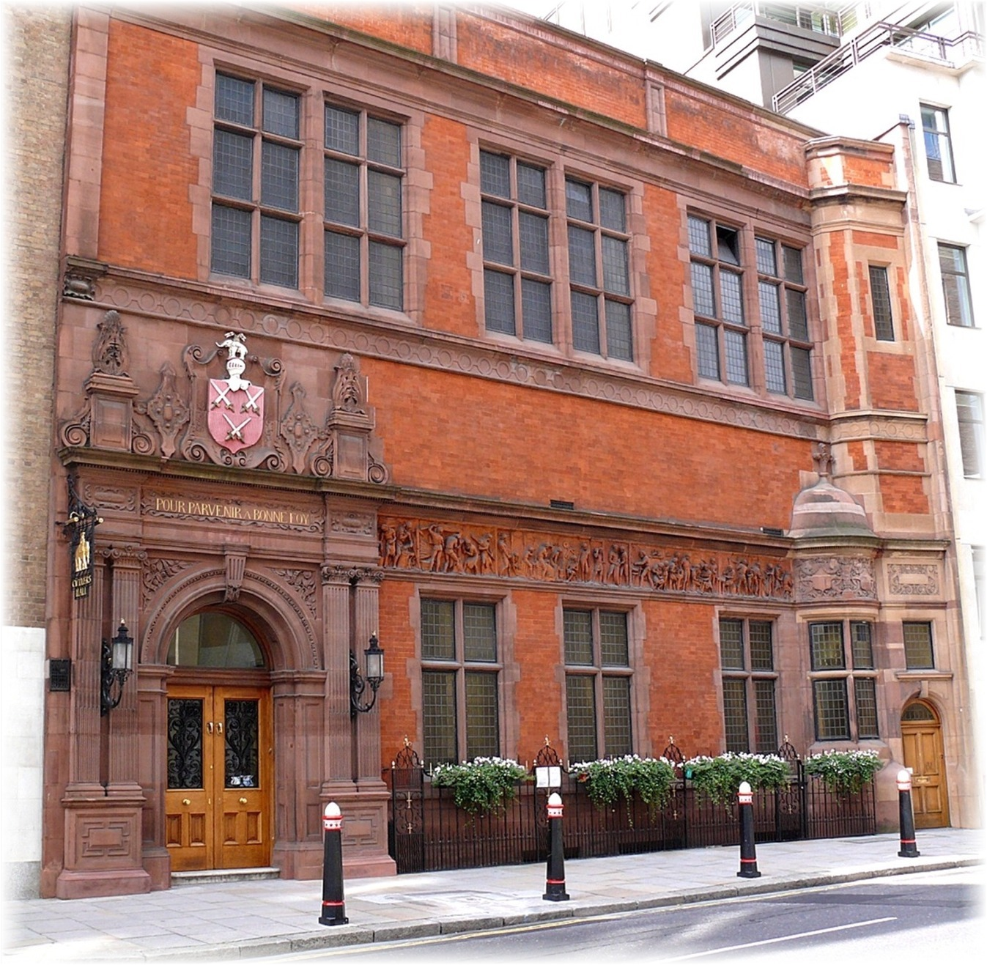

10.00 Cutlers’ Hall

In 1638, shortly after it came into being, the Company bought land for their Hall on
Church Street, Sheffield, opposite the parish church, which is now the Cathedral.
The second Hall was built in 1727 and the present Hall, a Grade 2 listed building, was
built in 1832, being extended in 1867 and 1888.

12.00 Abbeydale Industrial Hamlet: (including lunch)
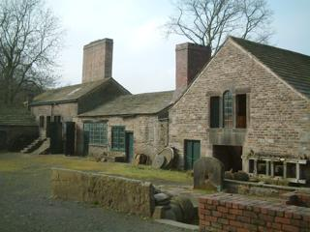

A unique 18c industrial works, one of the largest water powered sites on the River
Sheaf, it produces industrial scythes and other edged tools. Waterwheels, tilt
hammers and the only intact crucible steel furnace in the world today can also be
seen.

17.30 Civic Reception & Tour of Council Chambers, Sheffield

  - Dinner at the Edge

20.00 Lecture: by Professor G.R. Batho (Bess of Hardwick)

Elizabeth Talbot, Countess of Shrewsbury, known as Bess of Hardwick, the third surviving daughter of John Hardwick of Hardwick Hall. She married four times, firstly to Robert Barlow who died in his teens, secondly to the courtier Sir William Cavendish, thirdly to Sir William St Loe and lastly to George Talbot, the 6th Earl of
Shrewsbury, and sometime keeper to the captive Mary, Queen of Scots.

Wednesday 28th July

07.30 – 08.45 Breakfast
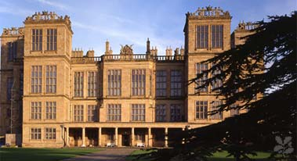
  - Hardwick Hall: (including lunch)

Spectacular Tudor house, built for ‘Bess of Hardwick’, Elizabethan England’s second
most powerful and wealthy women. Outstanding 16 & 17c tapestries and
embroideries, historic parklands, orchard and herb garden.

  - Dinner at the Edge

20.00 Lecture / Musical Evening

Thursday 29th July

07.30 – 08.45 Breakfast
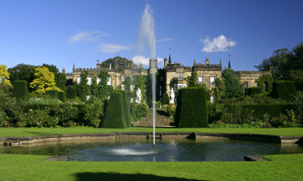
  - Renishaw Hall: (including lunch)

The stately home of the Sitwell family in Derbyshire, built mainly in the Georgian
period around a 17c core. It houses many treasures, large & small collected over
many centuries and has eight acres of the most important Italianate gardens in
England.

ACCOMMODATION

University of Sheffield
34 Endcliffe Crescent
The Endcliffe Village
Sheffield
S10 3ED

Single & Double en-suite rooms
available

Provisional Timings

Breakfast; 07.30 – 08.45 (Full English or Continental)
Coach will leave, 09.30 to start each days programme
Lunch will be between, 12.00 – 14.00
Dinner at The Edge, served 18.30
Lectures / Musical Events will start at 20.00

Booking form for ‘South Yorkshire Experience’

Name:

Address:

Tel: E.mail:

I would like to book place/s on the ‘South Yorkshire Experience’ 24th – 29th July 2010. I enclose a deposit of £100, per place booked, (We would appreciate deposits by 31st Dec. 2009, with balance of payment due by 30th April 2010). Single and double en-suite accommodation is available. Cheques payable to The History of Education Project please, and returned to Kevin Ffinch / Joy Savage at the address below. The cost will be £575 per person, inclusive of all accommodation, entrance costs (excluding special exhibitions within museums, galleries etc.), meals and gratuities but exclusive of alcoholic drinks.

I understand that insurance is a personal responsibility Signature

I have the following mobility requirements:

I have the following special dietary requirements:

Vegetarian ◻ / Vegan ◻ / gluten free ◻ / Diabetic / other ◻ please give details:

I shall ◻ / shall not ◻ require lunch on 29th July (no extra charge, but please tick).

I wish to have a room next to:

I shall arrive by train ◻ / car ◻ / coach from Durham ◻ (please tick) at pm

Signature/s: Date/s of Birth:

Please return to:
Kevin Ffinch / Joy Savage
The History of Education Project
The Miners’ Hall
Red Hill
County Durham
England
DH1 4BD
If you are a member of any of the following, can you please indicate and bring membership cards.

National Trust ◻

English Heritage ◻

Art Fund ◻

