Historical Association
Survey of History in Schools in England 2010

Nature of the survey
The findings reported here are based on the response of history teachers in England to an online survey sent by the Historical Association to all schools and colleges teaching students in the 11–18 age range. Responses were received from 598 teachers from a range of different centres (including middle schools and sixth-form colleges). Responses to the questions about teaching 11–14-year-olds (traditionally regarded as Key Stage 3 – although some schools now complete Key Stage 3 in two years) were received from 531 schools, although the numbers responding to each specific question about practices in different year groups varied slightly. The 531 schools included 411 state-maintained comprehensive schools, 28 state-maintained grammar schools, 26 academies and 79 independent schools. Responses to questions about provision at Key Stage 4 (conventionally ages 14–16) were received from 512 schools; while 339 schools and sixth-form colleges reported on their AS and A-level history provision.
Although the numbers of schools of each type obviously varies considerably, the pattern of responses provides a similar sample for each, in terms of the proportion of schools responding.
1. History at Key Stage 3
1. 1 How history is taught
1.1.1 How history is taught in Year 7
Respondents were asked to describe how history is taught: as an entirely separate, discrete subject; as a discrete subject within a humanities programme; within an integrated humanities programme; or within some other model. Overall, 86% of all schools that responded report history being taught as a discrete subject, either entirely separately, or as a distinct subject within a humanities programme. A further 9% teach it within an integrated humanities programme, where subjects are not separated out; while 5% report teaching some other form of programme. These alternative programmes are based on a competency- or skills-based curriculum.
Analysis of this data by type of school shows different trends (see Figure 1). Grammar schools and independent schools overwhelmingly teach history as a separate discrete subject, and none of those who responded had adopted an alternative curriculum model. Almost 70% of comprehensive schools teach history as a separate subject; while just under half of the academies use such an approach. Students in academies are also more likely to be taught history within a humanities programme than in other types of school. The main difference, however, is the proportion of academies that teach history either through an integrated humanities programme (13.6%) or through an alternative curriculum (again 13.6%) – proportions which are double those of the comprehensive schools.
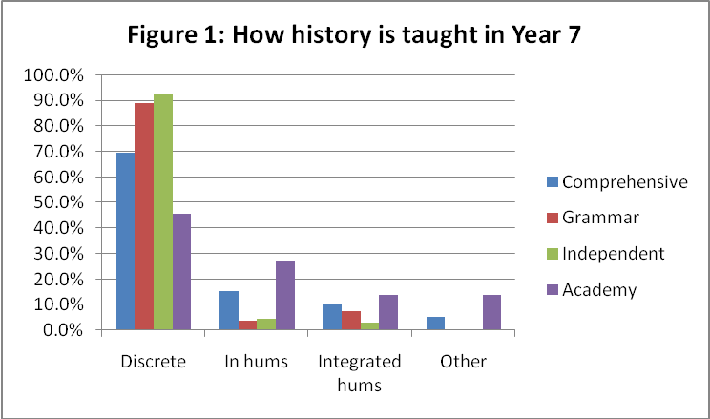
When comparing the results from the 2009 survey to the current survey, the overall pattern is very similar (see Table 1). This year’s figures also show a slightly higher proportion of schools adopting a humanities model, either teaching discrete subjects under the umbrella of humanities or providing an integrated programme. As last year, academies are more likely to provide history as part of an integrated humanities or an alternative curriculum.
Table 1: Comparison showing how history is taught within the curriculum in Year 7
Figures in bold relate to data from 2010; figures in (brackets) to 2009 survey
Proportion of schools offering Yr 7 history | All schools  531 in total  (589 in total) | Comprehensive  schools  377  (465) | Grammar schools  27  (34) | Independent schools  67  (68) | Academies  22  (22)
As a discrete subject | 72.9% (387 schools)  (75.9% = 447 schools) | 69.5%  (72.3%) | 88.9%  (94.1%) | 92.5%  (97.1%) | 45.5%  (59.1%)
As a discrete subject within humanities | 13.2% (= 70 schools)  (10.5 % = 61 schools) | 15.4%  (11.8%) | 3.7%  (2.9%) | 4.5%  (2.7%) | 27.3%  (13.7%)
As part of an integrated programme | 9% (= 48 schools)  (6.6% = 39 schools) | 10.1%  (7.7%) | 7.4%  (2.9%) | 3% | 13.6%  (9.1%)
Within an ‘alternative’ curriculum | 4.9% (= 26 schools)  (7.1% = 42 schools) | 5%  (8.2%) |  |  | 13.6%  (18.2%)

1.1.2 How history is taught in Year 9
The figures for Year 9 history show that few schools use alternative curriculum models or present history as part of an integrated humanities programme (see Table 2). Most schools teach history as a separate discrete subject, although academies are more likely to offer the subject within some kind of humanities approach. The survey reveals that in a small but significant number of schools, history has become an optional subject in Year 9 (i.e. the last year of Key Stage 3). The 2009 survey indicated that 5% of the schools that responded had adopted a two-year Key Stage 3, but this year’s survey includes a much higher proportion: 10%. The figures show that academies are more likely to make history optional in Year 9, with almost a quarter of academies claiming this is happening.
Table 2: The form of history teaching in Year 9 in different types of school
Proportion of schools offering Yr 9 history | All schools  488 in total | Comprehensive  schools  391 | Grammar schools  27 | Independent schools  69 | Academies  21
As an optional subject | 10.5% (51 schools) | 8.7% | 11.1% | 2.9% | 23.8%
As a discrete subject | 87.9% (429 schools) | 79% | 85.2% | 94.2% | 47.6%
As a discrete subject within humanities | 4.2% (40 schools) | 8.2% | 3.7% | 1.4% | 23.8%
As part of an integrated programme | 2.7% (13 schools) | 2.8% |  | 1.4% | 4.8%
Within an ‘alternative’ curriculum | 1.2% (6 schools) | 1.3%

1.1.3 Teachers’ concerns about the way in which history featured within the Key Stage 3 curriculum
The questionnaire included a question specifically about any concerns teachers had about history teaching in their current school. Respondents were invited firstly to consider a number of possible concerns (a list based on issues that members have raised with the Historical Association) and to indicate whether they regarded them as a current concern, a potential future concern, or of no concern at all in their school. They were also then invited to note any other issues of concern to them, and 66 comments were made that related to history teaching at Key Stage 3. Among these, issues associated with the place of history in the curriculum and how it is taught formed the second-largest category, featuring in 24 specific comments.
A number of these concerns related to a growing emphasis on generic ‘skills’ at the expense of specific subject understanding:
Increasing emphasis on skills, moving towards subjects just being vehicles to teach generalised skills areas with increasingly little value being placed on subject knowledge and understanding in itself. (Teacher 40, comprehensive school)
Year 7 is now part of a thematic integrated programme. Curriculum discussion seems to indicate there is a move to introduce a thematic integrated programme into Year 8… The History Department is feeling that as a subject we shall 'disappear' into a mix of 'thinking skills' and 'vocational pathways' which do not seem to recognise the contribution that history can make to developing young learners. (Teacher 211, comprehensive school)
Another related concern was the attitude of school leaders towards history. There were 21 concerns explicitly making the point that history is not considered a worthwhile subject within their school and that in many cases this emanated from the school’s Senior Management or Leadership Team (SMT/SLT).
We are disappearing! Integrated Humanities is the way our SMT wants to go and sees us as awkward, backward and obstacles if we suggest subjects like history are valuable in their own right. We constantly have to justify our existence. (Teacher 346, comprehensive school)
Proposals to drop History in Year 7 – students to study 'learning to learn' curriculum which for most will mean that any history content will be [taught by] non-specialist[s]. The feeling that we are increasingly viewed as a second-tier subject – poor ICT availability compared with other subjects, for example. (Teacher 289, comprehensive school)
SLT do not see the value of History. (Teacher 312, comprehensive school)

1.2 Who teaches Key Stage 3 history?
1.2.1 The extent of non-specialist teaching in Year 7
Respondents were asked to state how much of the teaching was carried out by non subject-specialists. Examining the responses relating to Year 7 history teaching reveals a mixed picture (see Figure 2a). All schools report some degree of non-specialist teaching in Year 7, although the extent of this varies by type of school. Independent schools report the overall lowest percentage of non-specialist teaching, with over two-thirds of schools reporting that all teaching is done by specialists. In nearly a third of comprehensive schools, grammar schools and academies, up to 30% of history classes receive non-specialist teaching. Of the grammar schools that responded, about 18% report that 46–60% of history classes are taught by non-specialists, while the situation in academies is more worrying, as nearly a third of these schools in the survey indicate that over 60% of history teaching in Year 7 is carried out by non-specialists.

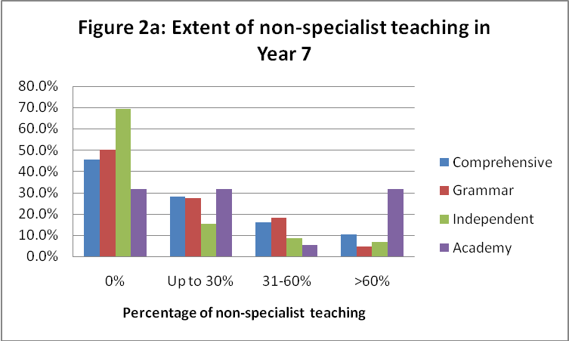
Comparisons with the data from the 2009 survey show different trends (see Figure 2b), although it is difficult to reach firm conclusions about trends over time given that different schools may have responded to the survey in each year. The figures for comprehensive schools and independent schools appear relatively stable. The picture is more varied when looking at grammar schools and academies. Among the grammar schools the extent of non-specialist teaching in Year 7 is greater in 2010 than that reported by schools responding in 2009. While just over 10% of academies responding to the survey last year reported that more than 60% of history teaching was being carried out by non-specialists, the proportion reporting this extent of non-specialist teaching in 2010 is 30%.

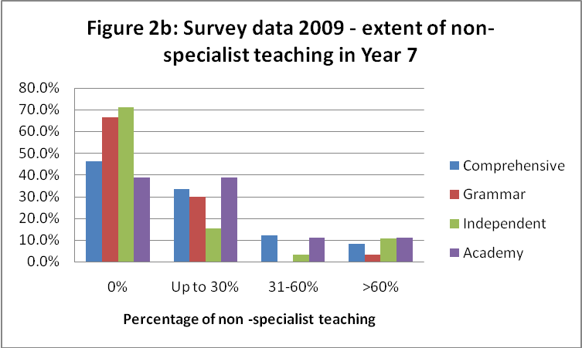

1.2.2 The extent of non-specialist teaching in Year 9
A slightly different picture can be seen in Year 9 (see Figure 3a). Overall the amount of non-specialist teaching in Year 9 is lower than in Year 7. In all types of schools the majority of history teaching in Year 9 is carried out by specialists. The figures are strongest in grammar schools (86.4%) and independent schools (78.7%). In comprehensive schools the figure is 70.1%, but in academies the figure is 60%. Overall, academies are more likely to report high levels of non-specialist teaching compared with other types of schools; in this survey a fifth of academies report that over 60% of history classes in Year 9 receive non-specialist teaching.
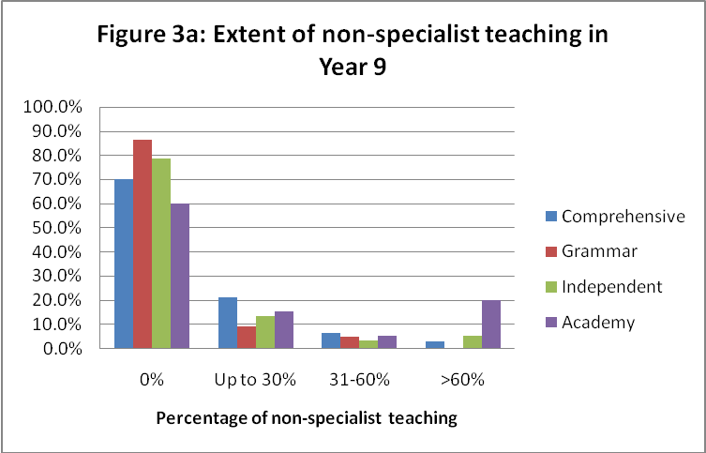

Comparing the figures from the current survey with those from the 2009 survey reveals different trends (see Figure 3b). The responses from comprehensive schools and grammar schools suggest a relatively stable situation. Among the independent schools, slightly less specialist teaching is reported this year (78.7%) than among those responding last year (84.5%). But it is within the academies that the growth of non-specialist teaching is most alarming. In 2009, few of the academies who responded to the survey reported much non-specialist teaching, whereas in 2010 a fifth of those who responded indicate that over 60% of history teaching is carried out by non-specialists. Again it is difficult to draw firm conclusions, but the trend in academy schools appears to be different to that in other types of school.

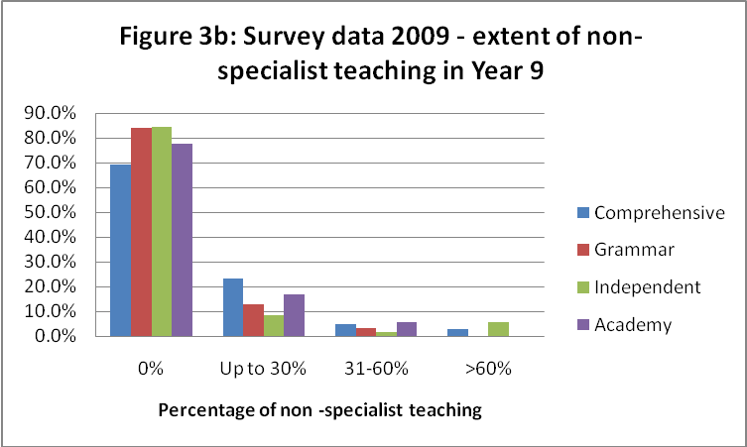

1.2.3 Teachers’ concerns about non-specialist teaching
Non-specialist teaching was a concern about which the survey asked directly. Of the 548 teachers who answered this question, 142 (25.9%) regarded the extent of non-specialist teaching as a matter of concern (with 53 of them, or 9.7% of the total, claiming it was a serious concern). A further 170 teachers (31%) thought that it might well become a concern in the future. While this fear may relate to the possible introduction of an integrated or competency-based curriculum it may also reflect the fact that some schools are seeing history specialists leaving and not being replaced (an issue of concern to 74 schools or 13.5% of respondents).
1.3 Time allocation for history
1.3.1 Variation in time allocated to history
As reported in 2009, there is considerable variation between schools in terms of the time allocated to history in Year 7; Figure 4 provides detail of the statistics for 2010. The vast majority of independent and grammar schools, and nearly three-quarters of comprehensive schools devote more than an hour a week per pupil to history teaching. The figure is much lower in academies, of whom nearly half provide an hour a week or less of timetabled history per pupil (although a slightly higher number/proportion than last year were offering rather more time). Overall the time-allocation figures show greater variation between different types of school than those reported last year. This year (as last) the mode for comprehensives is more than 90 minutes a week for history. The results for grammar schools show that the mode is also more than 90 minutes, whereas among last year’s respondents the most common response was 76–90 minutes. The modal figure for independent schools falls between 61–75 and 76–90 minutes, which is lower than that for last year’s respondents. The mode for academies among both this year and last year’s respondents was 46–60 minutes a week.

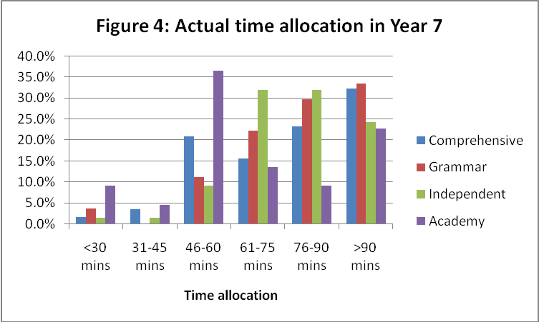

The situation in Year 9 looks rather different (see Figure 5). For both comprehensive schools and academies the mode time allocation is more than 90 minutes a week, whereas this figure is lower for both grammar schools and independent schools, with modes of 46–60 minutes and 61–75 minutes respectively. This is partly explained, especially in the case of the academies, by students making an early start to GCSE courses in Year 9, thereby necessitating an increase in curriculum time.
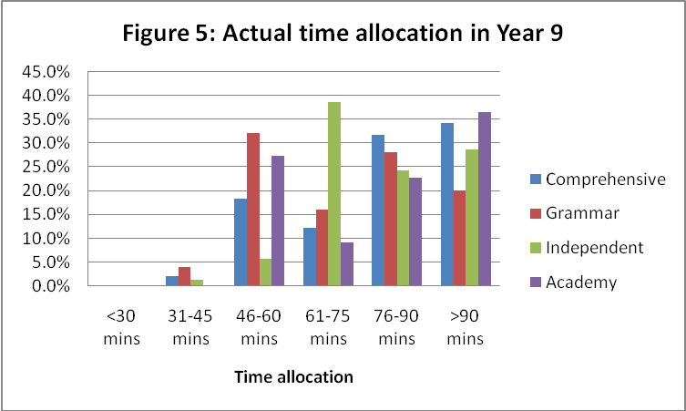

1.3.2 Cuts in the time allocated to history
As in 2009, a significant number of schools reported a cut in the time allocated for history teaching.
As Figure 6 shows, 118 schools reported a reduction in teaching time for Year 7. This includes a third of the academies who responded to the question, and a quarter of the comprehensive schools and grammar schools.
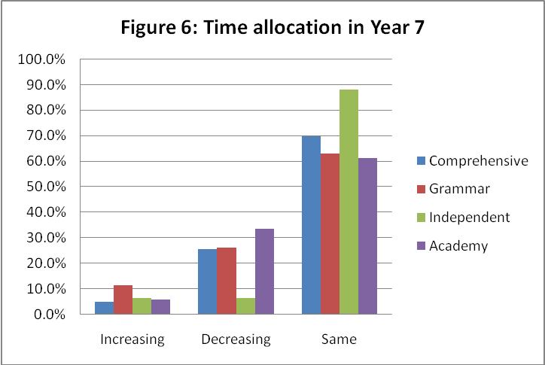

Similarly, Figure 7 shows that a significant number of schools – 89 in total – have cut the time allocated to history in Year 9. Somewhat surprisingly, a high proportion of the grammar school respondents (almost a third) reported such a reduction. Just over a quarter of the academies that responded to the survey also reported a cut.
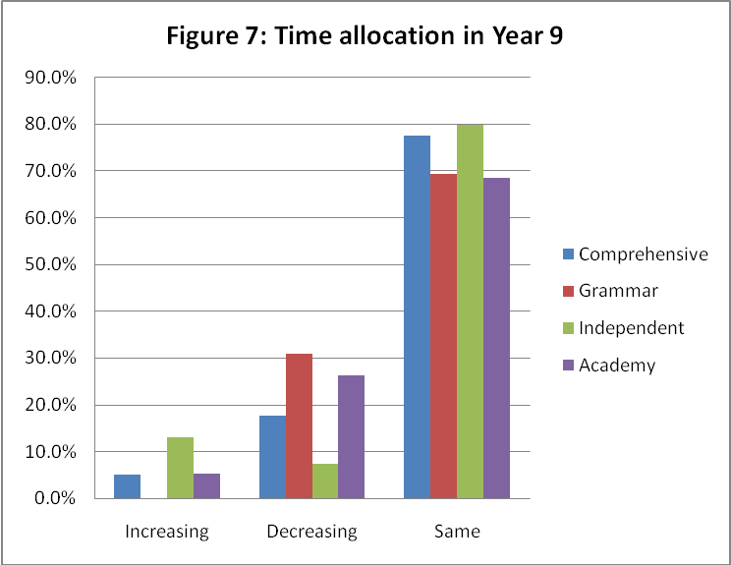

When invited to express their own concerns, lack of time was the most frequently cited worry that teachers raised about Key Stage 3, mentioned 36 times. At one level these concerns are about a straightforward reduction in teaching time, but there were also many comments about time being taken away to make way for other courses:
Time spent learning history in Years 7–9. In Year 7 although students get three lessons a week, it's only for two half-terms. (Teacher 263, comprehensive school)
The reduction of teaching time. We will be cut by 50% next year in Year 9 teaching time and this will inevitably have a negative impact on GCSE take-up. (Teacher 36, comprehensive school)
September 2010 going to two-year KS3. No more Year 9 History. May have to teach Year 9 & Year 10 together. (Teacher 85, comprehensive school)
Current plans are to cut time back further in Years 7 & 8 to one hour a week and no KS3 time in Year 9. Students will be able to opt for GCSE in Year 9 which they will complete in one year from September to June in four hours a week for the full course. They are then expected to resume it for A- Level in Year 12 if they wish to study it further. History would also be included in 'flexible' learning days covering cross-curricular themes etc. but there will be no training for these and will mean considerable planning/preparation etc. GCSE in one year will also be difficult and some students will drop it completely at the end of Year 8. (Teacher 106, comprehensive school)

2. History at Key Stage 4
2.1 Uptake at GCSE
2.1.1 Overall uptake (all schools)
Respondents were asked about the proportion of each year group currently studying for GCSE history. In a third of the schools that responded, 30% or fewer students in Year 10 are studying GCSE history – and the same is true of Year 11 (see Figure 8a). While the reports seem to suggest a slight increase in 2010 in the number of schools in which more than 60% of students are studying GCSE history (from 15% to 17%, comparing the current Year 10 with the current Year 11), this means that around half the schools responding have GCSE history cohorts of between 31% and 60% of students.
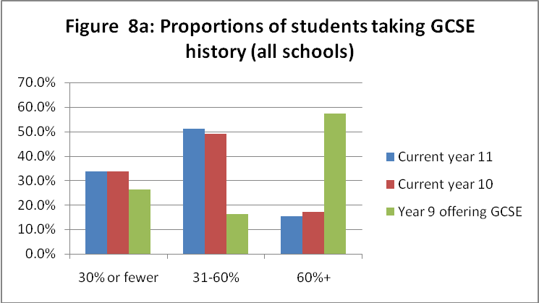
When these overall figures are compared with the responses given by the schools who answered the survey last year (see Figure 8b), the broad pattern in terms of uptake is quite similar, although there were rather more schools among last year’s respondents reporting cohorts of 30% or fewer students in Years 10 and 11, and slightly fewer schools reporting cohorts of between 31% and 60%.
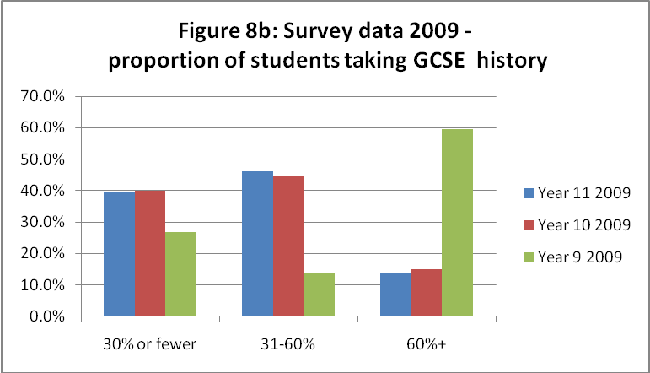
Since many schools have introduced a two-year KS3 with students beginning GCSE courses in Year 9, we also asked about the proportion of students studying GCSE history in Year 9. Although 110 schools answered this question, implying that they are running GCSE courses in Year 9, this figure is somewhat unreliable, since only 51 schools said elsewhere that history was optional for students in Year 9. It is possible that the 110 includes many schools who have introduced a compulsory one-year GCSE history or humanities course for all students in Year 9 (after a two-year KS3). It may also include schools that start the GCSE curriculum with all students part-way through Year 9, knowing that some have already opted to give up the subject at the end of the year. The fact that over half the schools offering GCSE in Year 9 have more than 60% of students studying history does not therefore mean that this proportion will continue with the subject into Year 10.
What can be concluded with confidence from these figures is that in more than a quarter of schools where history has become optional in Year 9 only 30% or fewer students are continuing with the subject. In 29 of the schools that responded, two-thirds of students do not continue with history beyond the end of Year 8; this directly echoes findings from last year’s survey, when more than a quarter of schools offering some kind of early GCSE provision had also allowed two-thirds of pupils to give up any study of history at the end of Year 8.

2.1.2 Uptake by type of school
When the proportion of students studying for GCSE history is examined in different kinds of schools, very clear patterns emerge.
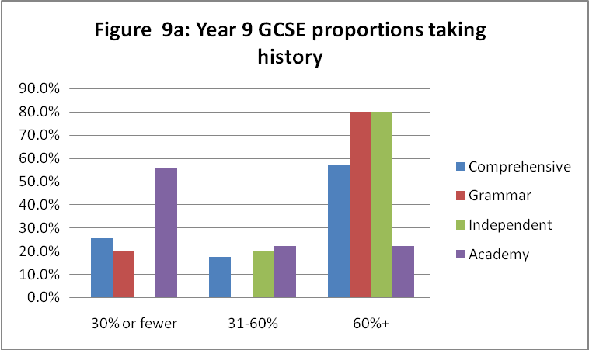
Figure 9a shows that while a fifth of the grammar schools and a quarter of the comprehensive schools that have allowed students to opt early have 30% or fewer students continuing with history in Year 9, well over half of the academies have similarly low numbers continuing with the subject. This confirms the trend evident last year for particularly low recruitment to history among the academies (see Figure 9b).
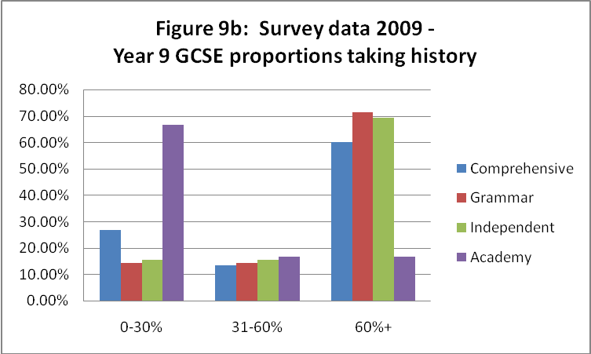
In Year 10, when all students are now following KS4 programmes (including GCSEs, BTECs and Diplomas), nearly two-thirds of the academies and more than a third of the comprehensive schools that responded report that history GCSE attracts only 30% or fewer students (see Figure 10a.) At the other end of the scale, fewer than 10% of the comprehensives and 5% of the academies have history cohorts that comprise 60% or more of their students. This contrasts markedly with the grammar and independent schools, over half of which have recruited more than 60% of students to the study of history.
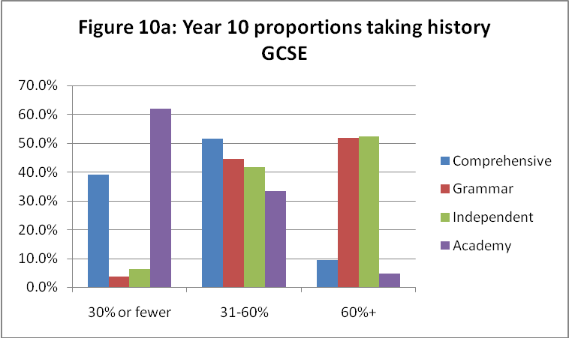
The pattern shown in Figure 10a is very similar to that evident among respondents in 2009 (Figure 10b). While history was recruiting well in 2009 in approximately 40% of schools of all type, it was among the academies and comprehensives that most schools with low GCSE uptake could be found. Over half the grammar schools, and 40% of independent schools, were recruiting at least 60% of students to history GCSE.

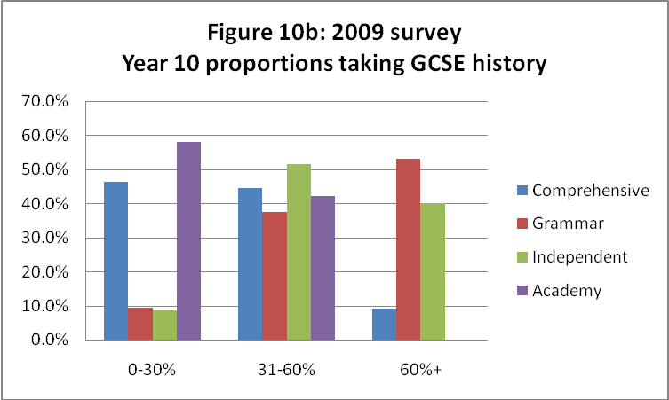

As Figures 11a and 11b show, the pattern is broadly replicated for current Year 11 students and reflects a similar distribution between schools to that observed in 2009.
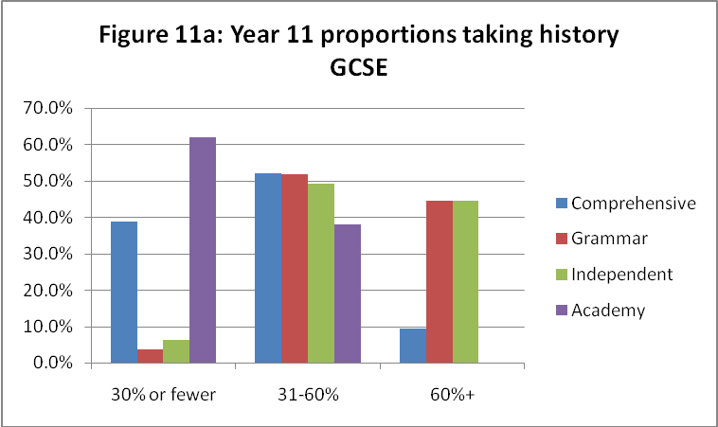
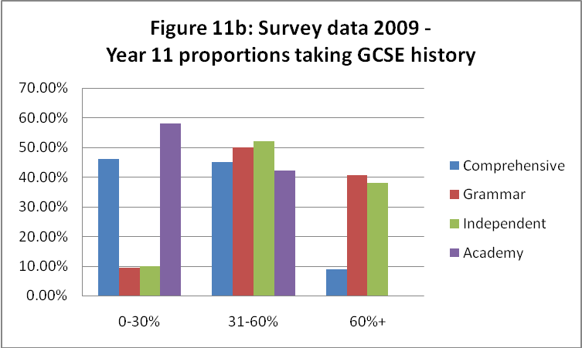

2.2 Patterns in GCSE uptake
2.2.1 Overall trends in GCSE uptake (all schools)
Schools were asked about any trends in their GCSE option figures over the last three years, indicating whether the number of students continuing with the subject was increasing, decreasing or essentially stable. Schools could also choose to indicate variation from year to year, but with no evidence of a trend in either direction. Examined in this way the picture presented by the 378 schools that responded to this question, and shown in Figure 12, appears essentially positive in that overall slightly more schools (24.1% of respondents) report an increase in GCSE uptake than report a decrease (18.5%). While this is broadly similar to the picture last year, the positive tendency among the survey respondents was slightly stronger in 2010. Numbers were regarded as stable in 25.9% of schools, with 31.5% experiencing annual variations.
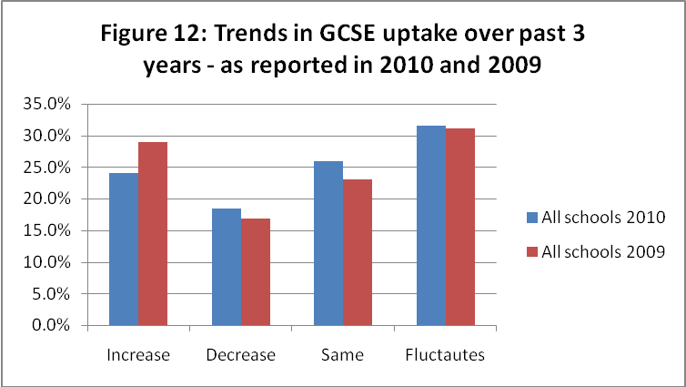

2.2.2 Trends in GCSE uptake by type of school
However, when the trends in 2010 are examined for different types of schools (as shown in Figure 13a), the responses from academies and grammar schools indicate more schools experiencing a decline in numbers than those reporting a rise. In both cases it should be noted that the total number of such schools responding to the survey was fewer than 30, so the picture may not be entirely reliable.
Other than the surprising report of a greater decline in numbers among grammar school respondents, the patterns are broadly similar to those revealed by last year’s survey. While the overall pattern had been generally positive among these schools – in that more schools were seeing an increase in GCSE numbers than were seeing a decline – this was not true of academies. Moreover, the type of school least likely to see a decline in GCSE history uptake both this year and last was the independents.
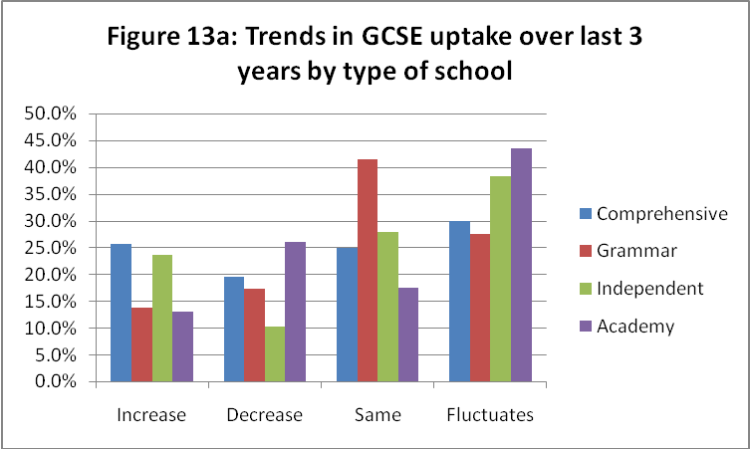
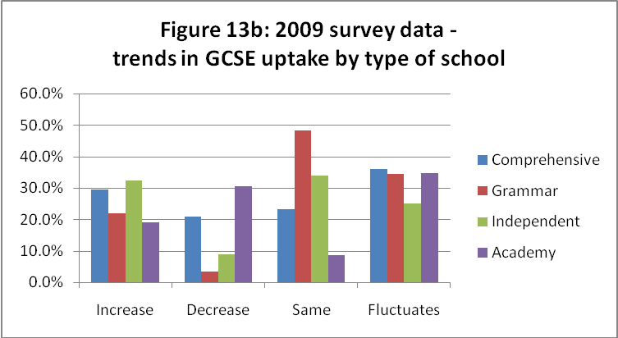

2.2.3 The relationship between time allocation and trends in Year 9 and GCSE uptake
Although the picture is complicated by the number of schools that have now made history optional in Year 9, usually in order to start GCSEs early, it is possible to compare teachers’ reports about time allocations in Year 9 with trends in uptake at GCSE (see Table 3). Does the amount of time allocated to history in Year 9 influence students’ decisions about whether or not to continue with the study of history?
Such a comparison reveals that where the time allocated to history in Year 9 is more than an hour a week, schools are more likely to see an increase rather than a decrease in the numbers opting for GCSE history.
Table 3: Analysis of GCSE trends in relation to Year 9 time allocations
GCSE trend | Time allocation per week for history |  | Totals
 | 60 mins or less | More than 60 mins
Increasing GCSE uptake | 20 | 100 | 120
Decreasing GCSE uptake | 22 | 68 | 90
Total | 42 | 168 | 210
χ² statistic 9.85 is significant at 0.5% with 1 degree of freedom.
Comparison of schools where the proportion of students opting for GCSE was declining with those where the proportion was actually increasing also revealed a statistically significant relationship between trends in Year 9 time allocations and GCSE uptake, as Table 4 makes clear. The proportion of students opting for GCSE was more likely to decrease as time for history was cut in Year 9, and to increase in those very few cases (only 12 in total) where time for history in Year 9 was increasing.
Table 4: Analysis of GCSE trends in relation to trends in time allocations in Year 9
GCSE trend | Trends in time allocation in Year 9 |  |  | Totals
 | Decrease | Stable | Increase
Increasing GCSE uptake | 14 | 97 | 8 | 119
Decreasing GCSE uptake | 26 | 56 | 4 | 86
Total | 40 | 153 | 12 | 205
χ² statistic 19.6 is significant at 0.1% with 2 degrees of freedom

2.3 Restrictions on GCSE choice
2.3.1 The extent to which students’ choices were restricted
Respondents were asked whether all students were given the option of studying for GCSE history. 16.8% of the 501 schools that answered this question reported some kind of restriction, preventing certain students opting for the course – a slightly smaller proportion than last year (23.6%). While restrictions were reported by all types of school, such curbs were much more common in comprehensive schools and academies – a pattern equally evident in last year’s data (see Figures 142a and 14b).
As Figure 14a illustrates, restrictions were applied in 18.7% of comprehensives and 27.3% of academies. These were largely based on ability, and often expressed through the ‘pathway’ systems that limit students’ choices to a particular menu of 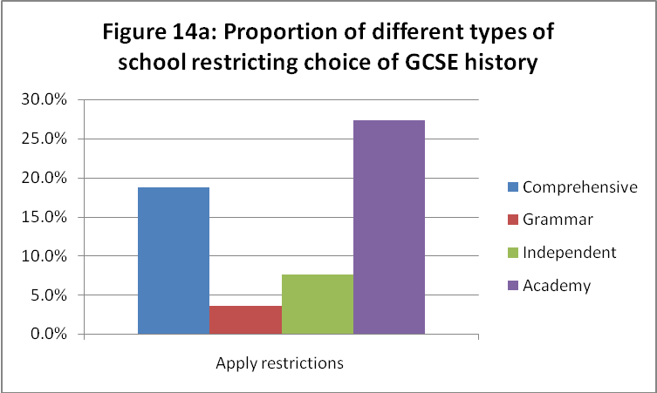

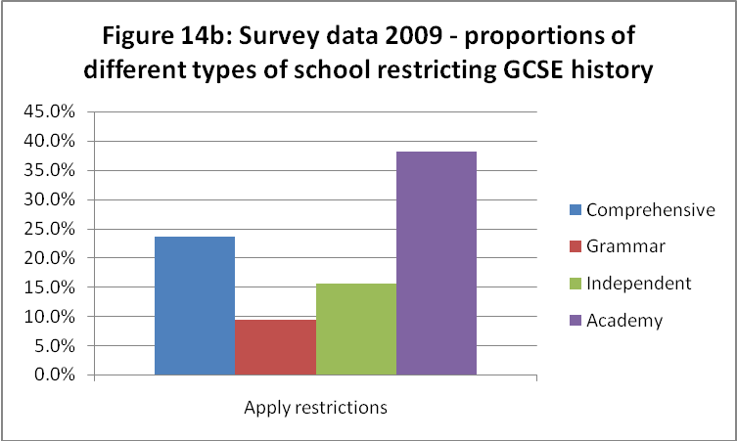
courses deemed most suitable for them. Among the comprehensive schools, 46 referred to ‘ability’ as the restricting factor, with 18 explicitly mentioning ‘pathways’ as the mechanism by which such a restriction was applied. Seven comprehensive schools cited the limited number of options open to students, with two specific references to the choices being blocked by Diplomas. In three of the four academies that reported restrictions, these were based on students’ ‘ability’. The constraints of Diploma timetabling also account for the restriction encountered in the fourth academy. A very small number of schools referred to the impact of the school’s specialist status (with students being required to take a GCSE in the school’s specialist subject.
Many teachers expressed deep regret about the fact that history was effectively out of bounds for lower-attaining students, and some deeply deplored the fact that there were no lower-tier GCSE papers that might be accessible to them. However, it should also be acknowledged that one or two teachers expressed relief that students were being counselled or directed away from GCSE history, which in its current form they regarded as still too inaccessible.

2.3.2 Alternative history or humanities options for those for whom GCSE was regarded as inappropriate
In a few schools low-attaining students in Year 11 have been directed to take ‘entry level’ certificate courses, an option reported by nine comprehensive schools. Two others suggested that GCSE Humanities is used to provide a more accessible GCSE qualification.
It should be noted that alternatives regarded as more challenging were also reported – with five independent schools choosing to offer IGCSE, and one comprehensive and one academy offering a Year 11 AS course.

2.4 Teachers’ reactions to the new GCSE specifications
Respondents were asked about their reactions to the new GCSE specifications that they had been teaching since September 2009. Among the 545 respondents, 43.9% thought that it was too soon to be able to report, while 14.1% thought the new specification would mean little significant difference for them or their students. Of the 299 judgments expressed, positive reactions outnumbered negative ones by more than two to one (see Figure 15).
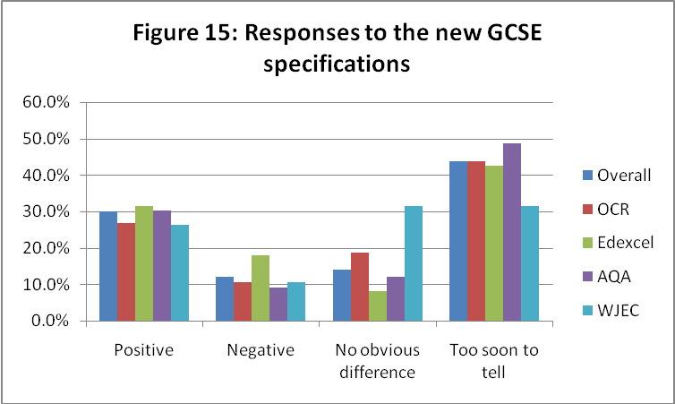
This pattern was similar for all the exam boards, although the proportion of negative comments was slightly higher among those following Edexcel courses, as Table 5 shows.
Table 5: Responses to the new GCSE specifications by examination board
 | Positive | Negative | No obvious difference | Too soon to tell | Total
All boards | 163 | 66 | 77 | 239 | 545
 | 29.9% | 12.1% | 14.1% | 43.9%
OCR | 56 | 22 | 39 | 91 | 208
 | 26.9% | 10.6% | 18.8% | 43.8%
Edexcel | 51 | 29 | 13 | 69 | 162
 | 31.5% | 17.9% | 8.0% | 42.6%
AQA | 43 | 13 | 17 | 69 | 142
 | 30.3% | 9.2% | 12.0% | 48.6%
WJEC | 5 | 2 | 6 | 6 | 19
 | 26.3% | 10.5% | 31.6% | 31.6%

Positive reactions
Only some of the teachers chose to explain their responses – and often those who indicated that their response was essentially positive also included reflections on negative features of the course. Among the 110 explanations of positive reactions, the features mentioned most often were: the modular structure (mentioned in 38 comments); the introduction of controlled assessment (30); the reduction in content compared with their previous specification (28); the nature of the content – variously described as more relevant for students or more engaging and motivating (21); and the fact that the exam paper was more straightforward, making clear what was required of students (10). Five schools commented on the continuities they valued between the new specification and their previous course, and four of them welcomed the guidance and supporting materials provided by the exam boards. Four teachers claimed the new specification would be easier for students and saw this as a positive feature. Other reasons given by two or three schools included the claim that it was better tailored for their particular students; that it offered greater flexibility; and that it included greater variety. Two teachers simply valued the way in which the introduction of new courses had prompted them to reflect on and review their practice.
Reasons for welcoming the modular structure focused predominantly on the chance to take some examinations in Year 10, allowing students to focus their attention on one aspect of the course at a time. Spreading the exams in this way would, it was assumed, lead to better results, partly because of this narrower focus at any one time, but also because of the scope that the system provided to allow students to retake modules in order to raise their grade.
Teachers’ endorsement of controlled assessment tended to focus on the fact it was easier to ensure that students’ work was completed and collected than it had been with coursework written at home; and that work undertaken in controlled conditions would provide a much fairer means of assessment, reducing the scope for plagiarism and ensuring greater consistency in the level of guidance provided by different teachers and schools.
Negative reactions
The fact that many teachers included negative comments while explaining a reaction that they had classified as essentially positive meant that overall there were 89 explanations of negative features (rather more than the 66 negative judgments). By far the most prominent feature in these negative comments was controlled assessment (mentioned by 33 respondents). The main concern was about the additional workload it imposed on teachers, in part because of the complexity of its administration (11 comments). Several were angry about the late publication of detailed requirements and guidance from the exam boards (five), while others were seriously concerned that the reduction of time imposed by the controlled conditions would tend to lead to poorer quality work and particularly disadvantage weaker students, who take longer to formulate, express and substantiate their ideas (six comments). Twenty-one other comments related to broader concerns about the impact on results, the high level of the demands introduced by the new courses, the introduction of higher grade boundaries, and the lack of any course that would be appropriate for weaker students. It should be noted, however, that nine of the teachers responding complained that the new specifications were effectively lowering standards, while four regretted that they failed to differentiate effectively between students or to prepare students for A-level study. The late issuing of detailed guidance and resources from the exam boards, along with exam board mistakes and the issue of contradictory advice, was raised as a problem by a further ten respondents. Thirteen comments focused on the nature of the examination: with several describing its requirements as ‘jumping through hoops’ – making success more dependent on examination technique than on knowledge and understanding, while others lamented the examination’s focus on recall, its lack of creativity, and the prescriptive nature of the mark-schemes. Two respondents simply dismissed the new specifications as ‘boring’.
Some patterns were evident in relation to different examination boards: among the 29 respondents taking Edexcel courses who regarded the impact of the new specifications as essentially negative, ten explanations included concerns about the likelihood of poorer results for their students (fears based in many cases on marks already awarded for modules taken in January 2010). While over a third of the 22 who were critical of the AQA specification shared this concern about more challenging requirements, an equal number complained that the new specification had reduced the level of demand. Among those following OCR specifications, the overwhelming concern of those who judged that its impact had been negative complained about the controlled assessment, criticising both its logistical demands and the lack of clarity in advice from the board.
2.5 The impact of the introduction of Diploma qualifications
Respondents were asked to indicate whether their schools were offering Diploma courses, and if so, to report on the impact of the new qualification on GCSE history uptake (see Table 6). About a third of the 184 schools that said they were offering Diplomas (in partnership with other providers) thought they were having a negative impact on GCSE history.

Table 6: Impact of the introduction of Diploma qualifications
Effect of Diplomas on GCSE entry for history | Number of schools
Positive effect | 3
Negative effect | 56
No obvious effect | 125

While the most obvious negative effect was the increase in competition – with another kind of qualification being offered (noted by seven respondents) – the inclusion of Diplomas also changed the way in which options were structured. Six teachers reported that in their school choosing any kind of Diploma automatically meant that it was impossible to take history, while three others pointed out how restricted students’ choices had become. Many teachers were keen to emphasise, however, that the choice was not a ‘free’ one: students, if not compelled to follow the Diploma route, were carefully steered that way (six comments); with the expectation that the Diploma – widely assumed to be easier – would generate higher scores for the student and thus for the school (seven comments):

History is not allowed as a subject alongside a Diploma pathway (Teacher 73, comprehensive school)
History was very popular among the weaker pupils who are now not able to take it. They are increasingly encouraged into vocational streams. (Teacher 395, comprehensive school)
Lots of students I would have expected to take history are taking the new Diplomas as they see them as an easier option with less writing and it gives them the equivalent of four GCSEs. (Teacher 65, comprehensive school)

2.6 Concerns reported by teachers relating to history GCSE
In asking about their concerns, the survey included one specific suggestion related to GCSE, following up worries reported previously to the Historical Association related to the quality of exam marking. Of the 526 teachers who answered this question, 160 respondents (30.5%) regarded this as a current concern, including 54 (10.3% of the total) who regarded this as a serious concern. A further 177 respondents (33.7%) thought this issue might well become a matter of concern.
The respondents’ own comments, noting issues of concern to them, included 62 related to GCSE history. While most of these (such as complaints about controlled assessment and the impact of Diplomas) echoed points that had been explored elsewhere in the survey, they provide a clear message about the particular issues of immediate concern. Over a third (24) pointed to school policies that encouraged students to take vocational courses that were regarded as being of higher value than history because of the number of GCSE passes they were deemed to represent. The following comments are typical:
Students being steered towards BTEC and Diploma courses because they are worth 'x' number of GCSEs whilst traditional GCSEs are being side-lined as only worth 1 GCSE, and don't reflect that well on school CVA score. (Teacher 328, comprehensive school)
Been squeezed out in name of personalisation. Diplomas and BTECs are more points-rich therefore get priority in Choices Evening, extra assemblies. SLT tell blatant lies to students and parents about these current and new qualifications as it impacts significantly on CVA. No focus on quality or enjoyment or what students and parents want. I am routinely ignored as a Head of Department. (Teacher 464, comprehensive school)

History and other subjects are being sidelined because they do not produce the results as easily as new BTEC courses. The current SMT [senior management team] thinking is to teach things in a themed way. I get the feeling that I no longer fit into my school because I champion the teaching of History to all. (Teacher 338, comprehensive school)

[In 2011 we’re] going to be turned into Academy. Lots of new BTECs being introduced. When they hear History is 'only' worth one GCSE they go to BTEC travel and tourism – four GCSEs for doing a project on Scarborough!! Now considering getting out of teaching – can stand this dumbing down no longer. (Teacher 85, comprehensive school)
The big problem is that there are so many courses available to students which have no exam content and minimal skill requirements and yet they complete the course with two grade 'B's. History is still a very difficult subject to pass, with several essays and difficult source analysis questions to complete. (Teacher 106, comprehensive school)
As these comments make clear, it is not simply the fact that history is in competition with more subjects or different kinds of qualification that worries teachers but the active promotion of such vocational courses as being of more value to the students because they count for more within school league tables. While some refer to the heavy steer that students are given by senior leaders, others deeply regret the pathway systems that deprive students of any choice at all about whether to take history. The emphasis given to grades of C and above means that those students thought unlikely to achieve such grades are actively deterred, if not prevented, from continuing with the subject. Several teachers suggest that this tendency is compounded by the fact that there is no lower-tier GCSE paper in history, which makes the subject seem even more inaccessible.
Vocational courses, particularly the Diploma programmes, are also cited quite frequently among the teachers’ concerns because of the impact that they have on timetabling. The need for students to attend courses run offsite by partners in the Diploma programme seems to mean either that many history courses have very disjointed timetables, with intensive teaching at certain points in the week/fortnight and long spells with no history lessons, and/or that students regularly miss timetabled history lessons in order to attend Diploma sessions or assessments.

3. History at A-level
3.1 Uptake at AS/A2
3.1.1 Overall uptake (all schools)
Out of all the institutions that responded to the survey, 347 offer history at AS/A2. The majority of schools and colleges report that between 11–20% of their sixth-form cohort study history. The overall figures suggest that uptake is stronger in Year 12 with numbers falling as students move into Year 13, as shown in Figure 16a. A comparison of the figures with those from the 2009 survey (see Figure 16b), suggests a high degree of stability in the numbers of students taking AS and A2 history.
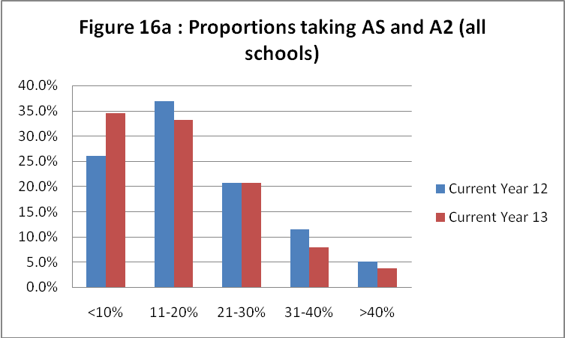

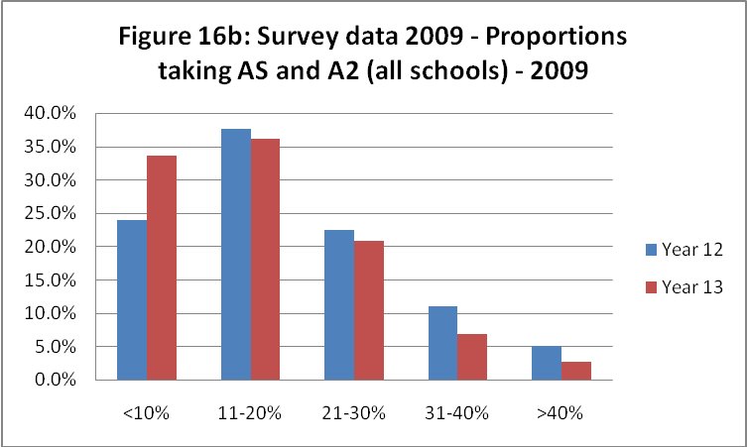
The data that we have makes it difficult to identify precise trends between GCSE uptake and A-level uptake because of the numbers of students who move between insitutions at this stage. In analysing the responses given only by those who teach at schools with a sixth form no clear connection was found between trends in GCSE uptake (as reported for Year 11) and trends in AS uptake (see Table 7).
Table 7: Analysis of trends in AS uptake in relation to trends in GCSE uptake
Trend in AS uptake | Trends in GCSE uptake |  |  | Totals
 | Decreasing | Stable | Increasing
Increase in AS uptake | 15 | 25 | 27 | 67
Decrease in AS uptake | 10 | 11 | 5 | 26
Total | 25 | 36 | 32 | 93
χ² statistic is 4.34 is not significant at the 10% level, with two degrees of freedom

3.1.2 Uptake by type of school
When comparing uptake at AS by type of school, clear patterns emerge (see Figure 17). The mode for comprehensive schools is for 11-20% of the cohort to study history at AS, as is the case in sixth-form colleges and independent schools. Grammar schools have the highest mode with 21-30% of students studying history, whereas academies have the lowest mode with nearly half reporting that fewer than 10% of the cohort study history at AS. The figures for 2009 reveal a very similar pattern – the only real difference being that in 2010 there has been a slight decline in the numbers of academies reporting large proportions of students studying history at AS.
Looking at the numbers for A2 (see Figure 18a), it is clear that there is a general fall in numbers from AS to A2, although academies see the starkest decline in numbers. Nearly three-quarters of academies have fewer than 10% of students studying history at A2, compared to nearly half at AS. Although there appears to be an increase in the number of grammar schools where 21–30% of the cohort study history, this is due to a fall in the number of such schools reporting more than a third of students studying the subject. There does appear to be a greater variation in A2 numbers between different types of school when comparing 2009 and 2010 (see Figure 18b). It is unclear at this stage whether this is a trend or part of natural variation.
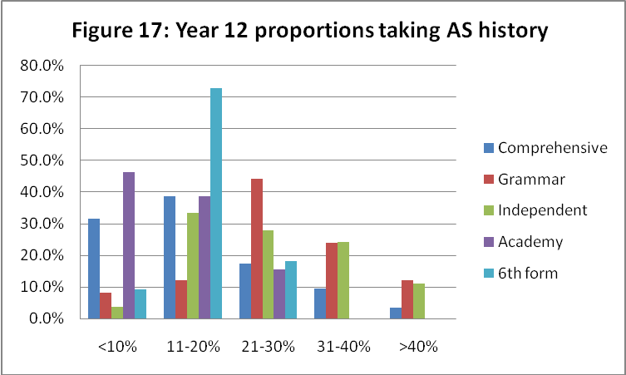

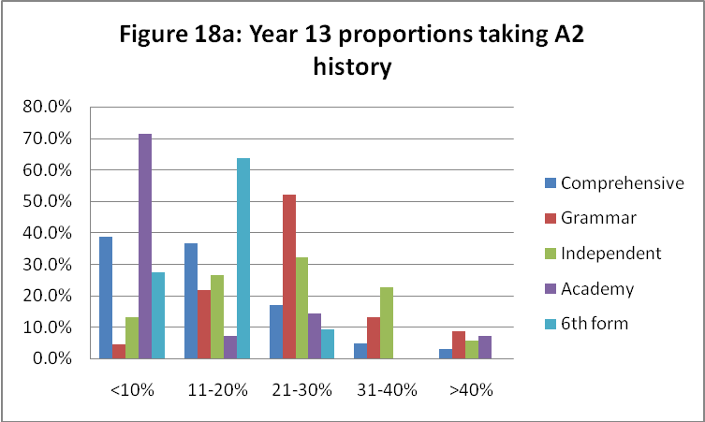

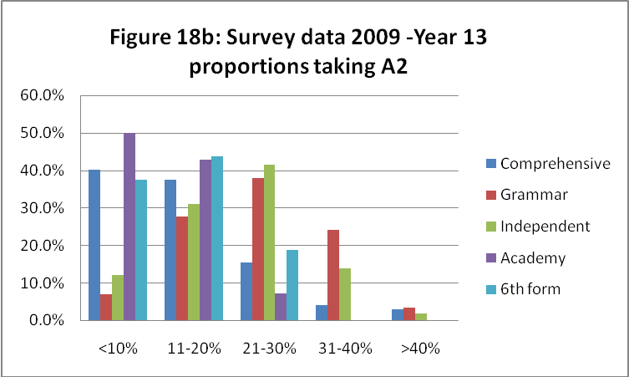

3.2 Patterns in AS/A2 uptake
Among those schools that responded to the survey, the overall trend in AS numbers is positive (see Table 8). The number of institutions reporting an increase in AS numbers is three times that of institutions reporting a decrease. The institutions showing the largest growth in numbers are sixth-form colleges (two-thirds, although the numbers of sixth-form colleges which responded to the survey make it difficult to provide an authoritative statement about trends) and comprehensive schools and academies (with almost a third reporting an increase). This picture is slightly different to that found in 2009, where a third of all types of school reported an increase in numbers, apart from sixth-form colleges, where the proportion was closer to two-thirds.
Table 8: Analysis of trends in Year 12 uptake of AS history by type of school
Trends in year 12
 | Increase | Decrease | Varies | Same | Total respondents
Overall | 102 | 37 | 125 | 70 | 334
 | 30.5% | 11.1% | 37.4% | 21.0%
Comprehensive | 65 | 25 | 76 | 42 | 208
 | 31.3% | 12.0% | 36.5% | 20.2%
Grammar | 6 | 6 | 9 | 4 | 25
 | 24.0% | 24.0% | 36.0% | 16.0%
Independent | 13 | 3 | 25 | 13 | 54
 | 24.1% | 5.6% | 46.3% | 24.1%
Academy | 4 | 2 | 6 | 1 | 13
 | 30.8% | 15.4% | 46.2% | 7.7%
Sixth-form | 7 | 0 | 0 | 4 | 11
 | 63.6% | 0.0% | 0.0% | 36.4%

At A2 the figures are less positive, apart from sixth-form colleges, but the general picture is still one of more institutions reporting an increase in numbers than a decrease (see Table 9). The figures are slightly less positive than those in 2009, except for sixth-form colleges. In 2009, about 20% of both independent schools and grammar schools reported an increase in A2 numbers, whereas in 2010 the figures are 15% and 16% respectively. At present it is not clear how attractive students will find the new A2 specifications and therefore how many will continue to study the subject into Year 13.
Table 9: Analysis of trends in Year 13 uptake of A2 history by type of school
Trends in year 13
 | Increase | Decrease | Varies | Same |  | Total respondents
Overall | 61 | 40 | 143 | 84 |  | 328
 | 18.6% | 12.2% | 43.6% | 25.6%
Comprehensive | 36 | 28 | 89 | 52 |  | 205
 | 17.6% | 13.7% | 43.4% | 25.4%
Grammar | 4 | 3 | 11 | 7 |  | 25
 | 16.0% | 12.0% | 44.0% | 28.0%
Independent | 8 | 3 | 24 | 17 |  | 52
 | 15.4% | 5.8% | 46.2% | 32.7%
Academy | 3 | 2 | 7 | 1 |  | 13
 | 23.1% | 15.4% | 53.8% | 7.7%
Sixth form | 8 | 0 | 0 | 3 |  | 11
 | 72.7% | 0.0% | 0.0% | 27.3%

3.3 The impact of Diplomas
The impact of Diplomas at the moment appears to be minimal. Among the schools and colleges that responded, 87 are offering Diplomas within their own institution, 70 are working in partnership with other schools and colleges, and a further 208 are offering no Diploma options at present.
Respondents were given an opportunity to explain the impact of the Diplomas on history uptake. The vast majority (121) suggested that Diplomas had had no impact. Only three respondents reported positively about the impact of Diplomas with seven reporting a negative impact, mainly due to restrictions being placed on student choices.
3.4 Impressions of the new AS/A2 specifications
As the A-level specifications are still bedding down in schools and colleges, it is not surprising that the majority of responses overall indicate that it is too soon to tell about the quality and impact of these (see Table 10). The only exception to this is the OCR B specification which, although it has been adopted by few centres, appears to have been well received. On balance the number of positive responses outweighs the number of negative responses, except for the OCR A specification, where the negative responses marginally outweigh the positive ones.
Table 10: Responses to the new AS/A2 specifications by examination board
 | Positive | Negative | No obvious difference | Too soon to tell | Total respondents
Overall | 107 | 69 | 66 | 147 | 389
 | 27.5% | 17.7% | 17.0% | 37.8%
OCR A | 18 | 19 | 14 | 26 | 77
 | 23.4% | 24.7% | 18.2% | 33.8%
OCR B | 17 | 6 | 7 | 17 | 47
 | 36.2% | 12.8% | 14.9% | 36.2%
Edexcel | 38 | 24 | 23 | 48 | 133
 | 28.6% | 18.0% | 17.3% | 36.1%
AQA | 34 | 20 | 19 | 54 | 127
 | 26.8% | 15.7% | 15.0% | 42.5%
WJEC | 0 | 0 | 3 | 2 | 5
 | 0.0% | 0.0% | 60.0% | 40.0%

A number of respondents provided comments to explain those aspects of the new specifications that they regarded positively or negatively. Overall there were 34 positive comments about the new content requirements. These were mainly linked to the degree of interest and variety of the specified content, and a few comments were related to the manageability of the new content. There were 17 positive comments about the new coursework requirements, which were seen as challenging and enjoyable by most respondents. Eleven respondents felt that results had improved as a consequence of the new specifications. Other responses indicated that the new specifications were popular with students and developed students’ understanding of history better. The more positive comments showed that the new specifications were a better reflection of the nature of the subject, promoted better thinking and ways of working, and provided good levels of challenge:
The papers seem to be clearer and more genuinely historical in focus – it seems to be more the case that better candidates do better and vice versa. In our previous specification, it was often very difficult to work out how the results we got corresponded (Teacher 5, independent school)

Again, students are learning real history. By Year 13, they are able to handle difficult texts, learn independently, and think like real scholars (Teacher 122, independent school)

There were 28 negative comments about content. These focused mainly on the limited range of choice available and the breadth that was required in some specifications, as well as a feeling that there was an imbalance between AS and A2 (AS was seen as too content heavy in comparison to A2). Although this appears to contradict many of the positive points about content, this may well be a reflection of teachers’ prior experience of A-level teaching, as there seems to be no pattern relating to the particular specification chosen. The new coursework attracted 20 negative comments. These comments were more specific to particular specifications – thus OCR A was more likely to be criticised for creating an increase in workload for teachers and Edexcel was more likely to be criticised for a loss of student independence (especially in comparison to the individual assignment in the previous specification). Assessment was also criticised, with 22 negative comments about it. In particular concerns were raised about the poor nature of questions being asked in exams and a lack of clarity regarding expectations. Additional concerns were raised about poor support from the exam boards and the lack of resources to support the new specifications.
It is clearly difficult to reach a definitive conclusion about the new A-level specifications. As teachers become more used to them views may change, but the general sense is positive, and where concerns are raised they tend to be quite specific and related to particular specifications.

4.5 Other reported concerns about A-level history
When asked in the more general question about concerns, 19 respondents identified issues of concern related to A-level teaching. The most frequent of these, raised by seven teachers, related to assessment. In these cases concerns were raised about the quality of marking, the artificial nature of some exam tasks and the limited choice of questions in the exam. Three respondents were worried about a narrowing of the curriculum. The limited number of responses, however, would suggest that the majority of respondents were either happy with the new specifications or at least did not have major concerns about them.

The implications of locating history within a humanities programme, even if it is taught as a discrete subject, tend to be either that students are taught one or more humanities subjects by a non-specialist teacher (since one teacher – of RE, history or geography – will teach them for all three subjects); or that they rotate between teachers, spending say six weeks (which equates to between six and twelve lessons) studying history with one teacher before moving on for another six weeks with a different subject specialist.
The focus of the analysis for the 2010 survey has been on trends in Year 7 and Year 9, as these were found to be important during the 2009 survey. Most schools that had adopted a competency or skills-based curriculum had done so only for the duration of Year 7 (with only a small number continuing with this format in Year 8), while the impact of a decision to adopt a two-year Key Stage 3 programme would obviously only become apparent in Year 9. While we have collected data for the teaching of history in Year 8, its inclusion added little more to our knowledge of the impact of recent curriculum changes in Key Stage 3.
CVA = Contextual Value Added: the score that schools achieve based on the students’ achievement relative to their background and prior attainment
BTEC = qualifications offered by the Business and Technology Education Council

