Planning for Historical Enquiry: The Mughal Empire

This unit confronts some of the fundamental issues that face history teachers in planning a rigorous and engaging sequence of lessons. The unit models important stages in the planning process and the four activities relating to these stages could be used as professional development in a history department. The unit focuses on the Mughal Empire as a context for firing pupils’ curiosity and imagination.

How does a study of the Mughal Empire fit into the new programme of study?

The revised statement on the importance of history emphasises that history encourages mutual understanding of the historic origins of our ethnic and cultural diversity. It also states that history enables pupils to investigate Britain’s relationship with the wider world, and to relate past events to the present day. In the specific context of the British Empire, the new programme of study emphasises the importance of recognising the cultures, beliefs and achievements of societies prior to European colonisation.

Why study the Mughal Empire?

There are a number of reasons why you may wish to include a study of the Mughal Empire in your key stage 3 curriculum.

Activity 1

Which of these reasons strike you as particularly important?

- The Mughal Empire was the greatest of the Muslim empires of the early modern period. The Mughal Emperor ruled over an estimated 100 million people at a time when Elizabeth I ruled over a population of 3 million.

- The history of the Mughal Empire is full of drama, diversity, big ideas and phenomenal creativity. It has enormous potential to fire pupils’ curiosity and imagination.

- The Mughal Empire was an extraordinary Indo-Islamic synthesis. Some of its rulers attempted to create a tolerant and pluralist society which embraced all religions. A study of the Mughal Empire can encourage pupils to consider fundamental questions of identity and diversity.

- A study of the Mughal Empire is critical if pupils are to understand the diversity, tensions and achievements of modern India.

- For pupils of Asian origin, the Mughal Empire is a central part of their heritage and personal identity.

- The close, complex and long-lasting relationship between Britain and the Mughal Empire, and the significance of the Mughal Empire in world history, make it an important part of all our identities.

- No other dynasty in the Islamic world has left behind more comprehensive historical documentation than the Mughals. A rich array of written sources, art, buildings and artefacts provides a plethora of learning resources.

- A study of the Mughal Empire offers rich possibilities for linking to other subject areas such as art, RE, geography and citizenship.

How might we decide what aspects of the Mughal Empire to cover?

Having decided that the Mughal Empire is simply too significant, wonderful and fascinating to leave out of the key stage 3 curriculum, your first challenge is to wrestle with the content. From the rich and complex history of the Mughal Empire how do you decide what to put in and what to leave out?

Activity 2

The table below shows some areas of content that might be included in a study of the Mughal Empire. Some of these areas are quite precise (e.g. the Battle of Panipat) while others are more open (e.g. the nature of Mughal power). The thirty different aspects are not exhaustive and you may wish to add ideas of your own.

- Which aspects do you consider essential?
- Which aspects would you leave out?
- How might you begin to group the aspects to create a focus for learning?
- Most importantly, what criteria are you using to make your decisions?

Areas of content to consider for inclusion within a study of the Mughal Empire

The Mughal economy – farming and trade | Jahan and the building of the Taj Mahal | Babur, the founder of the Mughal dynasty, 1526-1530
The Battle of Panipat,, 1526 | Mughal art | Akbar the Great, 1556-1605
Life at the Mughal court | Mughal warfare | The battle between Dara Shikoh and Auranzgeb
The nature of Mughal power | Akbar’s conferences on religion | The emperor at work
Akbar’s ‘city of dreams’ – Fatehpur Sikri | The reign of Humayan, 1530-40/1555-56 | The emperor at play
Mughal architecture | The reign of Jahangir, 1605-1627 | Elizabeth l and Akbar
European visitors | Women at the Mughal court | The Mughal cities: Delhi, Agra and Fatehpur Sikri
The reign of Aurangzeb, 1659-1707 | Mughal relations with England’s East India Company | The Imperial Harem
The daily lives and beliefs of the amirs (noblemen) | The daily lives and beliefs of the artisans and peasants | Mughal justice
Mughal jewellery | The Mughal legacy | Bahadur Shah Zafar, the last Mughal Emperor

What makes a good enquiry question about the Mughal Empire?

Crafting enquiry questions on the Mughal Empire that capture the interest and imagination of your pupils is an important stage in planning for effective learning. Rigorous, challenging and intriguing historical questions will ensure that pupils enjoy a purposeful learning experience. Some important points to consider are:

- Will you structure the learning around one big enquiry question or several smaller ones?
- What scope is there for pupils to generate their own enquiry question(s)?
- How can different questions combine outline and depth knowledge?
- Which concepts and processes will different questions reinforce?

Activity 3

From the list below, which question(s) could create the richest opportunities for rigorous and compelling learning about the Mughal Empire?

Possible enquiry questions on the Mughal Empire

- How did Akbar overcome his problems?

- What made Akbar ‘Akbar the Great’?

- Why can’t historians agree about the Mughals?

- What mattered to the Mughals?

- What made the Mughal court so special?

- How did the Mughal Emperors show their power?

- What can different sources tell us about the Mughals?

- How should we remember the Mughals?

- Who was the most majestic Mughal emperor?

- How much can paintings tell us about life in the Mughal Empire?

- What makes a good fictional story about the Mughals?

- How different were Delhi and London in the sixteenth century?

How can we plan a compelling sequence of learning for the enquiry: ‘What mattered to the Mughals?’ ?

The enquiry question ‘What mattered to the Mughals?’ could offer a particularly rich context for pupils’ learning, particularly if you decided to settle on just one overall question as a focus for study. The enquiry question forces pupils:
- to engage with the significant features of the Mughal Empire
- to explain the ideas, beliefs and attitudes that underpinned Mughal society
- to explore the diversity of people’s lives within the Mughal world
In pursuing this enquiry pupils would use a range of fascinating texts, pictures, artefacts and sites.

Defining the ‘end product’

Having settled on a rigorous and intriguing question, we need to decide how our pupils will communicate the knowledge and understanding they have developed. Defining a substantial and enjoyable ‘end product’ allows not only for a creative resolution of the enquiry question, but also helps us to assess what progress has been made. Devising challenging and motivating outcome activities is a central aspect of planning a compelling learning experience.

Activity 4

Which of the following end products would make a challenging and motivating outcome for the enquiry question: ‘What mattered to the Mughals?’ ?

Oral Outcomes | Written Outcomes | Visual Outcomes
Presentation  Lecture  Debate  ‘Panel’ discussion  Interview  Tour guide/audio presentation  Radio documentary  Podcast  Movie-maker commentary  Peer work reviews  Exhibition commentary  Speech to virtual character or audience | Academic article  Report  Letter/email  Review  Short biography  Fictional story  Web debate  Text book spread  Poem/song  Blog  Web site text  Trailers for movies/TV history series | PowerPoint – picture selection  Documentary film – movie-maker  Web pages  Exhibition gallery  Museum/gallery/site guide  Souvenir  Model  Film/stage set  Board game  Interactive display  Multi-media storyboard  Graphic novel

Finding a fascinating ‘hook’

An important dimension of planning for effective learning in history is the careful thought that we need to give to sequencing a series of learning experiences so that all the activities – teacher exposition, whole-class questioning, role-plays independent research, source-work, plenaries or whatever – systematically help pupils to move towards a resolution of the historical problem. Finding a fascinating ‘hook’ that will capture the curiosity of our pupils at the start of an enquiry is a vital part of planning a compelling sequence of learning. Intriguing images, interesting stories, puzzling features of the past and other such devices can all be used to hook pupils into history.

There are hundreds of potentially fascinating hooks for the enquiry, ‘What mattered to the Mughals?’ The exquisite painting Jahangir and his 15-year-old son Khurram (who later became the Emperor Shah Jahan) offers one possible starting point. The painting shows the prince sitting on a pair of scales. The ruling Mughals, since Akbar, had a tradition of weighing either the emperor or one of his sons at the start of the lunar and solar years. Their equivalent weight in gold and other valuables would then be given out to the poor and holy men.

Activity 5

How might you use this image to create a fascinating hook at the beginning of the enquiry, ‘What mattered to the Mughals?’ ?

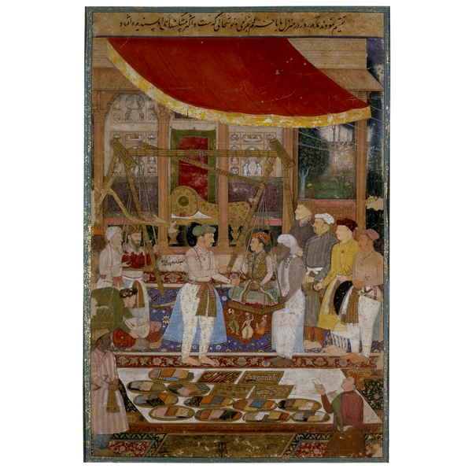

Where can we find some good resources?

Pupils’ resources

www.mughalindia.co.uk
This website, produced by the British Museum, provides a wealth of visual sources, artefacts and texts from the British Museum’s collections. It is designed to encourage pupils to use a wide range of evidence and to construct their own research paths. Pupils enter a research room where they can zoom in on objects and flick through documents and reference books. The website also includes a ‘staff room’ which provides additional information and teaching ideas.

Teachers’ resources

Michael Wood, The Story of India, BBC Books, 2007 (and DVD of the BBC series)

Bamber Gascoigne, The Great Mughals, Jonathan Cape, 1971

Annemarie Schimmel, The Empire of the Great Mughals: History, Art and Culture, Reaktion Books, 2004.

Abraham Eraly, The Mughal World: India’s Tainted Paradise, 2007

Francis Robinson, The Mughal Emperors and the Islamic Dynasties of India, Iran and Central Asia, Thames and Hudson, 2007

